Guide to using HumBox

Please note: this guide is a ‘work-in-progress’ and will evolve with the project and the technical development of HumBox.

HumBox is a place for us to store and manage our content, and ultimately, to publish and showcase our work. For most of the project, it is a ‘work in progress’ and the look and functionality of it will change as we go along, in line with your comments about the site. Please use it freely, and tell us if something does not work or needs amending or updating.

Also note: anything that you upload can be edited and/or deleted by you at any time.

- Go to http://www.humbox.ac.uk
- Choose ‘create account’
- You will see a screen like this:
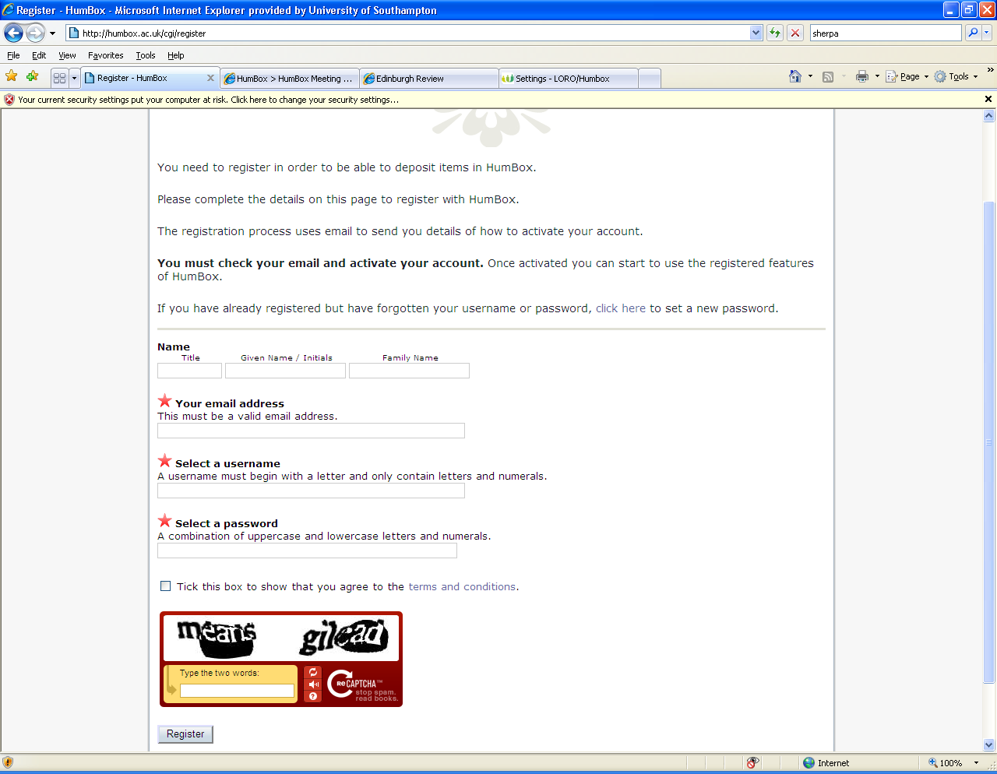

Complete your email address (this must be a valid address); select a username and a password. The starred fields are mandatory. You must also agree to the HumBox terms and conditions before you can be registered. Click ‘register’

- A confirmation email will be sent to the address that you provided. You may encounter a short delay in receiving your information. Click the link in the email to confirm your registration and activate your account. This link will take you to the login screen in HumBox, where you will be asked to put in your password. Then you will be sent to another screen: press the ‘continue’ button, and you will see this screen:

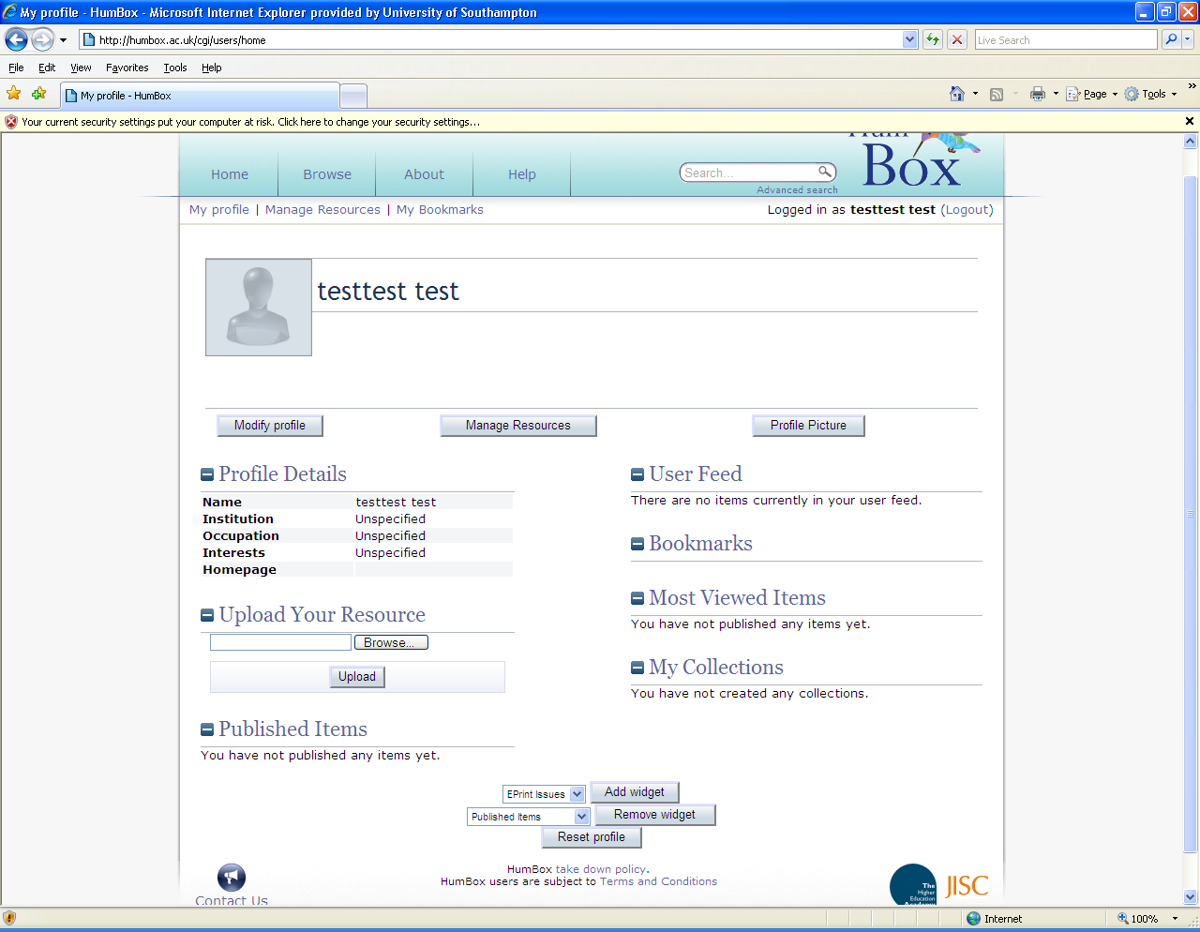
This is your blank user profile screen. Choose the ‘modify profile’ button to add your name and some personal details about yourself. Please provide some information here, as this page is a good guide to your professional life and to the resources that you are uploading.

Choose the ‘profile picture’ button to add a picture of yourself.

Your profile page is where you can see your most viewed and downloaded items and where you can see if other people comment on your resources. You can also see which resources you have bookmarked.

Uploading your resources:

- Now that you have created a profile, you can start uploading resources. Go to ‘manage resources’.
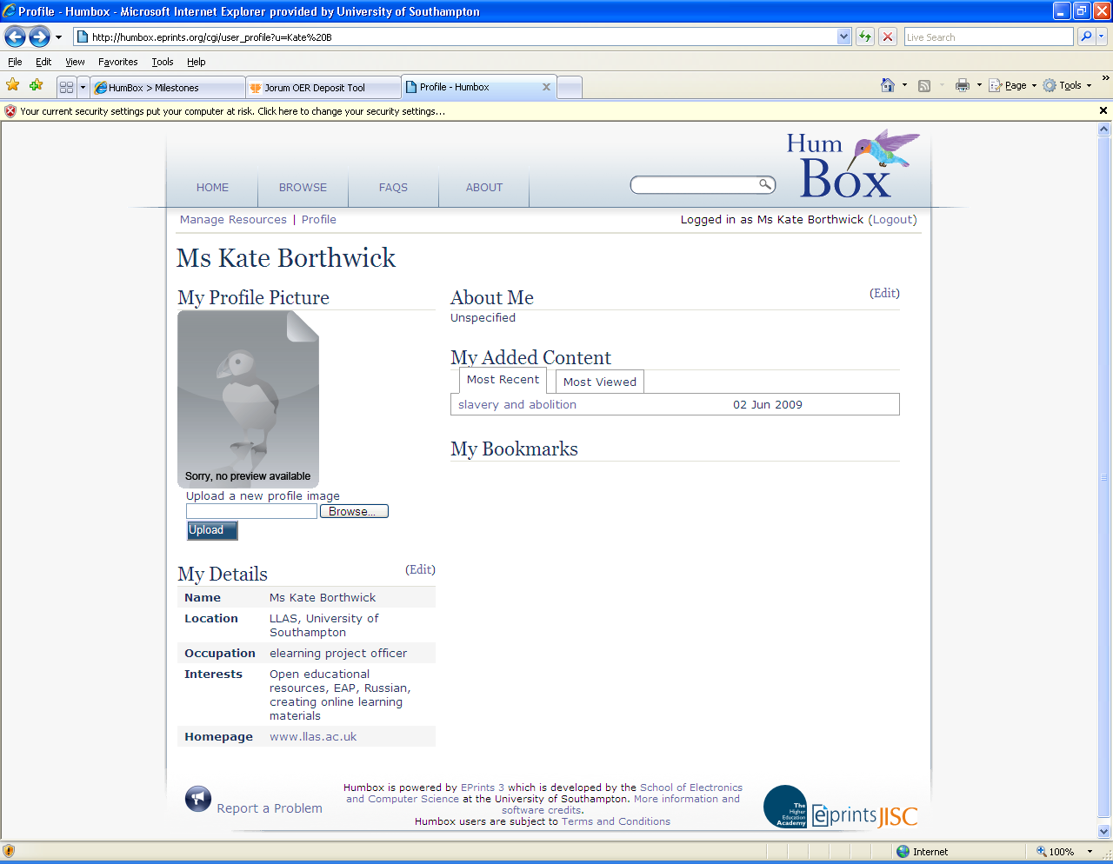

- You will see the resource management screen (the files you can see below are files from MY page – yours would be blank until you upload some resources:

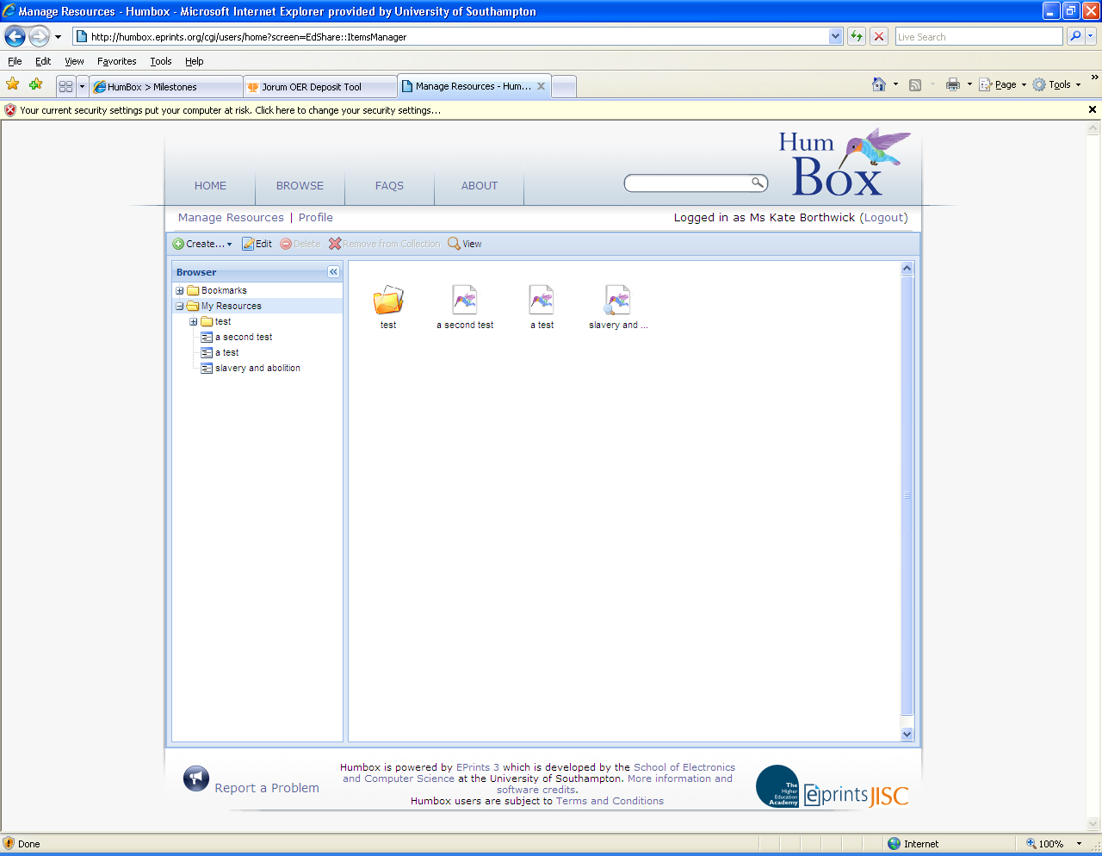
From here you can upload and edit your resources.

- Click the ‘create’ button. This allows you to upload either a single resource or a collection of resources. Choose ‘create resource’.

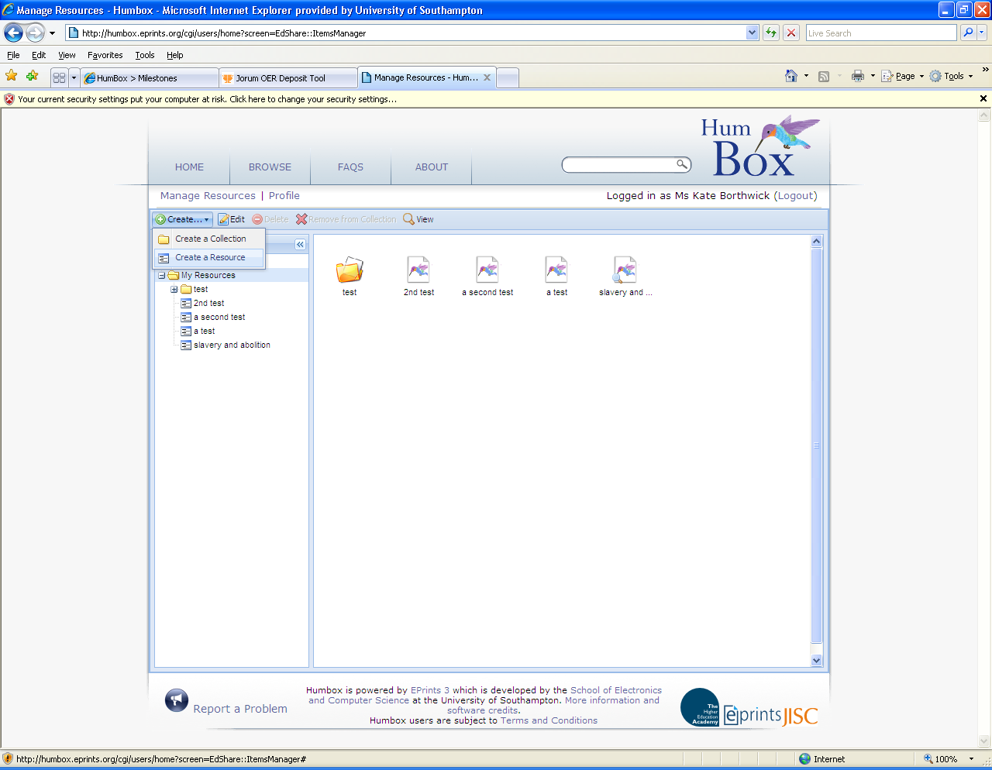

A space will appear in the file list below. Edit the name ‘new resource’ to the name of your resource.
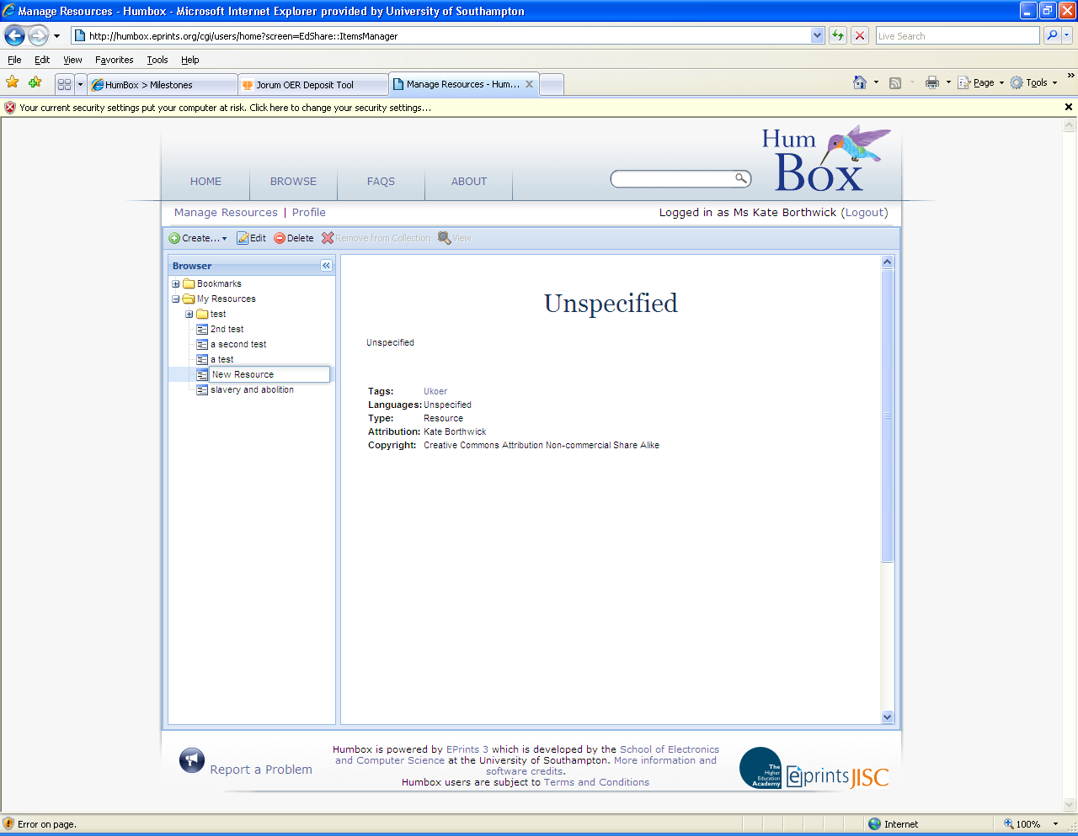

- Click the ‘edit’ button to add the details of the resource and to upload it to Humbox.
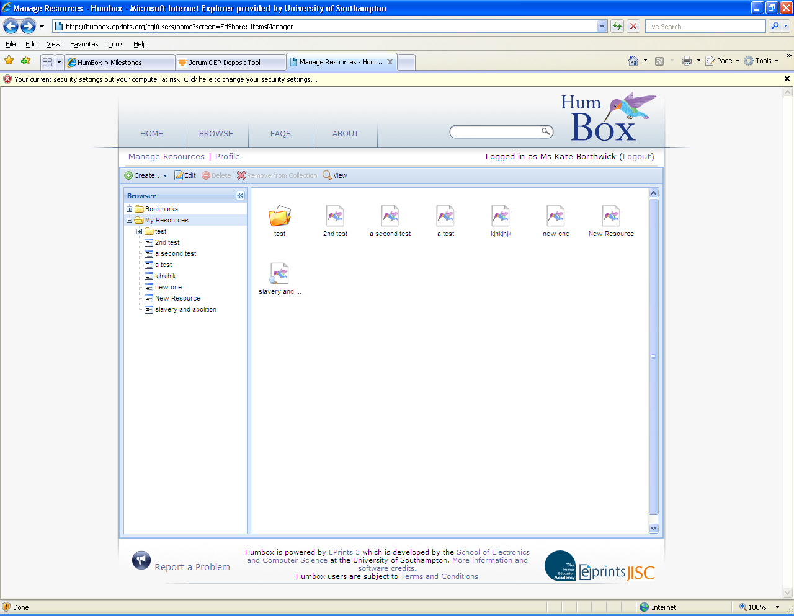

- Fill in details about the resource: title, creation date, visibility, attribution and copyright are mandatory.

Advice on titling:
Try to make your title concise, but also helpful and explanatory to other users. Avoid being too vague or too general.

Advice on tagging:
The project tag ‘ukoer’ has been automatically added to every resource and you will see this in the tag field.
Try to give useful tags (key words), as these will help users to find your material, for example, think about how you would use the resource, what its main themes are, what activities it might support and what kinds of students you might use it with. The project team has put together a brief list of suggested terms which you can use to describe your subject area:
history
classics
archaeology
languages
linguistics
area studies
philosophy
theology
religious studies
hps
English literature
English language
Creative writing

We have created this list in an attempt to avoid unhelpful variations of similar words – but you should add as many other tags to your resource as you can, so that users can find it easily when searching for resources.

You should separate your tags with commas. You may use phrases e.g. history, creative writing, English. HumBox will automatically capitalise all tags.

Description:
The description of your resource should be intensive yet concise. A good guide on what kind of information to include is to think about what information would be useful to users of HumBox to help them to search for, find your resource, and then use it in their own teaching.

Here are some suggestions for the kind of information you might include: what the resource is, e.g. ‘a video of a student seminar on XXX’; how you have used the resource in your teaching; an indication of the main themes or content.

Visibility:
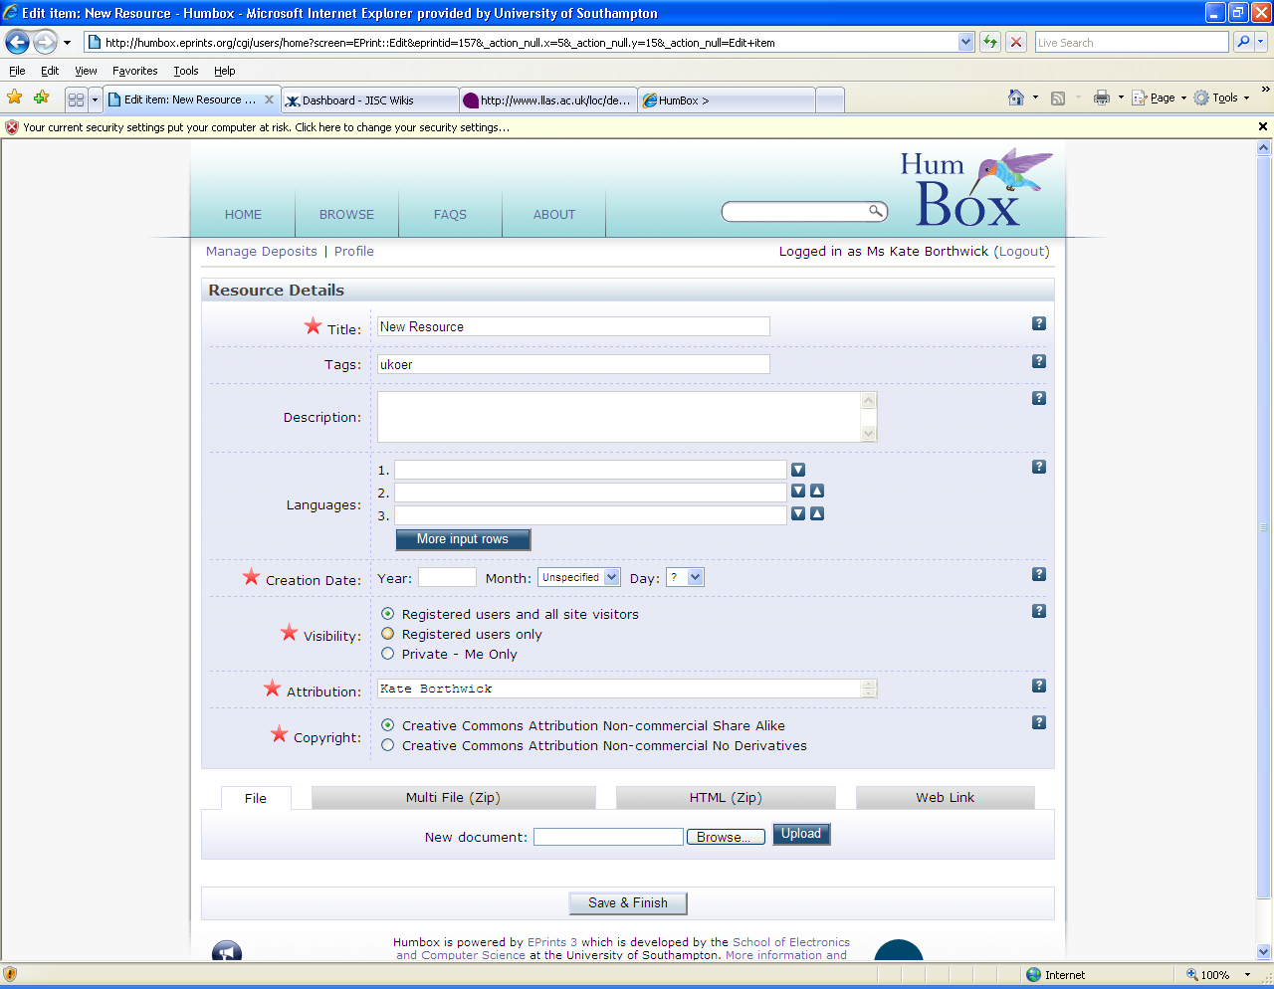

This section of HumBox gives you three options for making your resource visible to users: to all registered users and site visitors, to registered users only, or to keep it private.

You should choose the first option for this project, because all material in HumBox will be made as widely available as possible at the end of the project. If you choose the ‘private’ option, then only you will be able to see your resource – you might want to do this if you upload a resource that you wish to edit further before making it ‘live’.

Attribution:
This field will automatically be completed with the name of the person who is logged in to HumBox.

Note: If you are uploading a resource for someone else, simply delete your name and type in their name.

Copyright:
There are two options for copyright in HumBox, and ideally, we would like you to use the first, which allows users to make the best use of your shared resources:

- Creative Commons Attribution Non-commercial Share Alike, which:

"...lets others remix, tweak, and build upon your work non-commercially, as long as they credit you and license their new creations under the identical terms. Others can download and redistribute your work but they can also translate, make remixes, and produce new stories based on your work. All new work based on yours will carry the same license, so any derivatives will also be non-commercial in nature." See details at: http://creativecommons.org/licenses/by-nc-sa/3.0/

And
- Creative Commons Attribution Non-commercial No Derivatives, which:

"…allows others to download your works and share them with others as long as they mention you and link back to you, but they can't change them in any way or use them commercially." See details at: http://creativecommons.org/licenses/by-nc-nd/3.0/

Select the licence which you prefer to be attached to your resource. Your selection will be shown on the resource information page.

11. Once you have added information about the resource, you are ready to upload your files. To upload a file, browse for it, and select the ‘upload’ button, at the bottom of the screen. The file will appear under your resource information, to show that it has been added.

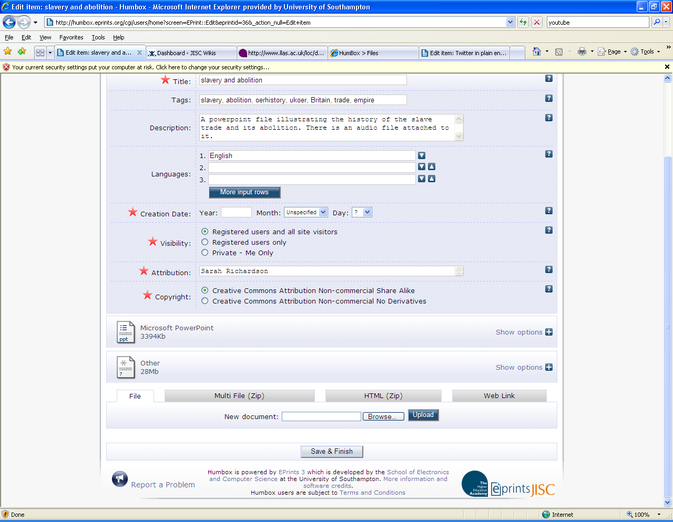

In this example, you can see that a powerpoint file and another kind of file have been added to this entry.

Choose ‘save and finish’ to save your uploaded file and its accompanying information, and to publish them both to the repository. When you click this button, you will be taken to the resource page where you can see the data and the file that you have just uploaded. Warning! It may take some time for your file to upload.

