

Learning Unit 4 – Web-based Research

Reading Material

Online databases are indispensable tools alongside the books and journals you may borrow from the library. They contain material ranging from bibliographical information to full-text articles. Databases containing e-journals will be particularly useful when it comes to using secondary material. The obvious advantage of this material is its electronic form. Whereas specific books in the library can become difficult to get hold of once an essay deadline looms, these online resources remain universally accessible.
Many important databases can be accessed from the Library website by following the ‘databases’ or, alternatively, the ‘e-journals’ link under ‘Resources’. From campus computers, you will be able to access most of these databases. You will also have to open an ATHENS account. ATHENS is a centralized system that allows access to web-based subscription services. This means that with an ATHENS account, you can also access the databases that the university is subscribed to off-campus. In order to find out how to open an account, please follow the link below:

Library Catalogue Tutorial: Opening an ATHENS Account
(hyperlink provided to relevant university library webpage)

Of course, you do not need to limit yourself to the Library website in your research. The most obvious place to start your web-based research is a search-engine like Google. However, because of the variable quality of the incredible mass of material that is on the web, you should keep the following guidelines in mind when doing your research online:
Authority
- Who created the website?
- Do they provide information on their background and credentials?
- Is the site maintained by a reputable source (e.g. a university)?
Reliability
- Are the facts that are known to you reliable?
- Is the coverage objective? If not, is the bias clearly stated?
- Is the site sponsored by a commercial organization? Is it trying to sell something?
- Who is the intended audience? Is this site for scholarly purposes?
- Is this the original document or has it been edited or abridged in some way?
Maintenance
- Does the web site give a date when it was last updated?
- If so, has it been updated recently?
- Is some of the information clearly out of date?
- Are any links broken? Broken links indicate that the site is not updated regularly.

A further useful rule of thumb when it comes to the quality control of internet sources is to look for sites containing ‘.ac.’ or ‘.edu’ in the URL. This means that the site is linked to an academic institution. Particularly when you use search engines, a lot of links will lead to commercial rather than scholarly sites (frequently ending in .com or .co.uk).
Generally, a good way to begin your research is by familiarizing yourself with the topic at hand. For this purpose, subject directories and gateways are highly recommended. A good subject directory allows you to explore numerous subjects, ranging from the general to the specific, by providing links to sites that have been reviewed by experts. Humbul and Bubl are two examples of subject gateways in the Arts and Humanities. You can access many useful gateways and databases through the ‘Web Resources’ tab of this Blackboard module, or in the Web Resources folder at the bottom of this page.
Finally, remember to keep track of the websites and online articles that you come across in your research and that you feel are useful in relation to the essay you are planning. Although we will come back to referencing and bibliographies in more detail in later weeks, you should keep in mind that websites, like any other material you use, need to be properly referenced. You will need to note down the following information for your webographic entries:
- Title
- Authors/Editors
- Date Published
- Location
- Date Accessed
- URL

Example of an Unreliable Website

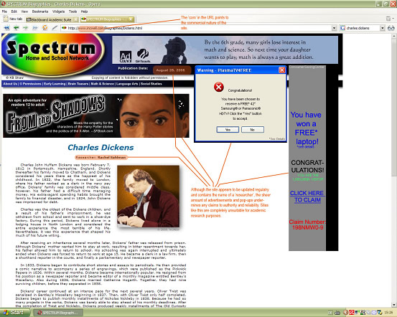
http://www.incwell.com/Biographies/Dickens.html
Example of a Reliable Website

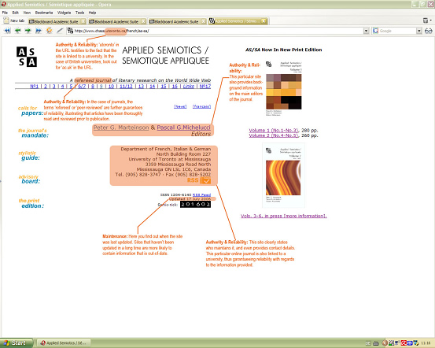
http://www.chass.utoronto.ca/french/as-sa/

Learning Outcomes
Having read the material and completed the assignments you should have:
- learned how to discern the quality of websites for research purposes
- understood the purpose and workings of online databases
- learned how to find relevant research material on the web
- learned to use the internet as a reference tool
- familiarized yourself with the search function of databases

Web-based Research - Assignment 5 (for both Literature AND Language and/or Linguistics Students)

Go to http://dictionary.oed.com/ - only available on University computers.
Click on ‘Enter OED Online’
Use ‘Find Word’ to investigate the following:
The word “curmudgeonly” occurs as an adjective and an adverb (abbreviated ‘a.’ and ‘adv.’). How old is the adverb, and what does it mean?

Web-based Research - Assignment 6 (for both Literature AND Language and/or Linguistics Students)

You will need to find three different articles on or by a writer, critic or linguist of your choice from one of the following websites (accessible under ‘full-text collections’ in the e-journals section of the Library webpage or, alternatively, in the ‘Web Resources’ section of this Blackboard module):
http://lion.chadwyck.co.uk/
http://muse.jhu.edu/search/search.pl
http://uk.jstor.org/
Use a different search method for each database (e.g. keyword, author, title). Provide the full bibliographical details for each article, the type of search used to find it, and a brief description of how the results changed relative to your search method. Please note that you do not need to provide a copy of the articles.

English Subject Centre Departmental Projects

This report and the work it presents were funded by the English Subject Centre under a scheme which funds projects run by departments in Higher Education institutions (HEIs) in the UK. Some projects are run in collaboration between departments in different HEIs. Projects run under the scheme are concerned with developments in the teaching and learning of English Language, Literature and Creative Writing. They may involve the production of teaching materials, the piloting and evaluation of new methods or materials or the production of research into teaching and learning. Project outcomes are expected to be of benefit to the subject community as well as having a positive influence on teaching and learning in the host department(s). For this reason, project results are disseminated widely in print, electronic form and via events, or a combination of these.
Details of ongoing projects can be found on the English Subject Centre website at www.english.heacademy.ac.uk/deptprojects/index.htm . If you would like to enquire about support for a project, please contact the English Subject Centre:
The English Subject Centre
Royal Holloway, University of London
Egham, Surrey TW20 OEX
T. 01784 443221
esc@rhul.ac.uk
www.english.heacademy.ac.uk

Copyright information for England & Wales / Scotland

England & Wales
This work is licensed under a Creative Commons License.
Creative Commons
Attribution-NonCommercial-ShareAlike
Attribution 2.0 UK: England & Wales
You are free:
- to copy, distribute, display, and perform the work
- to make derivative works
Under the following conditions:
- Attribution. You must give the original author credit.
- Non-Commercial. You may not use this work for commercial purposes.
- Share Alike. If you alter, transform, or build upon this work, you may distribute the resulting work only under a licence identical to this one.
- For any reuse or distribution, you must make clear to others the license terms of this work.
- Any of these conditions can be waived if you get permission from the copyright holder.
- Nothing in this license impairs or restricts the author's moral rights.
Your fair use and other rights are in no way affected by the above.
This is a human-readable summary of the Legal Code (the full license).
(http://creativecommons.org/licenses/by-nc-sa/2.0/uk/legalcode)

Scotland
This work is licensed under a Creative Commons License.
Creative Commons
Attribution-NonCommercial-ShareAlike
Attribution 2.5 UK: Scotland
You are free:
- to copy, distribute, display, and perform the work
- to make derivative works
Under the following conditions:
- Attribution. You must give the original author credit.
- Non-Commercial. You may not use this work for commercial purposes.
- Share Alike. If you alter, transform, or build upon this work, you may distribute the resulting work only under a licence identical to this one.
- For any reuse or distribution, you must make clear to others the license terms of this work.
- Any of these conditions can be waived if you get permission from the copyright holder.
- Nothing in this license impairs or restricts the author's moral rights.
Your fair use and other rights are in no way affected by the above.
This is a human-readable summary of the Legal Code (the full license).
(http://creativecommons.org/licenses/by-nc-sa/2.5/scotland/legalcode)

