- Rank the following images according to the ‘birdness’ of the depicted animal

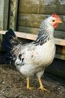
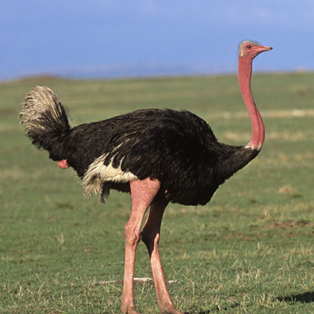
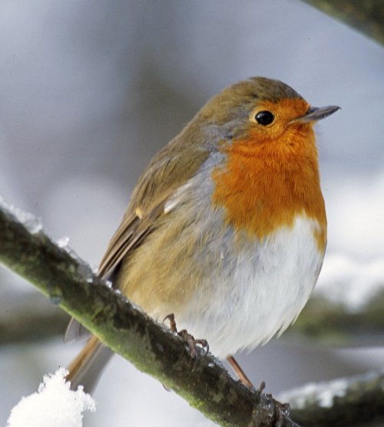
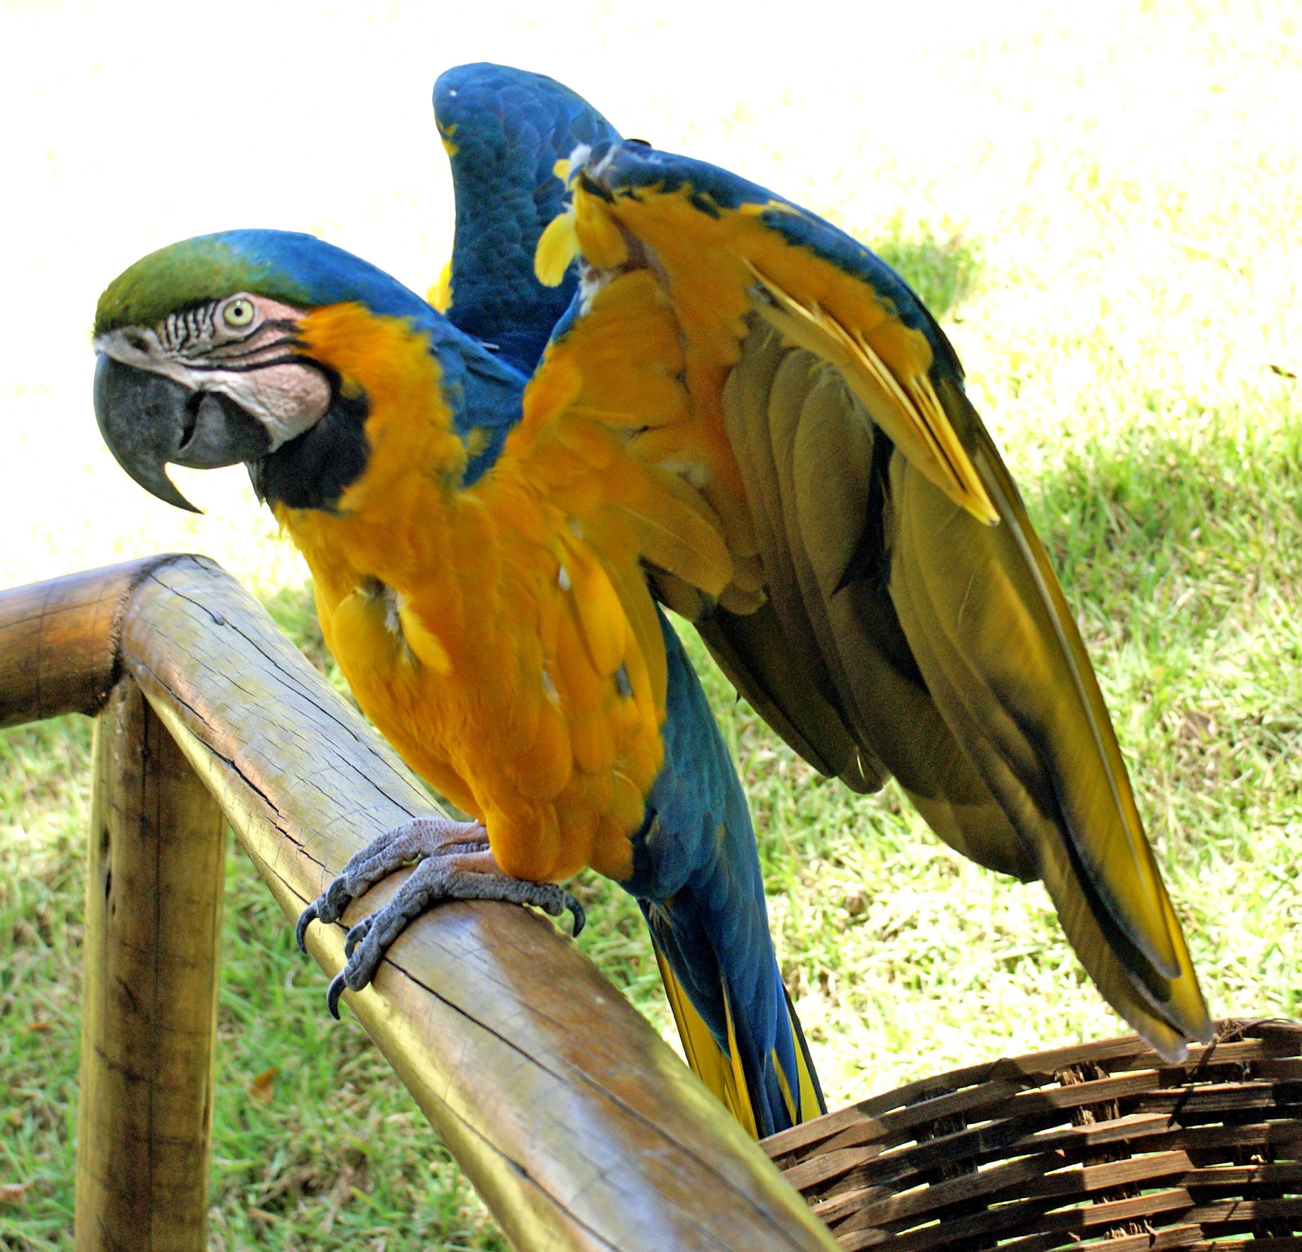
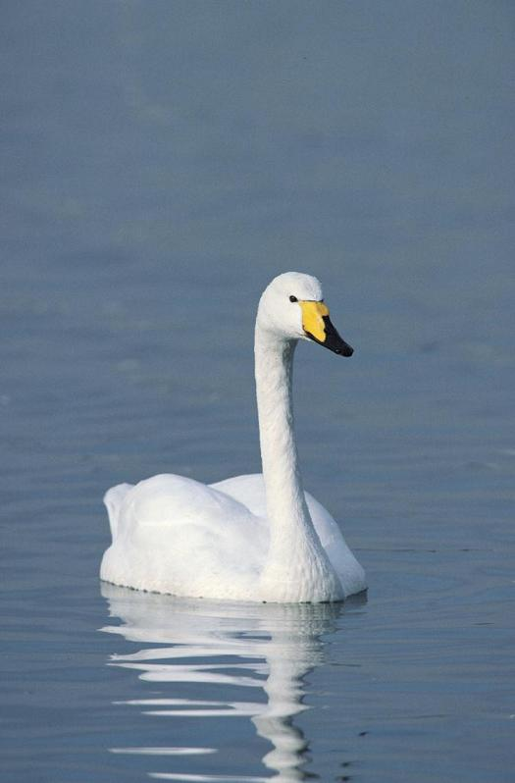
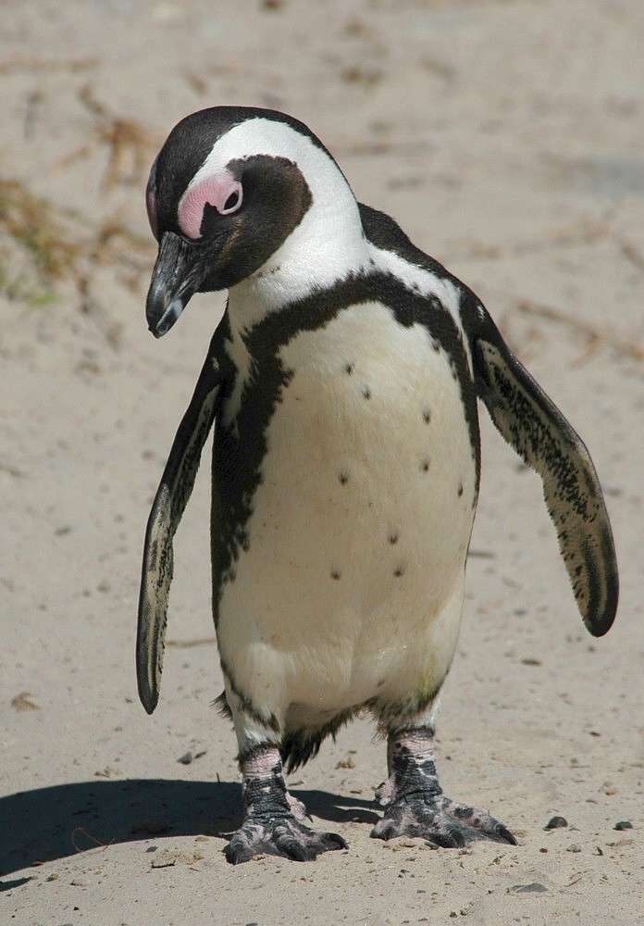
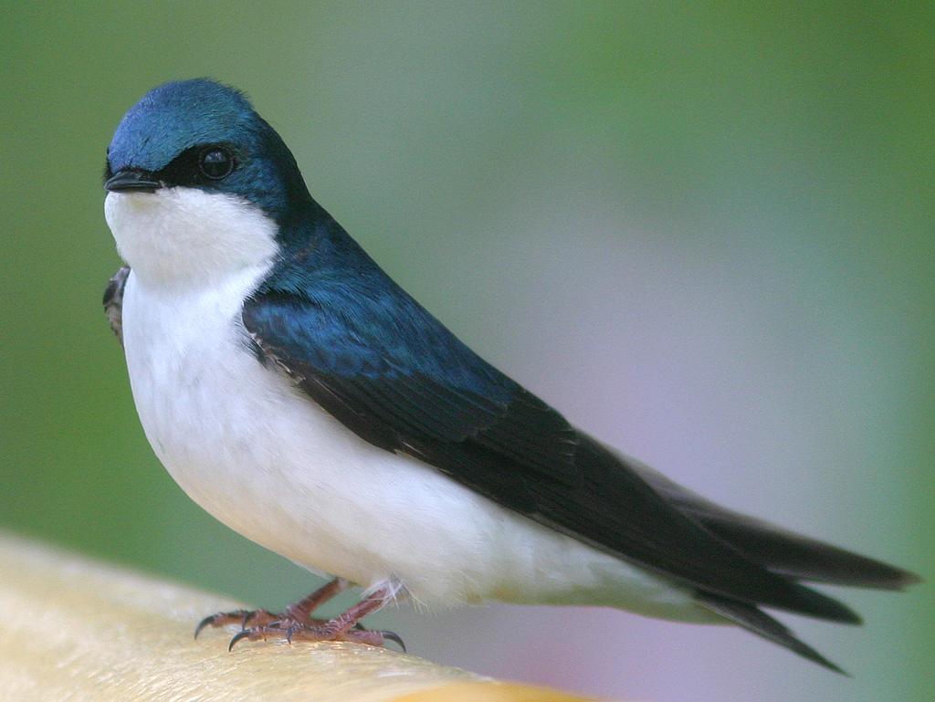

- Consider which semantic features belong to a prototypical bird. Separate them into those which are common to all birds and those features which make up family resemblances. There will be more family resemblances than category-wide features. (Continue on a separate piece of paper)

Category-wide Family resemblances

a) lays eggs________________________ e) can fly

b)

c)

d)

- Draw a family resemblance model: Write the bird names on the lines provided, with the prototypical bird in the centre. Then write the letters of relevant attributes next to each bird and link those which share family resemblances. NOTE: you only need to link the category-wide features to the prototype in the centre.

