SPPO 2650/ 2651: “The Spanish regional Melting Pot: the same old History?”
Discussion board 2

Deadline for contributions: 1/12/2014 by noon (12.00)
25% of the mark for the module for SPPO 2650 and 35% for SPPO 2651.
Interim feedback provided in class on 18/11/2014.
Final feedback and reflection plenary session in class: 10/12/2014

Aims and objectives of this Role Play - Online Seminar:
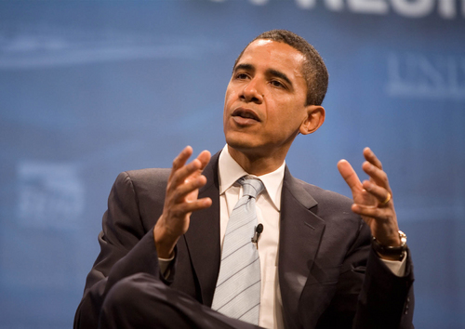
This online seminar is aimed at facilitating students’ interaction and co-operation in the process of understanding the history of the Spanish State, the history of the different nationalist movements in Spain and the relationship between national identity, political allegiances and the interpretation of these sometimes conflicting “histories”.

At the end of the seminar, students will be able to have a good idea of what each main political party in Spain, both national and regional, stands for in terms of the past and future of their nation or nations in a decentralised State.
Situation:

President Barack Obama is planning a 4-day visit to Spain in September 2015 and will be invited to a number of public events not only in Madrid but also in Catalonia, Valencia and the Basque Country.

In Barcelona, he will be attending the Ofrenda Floral a Rafael Casanova. In the Basque Country he will be visiting the Gernikako Arbola (El Árbol de Guernica) and in Valencia he will be visiting las Corts Valencianes.

In the three visits he will be accompanied by the regional authorities and representatives of the main political parties in each region, alongside the Spanish Prime Minister, Mariano Rajoy, and the leader of the main opposition party (PSOE), Pedro Sánchez. Obama’s public speeches in those visits will be televised live in Spanish National Television (TVE).

You are members of the International Politics Obama Team, a group of experts who plans carefully the President’s visits abroad. In this task you need to prepare, using the discussion room for your internal deliberations, a 300-word brief addressed to the President’s closest advisors, who will prepare the visits and the speeches.

As a former professor in Constitutional Law, President Obama has a decent grasp of the Spanish Constitution and the workings of el “Estado de las Autonomías”. However, he is not aware of the different interpretations given in Spain to historic events by followers of different political parties and their degree of acceptance of various national/regional symbols.

Therefore, Obama’s advisors need to tread their steps very carefully when writing his speeches. They will need to show a critical understanding of the history or “histories” of these regions, combined with a vision of the History of the Spanish State and the Spanish nation, trying to please as many people as possible with the speeches. They will have to pay special attention to the way Obama refers to anything that describes the relationship between the region and the Spanish state, the term used to designate the region (país, región, nacionalidad autonomía, pueblo…)

Students in Table 1 will prepare a brief for the visit to Barcelona.
Students in Table 2 will prepare a brief for the visit to the Basque Country.
Students in Table 3 will prepare a brief for the visit to Valencia.
Rules and responsibilities for participation in this online seminar:

- Contributions can be written in Spanish or English. It is your choice. If you write in Spanish, grammar or vocabulary mistakes will be taken into account only if they impede communication.
- Each message (thread) will have a maximum of 200 words. However, there is not a recommended amount of words for each message. All depends on what you want to say.
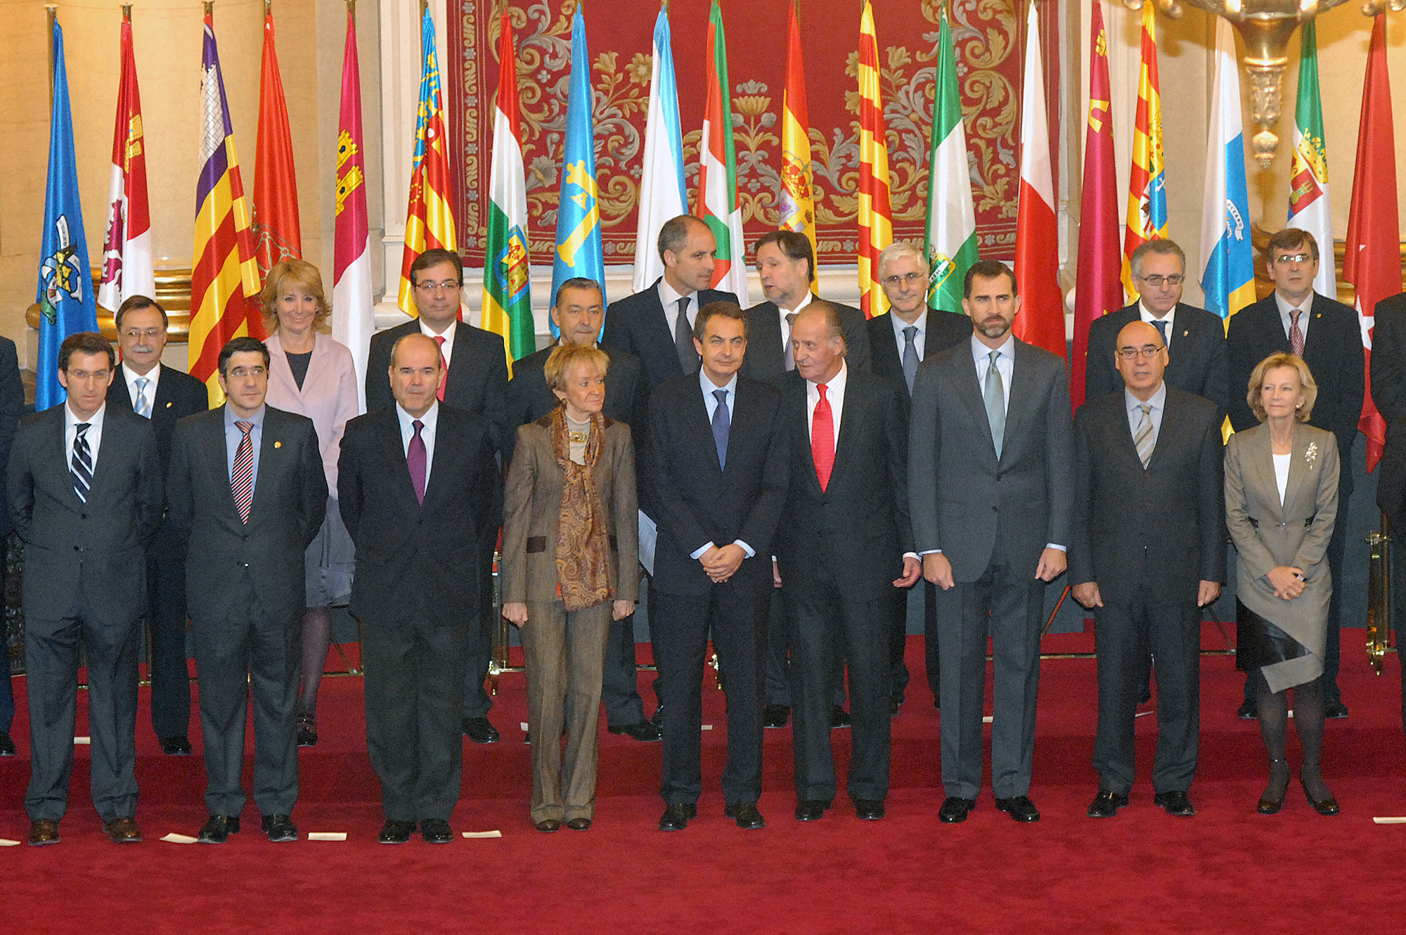
- You will receive a mark for the whole set of your contributions to each online seminar. (This role play counts as online seminar two of the course)
- You are allowed and encouraged to read other colleagues' contributions in other tables and learn from them.
- The process of discussion and the individual contributions are as important or more as the final outcome (the brief).
- Students will endeavour to be constructive, tactful and polite when dismissing other colleagues’ arguments or demands.
The former King of Spain, Juan carlos I, with the Príncipe de Asturias, now King Felipe VI, and members of the Spanish Government with the Presidents of all the Autonomous Communities.

The assessment criteria for this online seminar are the following:

- Focus: How well you concentrate on relevant issues and whether a final draft for the brief has been agreed or not.
- Content: critical understanding of the political history of Spain, its political parties and their political discourses on history and statehood.
- References: adequate references to any relevant sources such as academic articles, chapters in books, government or political online publications and articles in newspapers.
- Interaction: the extent to which you engage constructively with other colleagues’ comments in order to agree, disagree or qualify those comments.
- Form: concision and clarity of expression.

Photo Sources

Barack Obama Picture:
http://www.edupics.com/en-coloring-pictures-pages-photo-barack-obama-i12697.html under CC License.

Politicians’ pictures:
http://www.la-moncloa.es/Presidente/Fototeca/default.htm (Official Spanish Government website, free pictures)

Activity by Antonio Martínez-Arboleda. School of Modern Languages and Cultures. University of Leeds. 2009-2013

