Estonian History, Society and Culture
8.11.2006

Estonians in the 14th to 16th centuries.

Influence of the Livonian Order grows. The Danish king finally sold his part of Estonia for 19 000 silver marks in 1346.

The coat of arms of the Livonian Order (http://et.wikipedia.org/wiki/Liivi_ordu)

The peasant’s situation became worse (less human rights). The tithe raised, it often reached as high as one-fourth of the grain grop. By the beginning of the 16th century, many private manors had started to demand solely monetary rent.

In the 15th century the manufacturing industry began to develop in Western Europe, giving rise to cities and a need to import grain (especially rye). The wealth of the nobility grew, new manor estates were built and older estates were expanded (by the mid 16th century the number of manor estates had already grown to number over 500).

Intellectual life of the Estonians: the culture was under the strong German influence.
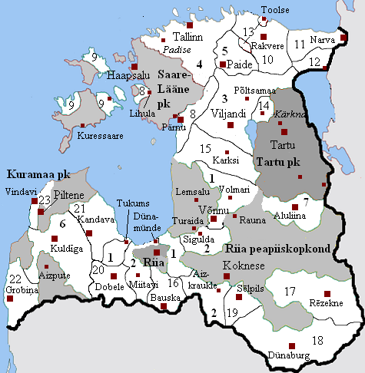
Lands of the Livonian Order in 1530-s (http://et.wikipedia.org/wiki/Pilt:Orduskeem.PNG)

Legal organisation of the cities:
Lübeck Law on Cities (a certain municipal form of government developed at Lübeck) According to this a city should be governed by council (raad) – this right was given to Tallinn (Reval, 1248), Narva (1345) and Rakvere (Wesenberg, 1302).
Law of Riga – was given to Tartu (1262), Viljandi (1283), Paide (1302) and New-Pärnu (1265).
The Bishop Law was valid in Old-Pärnu (1251) and Haapsalu (1278).

Coat of Arms of town Viljandi (http://et.wikipedia.org/wiki/Viljandi_vapp)

Words:
magistrate
bürgermeister
syndic
the town bailiff

References:
Laar, M. 2005. Birds-Eye View of Estonian History. Tallinn: Grenader Grupp
Laur, Lukas, Mäesalu, Pajur, Tannberg 2002. History of Estonia. Tallinn: Avita

More information about this historical period in Estonia:
http://www.estonica.org/eng/
http://www.einst.ee/publications/hip/
http://books.google.co.uk/books?id=YQ1NRJlUrwkC&dq=Estonian+History+Ancient&printsec=frontcover&source=in&hl=en&ei=Mh18S4ieMo_QjAfpg8HAAw&sa=X&oi=book_result&ct=result&resnum=11&ved=0CCgQ6AEwCg#v=onepage&q=Estonian%20History%20Ancient&f=false
http://wapedia.mobi/en/Livonian_Order
http://www.histrodamus.ee/

