Estonian history, culture and society. Eesti ajalugu, kultuur ja ühiskond.

The beginning of Estonian history – until the end of the Iron Age.

It is estimated, that humans have lived in Estonia for nine and a half thousand years. The first settlers arrived after the ice age, which was caused by global climate changes. The ice age shaped the Estonian landscape to a considerable extent. Glacier sheets one or two km thick carried masses of sand, gravel and clay on them, uncovered the limestone banks in northern and western Estonia, polished the rocks they had taken with them from the mountains and deposited them later as boulders. As the ice melted, lakes and deep river valleys, south-eastern Estonian hills and central Estonian drumlins developed.
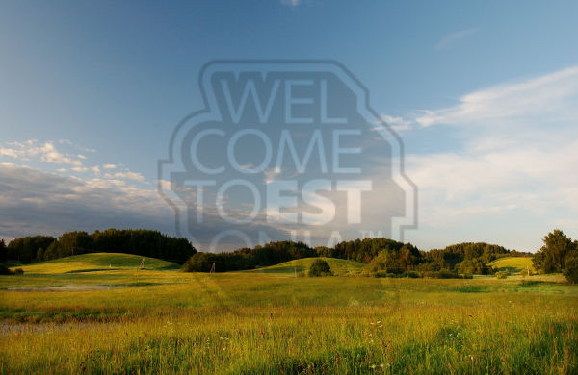
South-Estonia’s hilly landscape. Photo by Toomas Tuul (http://photos.visitestonia.com/)

After the ice receded, the surface began rising again. In north-west Estonia the ground has risen by already some ten meters and this process continues even today – by a few millimetres each year. As the ice retreated, Estonian mainland was considerably smaller than today. The climate was severe, too. Reindeer, arctic foxes and rabbits wandered around in the plain landscape where vegetation characteristic of the tundra started to go. Encounters with a mammoth or a woolly rhinoceros were also possible. From time to time groups of hunters could have come here by chance in pursuit of reindeer, but no firm traces of them have been found.
Before 8.000 BC the waters of the Baltic ice lake broke though to the ocean in central Sweden and Estonian territory increased by a remarkable extent. The climate of Estonia became considerably warmer. Birch and pine forests appeared. Elks, bears, beavers and other animals of the forest belt settled here. The first known human settlement in Estonia also dates from this period.

Ancient times. (Muinasaeg)

The period from the arrival of the first inhabitants to the loss of ancient freedom at the beginning of the 13th century AD is called the Ancient times. The majority of the period can be studied primarily due to the remains of human activities. Among them are former settlements, fortified settlements, burial mounds, sacrificial grounds, fields and places where metal was worked, as well as tools and utensils, arms and ornaments made in the ancient times.
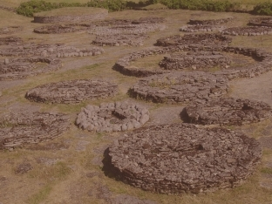
Stone graves in Rebala (from 8-7 centuries B.C.) http://www.rebala.ee/

During these centuries, significant changes took place in people’s ways of life:

Stone age:
The Palaeolithic era or Early Stone Age ended with the end of the Ice Age. During the Mesolithic Era or Middle Stone Age which lasted until the end of the sixth millennium BC in Estonia. Tools and artefacts were made of stone, horn and bone. (Pulli and Lammasmägi settlements)
These tools were still used in the Neolithic Era or Late Stone Age (until the middle of the second millennium BC). Pottery appeared as a necessary innovation at the beginning of the Neolithic Period. There may have been an extensive migration of Finno-Ugric tribes (fishermen and hunters) from the east in the middle of the 3rd millennium BC.
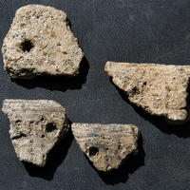
Stone age findings (around. 6000 years old), from Tallinn area
http://aerling.blogspot.com/2008/09/tallinn-kavatseb-kiviaegsed-leiud.html

Bronze age (pronksiaeg):
From the middle of the second millennium until the fifth century BC bronze objects spread to Estonia. The first metal tools arrived in Estonia three and a half thousand years ago. As copper and tin, components of bronze, are not found in Estonia, stone and bone objects remained dominant aside from individually imported bronze tools. Very strong influence of Scandinavian tribes. The Bronze Age was a period of significant changes.
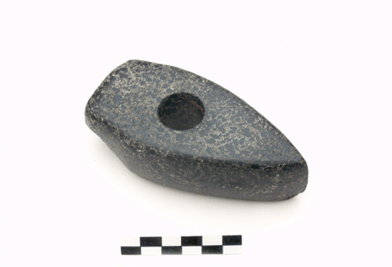
Bronze age stone axe from Estonia (http://ornament.dragon.ee/muinasesemed/pronksiaeg/032.html)

Iron age (rauaaeg):
The oldest iron tools arrived in Estonia in the fifth century BC. Compared to bronze, iron was an even better material, iron tools and weapons were stronger, sharper and more durable. During the Pre-Roman Iron Age (5th century BC until the middle of the 1th century AD), only occasional iron objects spread to Estonia from neighbouring areas. Rarely available and expensive, iron could not displace bronze and stone yet.
During the Roman Iron Age tillage and animal husbandry became the basic fields of subsistence for the local inhabitants. This resulted in an increase in wealth and population. Central Estonian lands, where the soil was less favourable for cultivation, were also taken into use. Crafts, especially metalwork, flourished alongside agriculture. Bronze was at this point imported to Estonia in huge quantities and several intricate types of brooches, pendants, bracelets, necklaces and rings were made. Merchants from the Roman Empire and its provinces arrived at the south-eastern coast of the Baltic Sea. They were primarily interested in amber and fur from forest creatures. Trade towards the south operated through the Baltic tribes. The fact that the Roman Iron Age was a peaceful period without wars probably favoured the remarkable economic progress. In fact, no fortified settlements are known and no weapons either individually or as burial offerings have been found.
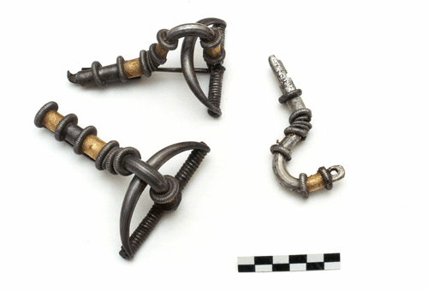
http://ornament.dragon.ee/muinasesemed/kraud/615.html
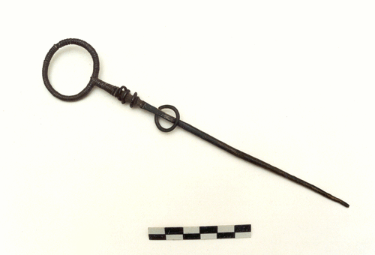
http://ornament.dragon.ee/muinasesemed/kraud/pildid/614a.html

Estonians first mentioned:
Roman geographers and historians also described the peoples living on the coast of the Baltic Sea. The “Aestii” people were first recorded by Tacitus in 98 AD. It is generally believed that “Aestii” refers to the Baltic tribes. However, it is also possible, that the ancestors of Estonia were among them as well.
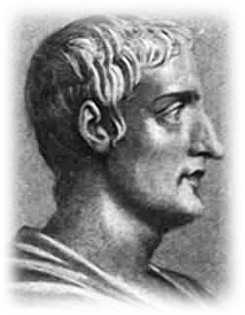
Gaius Cornelius Tacitus (http://en.wikipedia.org/wiki/File:Gaius_Cornelius_Tacitus.jpg )

According to the burial customs and the distribution of different ornament types, Estonia can be divided into three major cultural areas:
- West Estonia
- North and Central Estonia
- South Estonia

Some terms in Estonian:
tillage – põlluharimine
cattle-breeding – karjakasvatus
hunting – jaht
fishing - kalapüük
hoe – kõblas
slash-and-burn clearance – alepõllundus
rotating agriculture – mitmevälja-põllundus

References:
Laar, M. 2005. Birds-Eye View of Estonian History. Tallinn: Grenader Grupp
Laur, Lukas, Mäesalu, Pajur, Tannberg 2002. History of Estonia. Tallinn: Avita

More information about this historical period in Estonia:
http://www.estonica.org/eng/
http://www.einst.ee/publications/hip/
http://books.google.co.uk/books?id=YQ1NRJlUrwkC&dq=Estonian+History+Ancient&printsec=frontcover&source=in&hl=en&ei=Mh18S4ieMo_QjAfpg8HAAw&sa=X&oi=book_result&ct=result&resnum=11&ved=0CCgQ6AEwCg#v=onepage&q=Estonian%20History%20Ancient&f=false
http://wapedia.mobi/en/Ancient_Estonia

