Estonian History, Society and Culture
The Livonian War. Estonians Under the Swedish Rule. The Great Norhern War.

In 1558 the Russian tsar Ivan IV the Terrible attacked Estonia with numerous forces. This was the beginning of a longer period of wars known as the Livonian War. The country was devastated, and Narva and Tartu fell into the enemy`s hand without much resistance. Soon most of the territory was under their control.
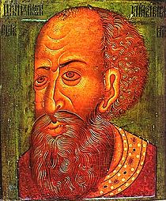
Ivan IV the Terrible (http://en.wikipedia.org/wiki/Ivan_IV_of_Russia)

In 1561 the Livonian Order surrendered to the Polish-Lithuanian
Union, Tallinn together with Northern Estonia asked for protection from Sweden, and the Estonian islands went under the rule of Denmark. By 1577 Russia had overrun the whole mainland Estonia except for Tallinn, which Russians, despite repeated sieges, were not able to conquer. Estonians didnt remain onlookers, either. In 1560 a peasant uprising took place, which covered mainly Läänemaa County. Manors were burnt down and German nobility was killed. Germans barely succeeded in defeating the rebels´ army at Koluvere. Yet, in 1558 the delegation of peasants had been to Prince Johann in Turku, making a promise to remise the land ”without a sweep of the sword”. It seemed to be the most useful for the peasants to get under the Swedish rule, as in Sweden personal freedom was guaranteed to peasants. Several Estonian peasants’ units also fought on the Swedish side, and among them the most famous ones were Hannibal’s People led by Ivo Schenkenberg and the unit led by Ohtra Jürgen.
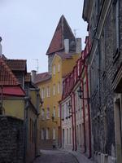
Medieval Tallinn (Photo: http://www.traveladventures.org/continents/europe/oldtallinn.shtml)

A turn in the military activities occurred in 1579. Stefan Batory, the Polish-Lithuanian king, transferred the action to the territory of Russia and made Ivan the Terrible relinguish to Poland its possessions in Estonia by the peace treaty of 1582. At the same time the Swedish troops under the leadership of Pontus De la Gardie ousted Russians from Northern Estonia, conquering Narva in 1581.
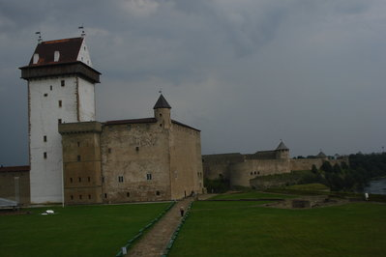
Narva, Hermann castle (Photo: Lea Kreinin)
A short period of peace began in Estonia, which was divided between Sweden, Denmark and Poland – a peace that the country needed so badly. The population had diminished disastrously, villages and towns were pillaged. In 1583 the Jesuits founded a college in Tartu and started a counter-reformation in Estonia. According to the Jesuits they received a very warm welcome from Estonian peasants. This also instigated the Swedish authorities to pay more attention to organizing church and education life.

In 1600 the contradictions between Poland and Sweden grew into a public conflict. The war that had progressed with changing success, ended with the Swedes` victory. By the Altmark Truce of 1629 nearly all the former Old Livonian territory went under the Swedish rule. As a result of decades of wars the country was severely devastated. The number of Estonians in their homeland had decreased so sharply that the existence of the nation was in the gravest danger ever.

The peasantry was disappointed by the first decades of the Swedish rule. The landlords extended their rights. The Swedes were not especially interested in their provinces on the coast of the Baltic Sea, and as a result, Estonia’s economic importance diminished. In spite of this, the national memory still recalls this period as the „good Swedish time”. Obviously, one of the reasons for the formation of such an understanding was the efficient activity of the Swedish authorities in the sphere of culture and education. Several gymnasiums and printing works were opened in Estonia. In 1632 the University of Tartu opened its doors. The studies of the Estonian language progressed, and the number of books published in Estonian grew constantly (see: First Estonian Books).

In 1684 B.G.Forselius founded a seminary at Piiskopimõisa, in the vicinity of Tartu to train teachers for peasant schools. As a result of his activities, numerous peasant schools with Estonians as the language of tuition were opened, which established the foundation to the tradition of national education.
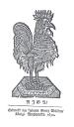
Image from the Estonian ABC-book (1694) http://www.ents.ee:81/PrintArticle.aspx?aid=10

Another reason, why the Swedish period deserved a positive response was the reforms carried out by the Swedish authorities at the end of the 17th century, which among other things were aimed at improving the situation of the peasantry. The rights of the landlords were restricted, peasants were conferred the right to defend themselves from injustice in court.

Unfortunately, the last years of the Swedish rule were beclouded by the great famine, which devastated the land in 1695-1697 and killed tens of thousands of people.

In 1700 the Northern War broke out, Russia (Peter I), Denmark (Frederik IV) and Poland (August II the Strong) joined their forces to overthrow the Swedish rule on the Baltic Sea. The Russian troops laid siege to Narva fortress, to which a Swedish unit – small but with much striking force – led by the young Swedish king Karl XII came to the rescue. In the battle that was waged on November 19-21, 1700, the Swedish army defeated the Russians. The Narva battle created a sensation all over Europe, and Karl XII as a romantic hero deserved much attention. After this battle Karl XII stayed for the winter at Laiuse, which for this period actually became the capital of the Swedish Empire. In 1701 Karl XII left Estonia and the initiative went over to the Russian army again – it was getting more and more powerful with each subsequent year. Estonia was ruthlessly devastated, tens of thousands of people were killed or taken to Russia into slavery.
In 1704 the Russian army led by Peter I conquered Narva and Tartu, which in 1708, for fear of the Swedes´ counterattack, were completely ruined and the inhabitants were deported to Russia. In the summer of the same year Tartu was blown up almost entirely. Käsu Hans, the pastor of Puhja who is considered to be the first poet of Estonian origin, has described this event in a „lamentation”.

Oh! ma waene Tardo Liin:
Mes sündi nüüd siin minnoga
Perratu ma olle siin:
Kes woib mo päle Kaeda?
Mo Pat mulle teggi sedda,
Et mul johtu ni suur Hedda,
Sedde pea nüüd tundma siin,
Oh! ma waene Tardo Liin…
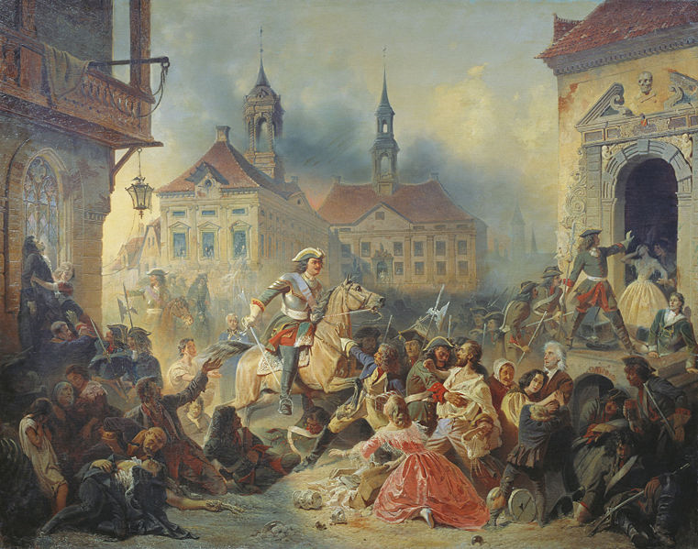
Peter I in a battle of Narva (http://en.wikipedia.org/wiki/File:ZauerveydNA_Petr1UsmirDA19.jpg)

For Estonian peasantry, the war brought about terrible suffering. In the areas living under a reign of terror, tillage did not occur. In the first years of the war, many families tried to resettle in the western part of Estonia or sought shelter in the woods and bog islands. The Swedish policy was based on the principle that the country in which the war is held covers the war expences. The peasants refused to fulfil their duties and sometimes plundered the manor.
In the battle of Poltava (late June 1709) Peter the Great completely smashed the Swedes´ main force. In early 1710 Riga surrended to prevailing Russian troops, followed by Kuressaare and Pärnu in August and Tallinn in September.
In 1710 the whole territory of Estonia was occupied by the Russian army; Tallinn, which suffered from plaque, surrended without any fight. In 1721 Estonia was officially incorporated into Russia by the Uusikaupunki Peace Treaty.

References:
Laar, M. 2005. Birds-Eye View of Estonian History. Tallinn: Grenader Grupp
Laur, Lukas, Mäesalu, Pajur, Tannberg 2002. History of Estonia. Tallinn: Avita

For more information:
http://www.estonica.org/eng/
http://www.einst.ee/publications/hip/
http://books.google.co.uk/books?id=YQ1NRJlUrwkC&dq=Estonian+History+Ancient&printsec=frontcover&source=in&hl=en&ei=Mh18S4ieMo_QjAfpg8HAAw&sa=X&oi=book_result&ct=result&resnum=11&ved=0CCgQ6AEwCg#v=onepage&q=Estonian%20History%20Ancient&f=false
http://wapedia.mobi/en/Livonian_Order
http://www.allempires.com/article/index.php?q=medieval_tallinn
http://www.histrodamus.ee/

