Estonian History, Culture and Society course
Estonia in the Middle Ages. The ancient Estonian religion

1. Estonia`s middle ages
The victors divide the land and their reign over the lands begin:
The Old Livonia (the territories in Estonia and Latvia under the rule of Germans) and Estonia (the territory of Northern Estonia under the rule of the Kingdom of Denmark).
Whenever possible, the Estonians put up resistance to the foreign rulers to protect their natural way of life, but the latter proved to be stronger.
Livonia never managed to become a united territory. The land was divided into individual regions headed by so-called reigning princes, their territories were similar to small feudal states. The king of Denmark also held the title Duke of Estonia. Other parts of Estonia were ruled by relatively independent reigning princes – the Bishop of Tartu, the Saaremaa-Läänemaa Bishop and the Livonian Order (the Livonian branch of the Teutonic Order). The greatest dependency was experienced by South Estonia (Sakala and Ugandi), Läänemaa and especially Saaremaa gave in to the conquerors under much more advantageous conditions. In essence, Saaremaa managed to maintain independence. The situation of the people of Harju and Viru region fell somewhere in the middle.

A political map of the medieval Livonia:
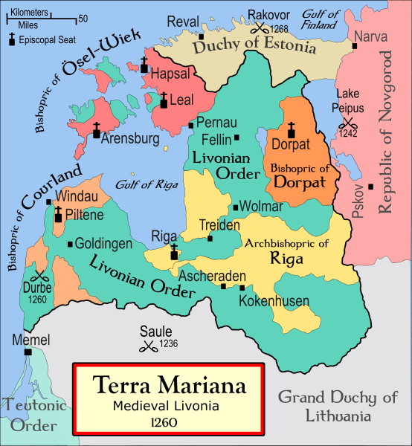
http://et.wikipedia.org/wiki/Pilt:Medieval_Livonia_1260.svg

1297 – the 1st civil war in Old Livonia (The Archbishop, the city of Riga and the bishops of Tartu and Läänemaa against the Order). The situation was unstable. The Pope sent his own special emissary, who composed a protocol. Virumaa, Järvamaa and Läänemaa were subordinated directly to the Roman Pope.
1227 – Tallinn was forced to surrender.
1233 – 100 opponents of the Order were killed
1238 – Stensby agreement
1241 – Liber Census Daniae (Danish audit book)
Building of manors.
1242 – Ice Battle (Alexander Nevski)
1260-70 – attacks of Lithuanian tribes.

Cities in Estonia:

1248 – Tallinn
1262 – Tartu
13th and 14 th centuries - Old and New Pärnu, Haapsalu, Paide, Viljandi, Narva, Rakvere.

Otepää – the first stone fortress in Estonia (started in 1224), also the oldest known brick construction.
Viljandi – the biggest convent fortress in Estonia.

1343 - The St George day uprising started (23 April) in Harju region.
The Paide negotiations 4 May 1343. The Estonian military leaders were killed.
24 July – revolt broke out on Saaremaa.
References:
Laar, M. 2005. Birds-Eye View of Estonian History. Tallinn: Grenader Grupp
Laur, Lukas, Mäesalu, Pajur, Tannberg . History of Estonia. Tallinn: Avita

More information:
http://www.histrodamus.ee
http://www.estonica.org/
http://www.einst.ee/publications/hip/

2. Ancient Estonian Religion

Compared to the other European countries, in Estonia Christianity became the main religion quite late. Before the Christianity there was no single religion with defined rules.
Force – people, like all other creatures, posses a special force of power besides their physical body. There was also force in certain objects, places and in the sky (thunderstorm). Words also could contain force (spells). Force was not distributed evenly: some trees, springs and stones were considered sacre. Animals and human beeings held most of their force in their heads, hearts, blood, nails, hair, fur and teeth.
Soul – very important of keeping the body alive. While sleeping, a person`s soul could escape the body temporarily, move around and sometimes even settling in another person`s body. After death the soul continued in a new „home”, such as sacred grove or cemetery. The souls of the dead continue to influence the lives and destinies of their families. In late autumn there was the time of souls – the souls of the dead roamed, visited their homes.
People lived very close to the nature – they were a part of it. People believed that animals, insects, plants, trees, bodies of water, the Sun and the Moon had souls (animism).
Spirits, fairies, gods – forest fathers and mothers, field and water spirits.
haldjas – fairy
Tõnn, Peko – home fairies
Estonians had few dominating so-called greater deities.
Tarapitha (from the chronicle of Henry of Livonia) Taara avita!
Places of sacrifice – sacred groves or a single tree (oaks and linden), springs (also healing springs), offering stones (dimples on the surface), rarery lakes, hills and rivers. Thursday was a sacred day. Milk, meat, blood, wool, grain, silver coins and, on important occasions, animals were the offerings.
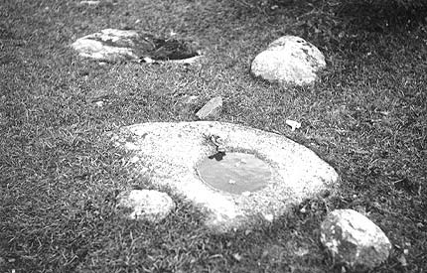
Offering stone http://www.estonica.org/eng/pilt_maastik_index.html?pilt_id=69&nimi=ohvrikivi&tekst=1312&peal=Offering%20stone&tekstid=1312)

More information:
http://www.estonica.org/eng/lugu.html?menyy_id=100&kateg=41&alam=55&leht=8
http://en.wikipedia.org/wiki/index.html?curid=1606162

