O’Casey Activity:

Juno and the Paycock and Irish History

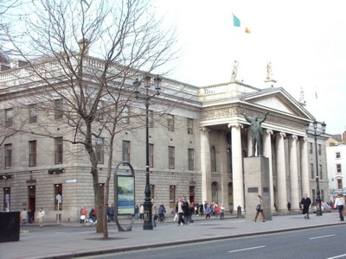
The General Post Office, O'Connell Street, Dublin:
an iconic place for modern Irish history.

O’Casey shares at least one characteristic with Synge: just as The Playboy of the Western World (1907) was disrupted by near riot amongst the audience at the Abbey, so too was O’Casey’s second play The Plough and the Stars (1926), which gave a controversial account of the Easter Rising of 1916. His first play, Juno and the Paycock (1925) did not provoke such a sharp reaction – but it too dealt with the recent history of the Ireland. If there are a whole range of contexts which we need to understand Playboy, this is equally true for Juno, and in fact these contexts may be more immediate. One could probably understand to a limited extent the plot of Playboy, if not its possible range of meanings, without studying its historical and theatrical contexts. But it is more literally difficult to understand the events of Juno without a sense of the recent historical events which preceded and followed Ireland's becoming an independent nation in 1922 and to which the play constantly refers.

Consider, for example, these three extracts focussing on Johnny, noting anything which seems to require knowledge outside of that directly provided by the play:
from Act I (p.27)
Mrs Boyle. Come on Johnny, till I introduce you to Mr Bentham. (to Bentham) My son, Mr Bentham; he's afther goin' through the mill. He was only a chiselur of a Boy Scout in Easter Week, when he got hit in the hip; and his arm was blew off in the fight in O'Connell Street. (Johnny comes in). Here he is Mr Bentham; Mr Bentham, Johnny. None can deny he done his bit for Irelan', if that's goin' to do him any good.
from Act II (p.50)
The Young Man. Quarther-Masther Boyle.
Johnny (with a start). The Mobilizer!
The Young Man. You're not at the funeral?
Johnny. I'm not well.
The Young Man. I'm glad I've found you; you were stoppin' at your aunts; I called there but you'd gone. I've to give you an ordher to attend a Battalion Staff meetin' the night after to-morrow.
from Act III (p.71)
Mrs Boyle. Maybe I didn't feel sorry enough for Mrs Tancred when her poor son was found as Johnny's been found now - because he was a Diehard! Ah, why didn't I remember that then he wasn't a Diehard or a Stater, but only a poor dead son!
I imagine that the kinds of things you have noted might include:
Easter Week
O'Connell Street
Quarther-Masther Boyle
The Mobilizer!
Diehard
a Stater
Different readers have, of course, different levels of knowledge of particular topics, so that for some people (with a knowledge of modern Irish history and politics) these references are reasonably clear, while for others, they may be very much obscure. To begin with, this activity will introduce the history of Ireland from the late 19th century until the 1920s so that everyone has a historical context and can pick up the sense of these kinds of reference. After this, the activity will move on to questions about what O'Casey's play does with these references to recent history.

The following websites pick up the specific references in these scenes as well as providing quite full background material:
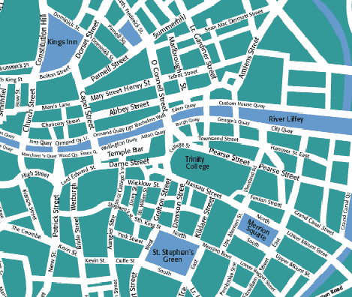
O’Connell Street:
http://www.12travel.co.uk/ie/Dublin/OConnellStreet.html
(brief history of the events of 1916 in O’Connell Street)

Even knowing the location of O’Connell Street may give the play’s references to it a further dimension: the Abbey Theatre is at the intersection between Abbey Street and O’Connell Street and close by is the General Post Office – the centre of the Easter Rising.

Easter Week:
Irish Independent article published to mark the 50th anniversary of Easter Week,1916-1966 (a modern Irish establishment account):
http://www.iol.ie/~dluby/1916.htm
Lily Stokes’ diary of Easter Week was a contemporary middle-class Irish woman’s account:
http://www.chaptersofdublin.com/books/1916/stokesdiary.htm
Contemporary postcards were printed showing the key sites of the 1916 rising and some of the key personalities:
http://islandireland.com/Pages/history/archives/easter.html

The Free State:
History of Ireland 1919-1921 (click on previous and next for preceding and subsequent years)
http://www.wesleyjohnston.com/users/ireland/past/history/19251932.html
and
http://news.bbc.co.uk/1/hi/events/northern_ireland/history/64206.stm
BBC news online: Ireland – the search for peace: see partition 1917-1920 and the Free State and the Civil War 1921-2.
See also a brief biography of Michael Collins, a Nationalist who became a leading figure in the Free State war against the ‘anti-treaty’ forces (the ‘diehards’) and was assassinated by his opponents in 1922 at the age of 32.
http://www.bbc.co.uk/history/british/easterrising/profiles/po03.shtml

Sean O’Casey was himself involved with the nationalist movement as the biographies below explain. According to these accounts, what were O'Casey's attitudes and experiences of nationalism and politics? And what kind of theatre did he favour?

http://lion.chadwyck.co.uk/searchFulltext.do?id=BIO002823&divLevel=0&trailId=1291B9C23BD&area=ref&forward=critref_ft
(biography of O'Casey on Literature Online; you will only be able to access this if you or your university have a subscription to the database. If not you can try the resources below)
Wikipedia entry - remember to tread with caution!: http://en.wikipedia.org/wiki/Sean_O%27Casey
Brief biography: http://www.irish-society.org/Hedgemaster%20Archives/sean_o'casey.htm

We need to be wary (of course) of simply transplanting biographical information into our interpretation of the play, but it may well be that the suggestions of conflict between the 'major currents of his day, the revival of Irish culture and the Irish freedom movement [and] the cause of labour' provides a way into interpretation of Juno. The Boyle family and their neighbours and acquaintances refer a great deal to the events of Easter 1916, and to the conflict between the Free State's pro-treaty forces and the anti-treaty Diehards of the IRA.

Read the following reviews of two different productions of Juno.
What strengths and weaknesses are noted in these particular realisations of the play?
How do these various reviewers see the relationship between the Boyle family and the wider world of Irish politics?
How do they think different generic forms (e.g. comic and tragic) should interact in the play? What do they say about gender roles in the play?

Brief Guardian review of 2001 production at Glasgow Citizen’s Theatre:
http://www.guardian.co.uk/reviews/story/0%2C3604%2C556069%2C00.html

Extracts from reviews in a variety of newspapers of 1999 Donmar Warehouse production:
http://www.albemarle-london.com/Archive/ArchiveShow.php?Show_Name=Juno%20and%20the%20Paycock

Finally:
a) What do you think the play achieves by its constant reference to recent political events?
b) How fair is it to say that men in the play are seen in a comic framework, but women in a tragic one? How does the play's handling of genre and gender relate to its representation of politics?

Follow-up Work
One (or both) of the following pieces of research should provide interesting ideas about O'Casey.
1) Both Synge and O'Casey upset nationalist sensitivities with some of their work. How similar is the depiction of Ireland in Juno and the Paycock and The Playboy of the Western World?
(you could, for example, start by comparing the pair Mahon / Christy to the pair Boyle / Joxer . . .)
2) Try exploring some uses of language and attitudes towards nationalism using the search facilities in the ISU concordance to Juno at:
http://www.public.iastate.edu/~spires/concord.html
Perhaps search terms for words associated with the following concepts might turn up interesting results? free? principles? Ireland? Place names? song? drinking (or dhrink)?

See 'Miller Activity: Key Words in Death of a Salesman', also on Humbox, for instructions on how to use the Iowa State University Concordances.

