Investment Vocabulary

Task One: Working with a partner, mark the stresses on the words below

Anonymous Trading Brokerage Firm Transactions

Commission Speculator Liquidity

Commodities
Revenue Kickback (inf) Dividend

Diversification Financial advisor Insider Trading

Task Two: Complete the table below using different forms of the given words

Verb | Adjective | Noun | Person
 |  |  | speculator
 |  | transaction
 | financial
to broker
 |  | commission
 |  | diversification

Inheritance Tax Transcription

Task One: In pairs, read through the text and identify any vocabulary that you are unsure of in terms of meaning or pronunciation. Discuss these with your partner.

Runaway house prices have dragged more and more families into the inheritance tax net. They’ll be liable to pay death duties on homes and other assets passed on by parents which are valued above the tax threshold. Right now, there’s a problem for families like the Aspirations. They don’t want to pay tax when they inherit assets from an older generation. Grandad’s died and Granny owns a house worth more than £300,000. Before today, when she passed away, the family would have to pay tax above that level. The threshold’s now been raised to £600,000. It’ll be £700,000 by 2010.

First interviewee: A lot of people are very concerned that IHT will be a big burden to their future generations and they want to see that they can restrict it, limit it…keep themselves out of that tax…and so, they’ll be looking at today’s proposals thinking, ‘That’s going to help me in the future… that’s going to help my family.’

But this measure is targeted at married couples and those in civil partnerships. It doesn’t apply to cohabiting couples, single or divorced people. The tax threshold on their estates, including their houses, will stay at £300,000. What’s more, there are some families who, through clever tax planning, already get the £600,000 exemption.

Second interviewee: In one sense, this idea on [sic] inheritance tax of giving a double allowance to a couple is nothing new. A couple can make use of this double allowance. Um…a husband can leave £300,000 to the children…wife can leave £300,000 to the children.

But there are many who don’t realise you can do that and who haven’t spotted that the value of their house could create a tax issue. They’ll gain from today’s announcement. What’s more, it’s retrospective, so widows and widowers will get the full exemption.
Hugh Pimm, BBC News.

Task Two: Look again at the first paragraph and mark where you think the tone units (chunks), the feet (stress timing) and the main stresses will be in the text. You will be able to check this when we listen to the audio file.

Task Three: Repeat Task 2 looking at the third paragraph.

Vowel Practice for /i:/ and /I/

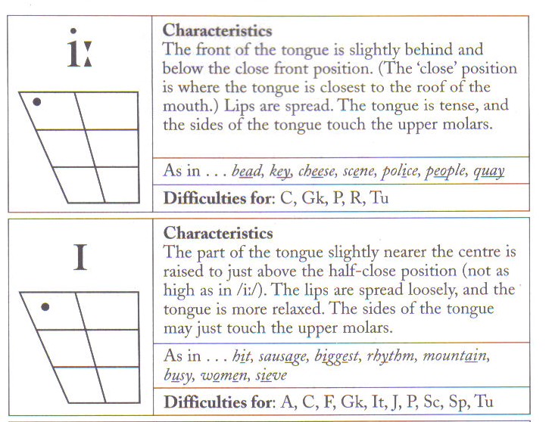
Task 1: Try to make the differences between /i:/ and /I/ clear in the following minimal pairs. Create more of your own examples with a partner and practise those as well.

- sit seat 9.
- bin bean 10.
- din dean 11.
- Tim team 12.
- gin Jean 13.
- brim bream 14.
- hip heap 15.
- slip sleep 16.

Task 2: Create a dialogue between two characters with a high frequency of words containing /I/ and /i:/. Another pair will practise your dialogue.

