Free Trade Protests in Colombia

Task One: In pairs, read through the text and identify any vocabulary that you are unsure of in terms of meaning or pronunciation. Practise reading for fluency and appropriate pronunciation. Mark the chunks.

As the talks continued, protestors made their feelings known. Demonstrations were held in the capital, Bogota, and Cartagena, although marchers were kept well away from the delegates. Trade unions believe any deal could result in the loss of a quarter of a million jobs in the poultry, sugar, cotton and rice industries. Farmers say they won’t be able to compete with heavily subsidised American goods if an agreement is signed. Negotiations between the United States, Colombia, Ecuador and Peru began last year, but differences over agricultural and intellectual property matters have stalled progress.

We are showing here that Ecuador is willing to head the fight against the free trade treaty because it threatens the lives of all the people of Latin America.

Talks are already nine months behind schedule and a deal by next month looks unlikely. The United States is also facing pressure from Brazil over subsidies to its cotton farmers. A ruling by the World Trade Organisation declared that America’s subsidy system was unfair and should be changed. The case was brought by Brazil earlier this year and the US had until Wednesday to comply. With that deadline gone, Brazil says it now wants to impose sanctions. Such delays and disagreements are likely to have an impact on a key global trade summit in Hong Kong in December. Delegates are likely to face tough negotiations if any deals are to be made.

Task Two:
Punctuation in writing and appropriate pronunciation can radically change the meaning of a text. Read the following two sentences as an example:
A woman, without her man, is nothing.
A woman: without her, man is nothing.

Task Three:
Now work with a partner. Each of you should choose either A or B and practise reading your text aloud before reading it to each other. Pay close attention to the punctuation.
Dear Jack,
I want a man who knows what love is all about. You are generous, kind, thoughtful. People who are not like you admit to being useless and inferior. You have ruined me for other men. I yearn for you. I have no feelings whatsoever when we’re apart. I can be forever happy – will you let me be yours?

Dear Jack,
I want a man who knows what love is. All about you are generous, kind, thoughtful people, who are not like you. Admit to being useless and inferior. You have ruined me. For other men I yearn! For you, I have no feelings whatsoever. When we’re apart. I can be forever happy. Will you let me be?

Yours,

Practice with /r/

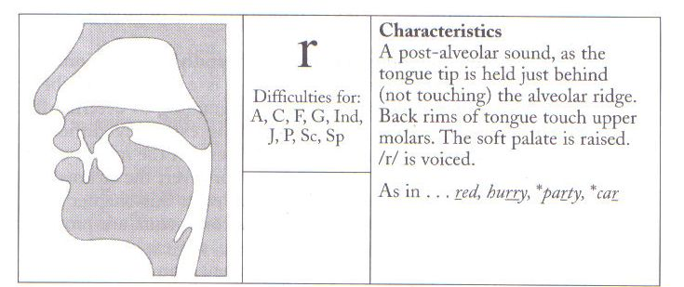

Word initial practice Word middle practice Word final
- revenue 9. Greece 17. Dear oh dear!
- release 10. country 18. There are four of us
- rise 11. children 19. Are you sure of that?
- raise 12. growing 20. sooner or later
- regulations 13. secretary 21. earlier, if possible
- recognise 14. extremely 22. a tour of the company
- rules 15. France 23. Can you hear it?
- retrospective 16. cleverer 24. I’m sore all over

