University of Leeds – School of Modern Languages and Cultures
SPPO3640 Discovering Spanish Voices Abroad in a Digital World (OpenLIVES)

Task for Seminar 1, which will take place in Week 3 (Seminar 1 of the programme)

Although Germinal Luis is not an economic migrant, his interview includes such a variety of life experiences that it is a great way for you to get started with Oral History and Migration.

- Please, read the whole interview of Germinal (Learning resources - entrevistas). Remember that it is a literal translation of oral conversational language. Do not be picky with grammar or sentence structure. Get to the gist.

- Select 3 extracts that you would like to talk about with the rest of the class.

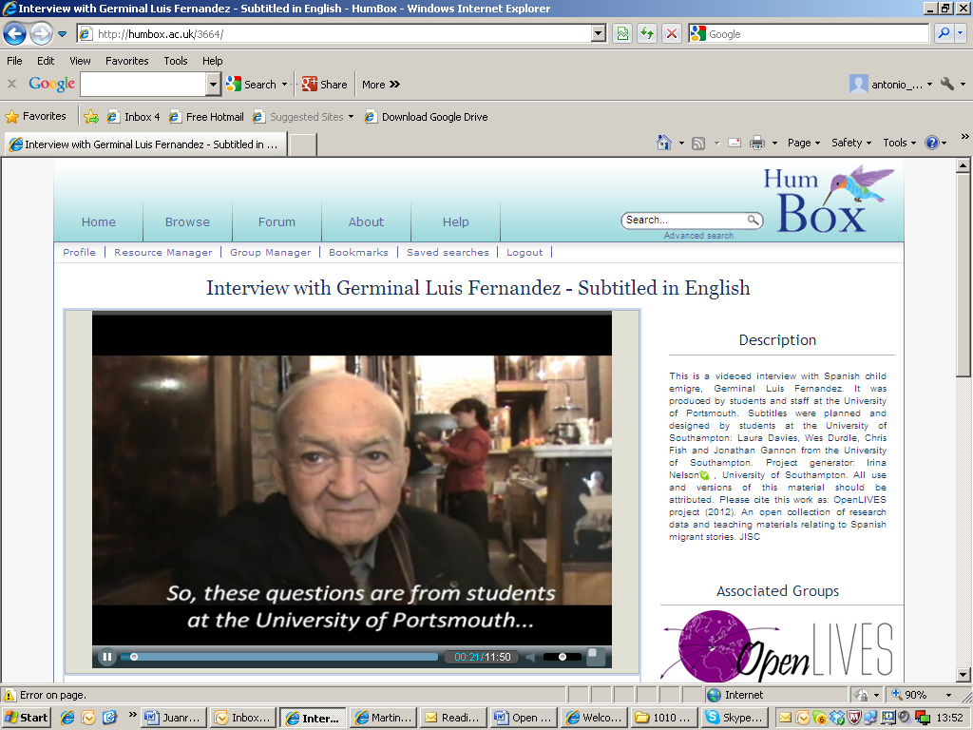
- During the course of the seminar session of Week 3 you will be able to share your impressions and reflections with the group about those extracts. Think about topics or themes associated to the extracts that you choose (for instance: conditions of living, education, war, hope, identity…). Please make up as many themes/topics as you wish.

Interview with Germinal Luis Fernández
HumBox - JISC OpenLIVES Project 2012
- Those of you who want to share their reflections with others beyond the module, can write a short piece, in Spanish or English, about one or more extracts.

- You can see a video of Germinal and some of his artwork in www.humbox.ac.uk
Antonio Martínez-Arboleda.
University of Leeds and JISC OpenLIVES Project. October 2012

