Spanish Language Autonomous Learning Activity
Writing an introduction for an OpenLIVES interview to a specific readership/audience
University of Leeds – School of Modern Languages and Cultures

Task Instructions and procedure
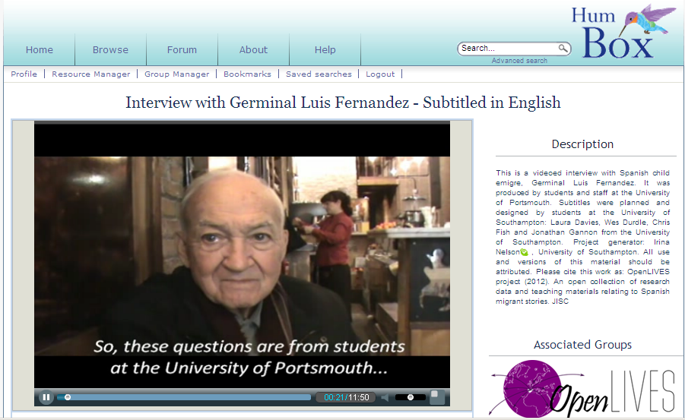
Imagine that you are members of a web editorial team. You have to prepare, as a team, a written presentation of an audio clip of an OpenLIVES interview in Spanish in the www.humbox.ac.uk repository.

Your presentation is meant to appear in a text box of a web page alongside the link to the audio clip. The maximum length of the text is 500 words. There is an additional 150 words for a learning reflection that must be completed.

The HumBox (2012). OpenLIVES. An open collection of research data and teaching materials relating to Spanish migrant stories. JISC

Phase 1 (Team work – preparation work not to be included in the worksheet):

Meet with 3 or 4 students in SPPO 1010 and choose 1 audio clip interview from the OpenLIVES collection that you would all like to work on. www.humbox.ac.uk/

Phase 2 (Individual work – preparation work not to be included in the worksheet):

- Listen to the audio clip (and read the script if necessary).

- Make a list of words or short ideas that appear literally in the interview that you think are essential to understand the gist of the interview.

- Find information about what was happening in Spain and the rest of the world at the time (s) referred in this person’s narration. You should endeavour to look at academic sources.

- Make a list of several words and short ideas that are not explicit in the conversation but can be easily inferred from it. The purpose of these words or ideas is the same as before: to help other people to understand better the gist of the facts of the interview. For instance, if the interviewee is explaining that him and other children used to steal food in Marseille because they were hungry, you could easily say “Escasez de alimentos en Europa durante la 2ª Guerra Mundial” or “Condiciones de vida duras en Europa durante la 2ª Guerra Mundial”.

- After reflecting critically on the content of the interview as a whole and after having read about the period of time referred in the interview, make a list of ideas and concepts that are part of the narration of the interviewee but do not appear in the interview at all. These words or ideas require of you a certain degree of research, personal interpretation and judgment and therefore there are no right and wrong answers. These words or ideas would help other people to understand the personal or social context of the events being narrated.

- Example 1: If you think that after the narration of the interviewee, she had very little options but to leave Spain, you can include in this list the following sentence: “Para María la emigración era casi inevitable”

- Example 2: If you think that the Dictatorship of Franco placed serious constrains on the personal and political freedom of the population you can say: “El caso de Pedro ejemplifica la diferencia entre las restricciones de la España de Franco en los años 60 y el ambiente de libertad de Francia en esa misma época”.

Phase 3 (team meeting)

- Meet up with the other team members and share and discuss your ideas in Phase 1

- Since each student will write their own introduction at the end, the team must choose one target audience for each student to work on from the lists bellow. The interview itself may be unsuitable or unattractive for some of these groups, so please choose carefully.

Educational audiences
- University Undergraduate Students of (subject/s) ……. based in (country/countries) ……..
Spanish Language/ Spanish Culture / European History and Politics / etc
- A-level students of Spanish in the UK
- Secondary School students in (country)……...
- FE in the UK students in the area of ………
- Informal learners
- Other………..

Academic audiences
- Postgraduate students and academics in the area (s) of…….

Media audiences (journalism)
- General audience based in (country/countries)…………..
- Specialised audience with an interest in the topic (s) of……and based in (country/countries)…….

The group can also discuss what points they would like to cover in the text of each student. This includes discussing and deciding how much information about the history of Spain, about the interviewee’s circumstances or about the topic of migration is needed. The discussion must be informed by the perceived needs and expectations of the targeted audiences. The group will also discuss the type of language used. For instance, if it is a general audience from the UK who has some knowledge of Spanish the style must be relatively concise and a lot of historic context should be given, as they may not be as familiar with the history or with that type of migration experiences as a Spanish audience.

The first two pages of this worksheets are not to be submitted as part of the portfolio

Spanish Language Autonomous Learning Activity
Writing an introduction for an OpenLIVES interview to a specific readership/audience
Worksheet for submission

Phase 4 (individual work – Introduction):

Complete your own work and submit it as part of the Portfolio of Autonomous Learning. Each student must write and submit their own introduction. This work must be done collaboratively only in Phase 2.

Your target audience:

The names of the other members,
the names of their language tutors
and their chosen target audiences:

Your introduction here (maximum 500 words):

Phase 5 (individual work - reflection)

Explain what you have learnt about yourself, about others and about the subject by working in this task (maximum 150 words):

Phase 6 (Optional activity)

With the advice and permission of your tutor, you may upload your work in the HumBox for it to be accessible to the Global Educational Community. Contact the module co-ordinator once this work has been given feedback and marked if you are interested in sharing it with the world.

