IEREST
Intercultural Education Resources for Erasmus Students and their Teachers

Module 2 - Activity 1
24h Erasmus life

- Introduction

This activity is designed to encourage students to reflect on their actual Erasmus experiences along four complementary themes: (1) the emotional dimension of living abroad; (2) their social contacts within the Erasmus community as well as with local students/people; (3) the academic life in the host institution; and (4) their language experiences. Students’ writing of and reflecting on personal journals constitutes the leitmotiv of the overall activity. Figure 1 shows how you can choose to focus on one, two, three or all four themes (in whatever order) after having identified the interests and needs of your specific group of students.

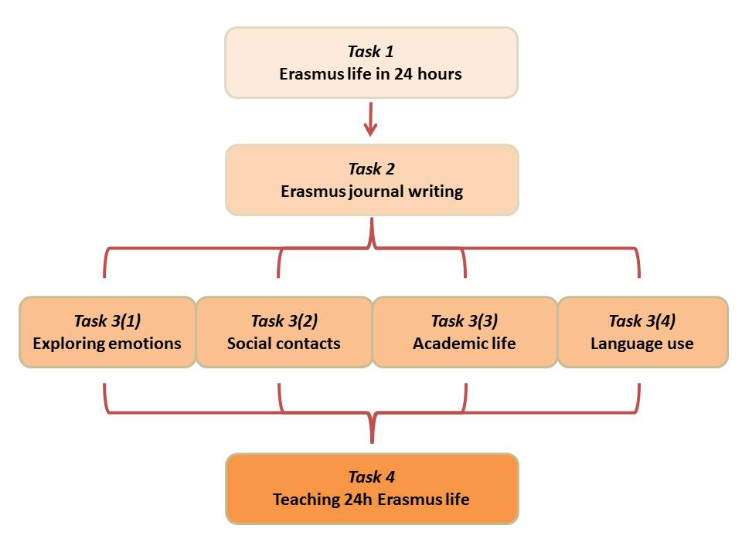
Figure 1 General structure of the activity

For example, you might want to encourage students’ reflection on language issues if their journals and/or their comments in the two preparatory tasks show willingness to share their language-related experiences or, on the contrary, reveal that students underestimate this aspect. Alternatively, if students bring up their academic experiences in the host institutions, it might be advisable to start with Task 3(3) focussing on the academy, in order to capture their attention and satisfy what they might perceive as an urgent need. Generally speaking, the overarching goal of this activity is to provide students with challenging and meaningful inputs for them. For this reason, the teaching materials and methods mostly represent chances to better stimulate students’ stories, interpretations, and reasoning.

Here is a short description of the alternative themes in Task 3:
- The emotional dimension of living abroad: Guiding students to explore the notions of ‘culture shock’ and to gain better awareness of the complexity of factors that can affect their feelings and perceptions while abroad (e.g., homesickness, number and quality of social contacts, appreciation of autonomy, and personal assumption of responsibility towards their own wellbeing).
- The social contacts within the Erasmus community as well as with local students/people: Encouraging students to benefit from the personal and intercultural potential of being part of a usually strongly-bonded international community of students and to enjoy diversities; guiding them to explore their relations with local students/people, and acknowledge the fact that, if a student finds it difficult to befriend locals, such difficulty can also depend on the student’s attitude, at least to the same extent that positive experiences can be credited to him/her.
- Academic life in the host institution: Having students compare their own opinions, attitudes, and feelings toward the host educational system and, while doing so, taking the opportunity to reflect on how their interpretations might be conditioned by their acquaintance with the home university’s educational system as well as by some stereotypical images of what universities are like in the host city/country.
- Language experiences: Providing opportunities for students to explore several issues linked to language learning and use, e.g. the identity-related aspects of language proficiency, personal multilingual repertoires, language learning beliefs, linguistic self-concept.

The estimated overall time for completing the activity is 14 hours.

- Learning objectives and outcomes

 | Learning objectives  This activity aims to enable students to: | Learning outcomes  Learners will be able to:
3 | Reflect on how communication in academic communities is shaped by differing histories, expectations and attitudes towards learning. | Interpret their opinions on the academic systems also in the light of their awareness of how communication in academic communities is shaped by differing histories, expectations and attitudes towards learning.
4 | Explore and reflect on their emotional reactions (positive or negative) towards living abroad, going beyond easy attributions of their emotional states to cultural differences. | Analyse and describe their own emotional states and reactions and assign reasons to them beyond easy attributions to cultural differences.
5 | Develop curiosity towards and further knowledge about the new environment and the people who inhabit it. | Demonstrate willingness to engage with the local environment and the people who inhabit it.
6 | Examine how using another language can affect one’s self-image (and capacity to project an image) and feeling of belonging. | Interpret how their capabilities in using another language affects their self-image (and their capacity to project it), as well as their feelings of belonging.

- Overview and description of tasks

Task 1.  Erasmus life in 24 hours | - Show the video Erasmus Life in 24h up to minute 6:58.  - Divide students in groups, and ask them to answer questions about the video and its relation to their own experiences.  - Have groups report on their discussion in plenary.  - Show and discuss the ending of the video.
Task 2.  Erasmus journal writing | - Provide general guidelines and specific instructions on journal writing (Attachment 1).  - Set the students to start their journal writing.
Task 3(1).  Exploring emotions | - Ask students to discuss journal excerpts that focus on the exploration of emotional reactions towards living abroad.  - Present three web documents on emotional reactions to studying abroad.  - Invite students to answer the questions about the documents and how they relate to their personal experiences.  - Provide explanation of the concepts of ‘culture shock’ and ‘Erasmus myth’, and ask the class to discuss how social pressure might influence their own accounts of the Erasmus experience.
Task 3(2).  Social contacts | - Divide students in groups, and ask them to discuss journal excerpts that focus on the social contacts they have had with different groups while living abroad.  - Present texts containing dos and don’ts for Erasmus students, and invite students to analyse in groups these texts with the help of Attachment 2.  - Discuss the texts and the students’ analyses in plenary.  - Introduce some theoretical concepts such as ‘imagined community’ and ‘English as a Lingua Franca’.
Task 3(3).  Academic life | - Divide students in groups; ask them to discuss journal excerpts that focus on aspects of academic life at the host institute.  - Instruct the students to design a survey on student attitudes towards aspects of academic life. See an example in Attachment 3.  - Optionally, ask the students to administer the survey, analyse the data, and present their findings.
Task 3(4).  Language use | - Select journal excerpts that focus on language-related issues (or have students select them themselves).  - Ask students to draw up a conceptual map on language use in student mobility. See an example in Attachment 4.  - Engage the class in a guided discussion about the conceptual maps, introducing some theoretical concepts such as ‘language repertoire’, ‘language appropriation’, etc.
Task 4.  Teaching 24h Erasmus life | - Divide the class in groups and have each group prepare a short lesson about one of the issues of Task 3.  - Invite Erasmus students who have not taken part in this activity and engage them as audience for the short lessons taught by your students.  - Invite students to assess other students’ lessons (Attachment 5).  - Ask students to self-assess their own learning (Attachment 6).

Task 1. Erasmus life in 24 hours
Time required: 1 hour

Task overview: In this task, the students share their personal Erasmus experiences by discussing a short film presenting Erasmus life through a range of typical situations (attending classes, meeting friends in the canteen, parties at night, etc.).

- Show the video Erasmus Life in 24h (https://www.youtube.com/watch?v=iRTtv60VTEE) up to minute 6:58, stopping the film ten seconds before its end.

- Divide the students in groups of 3 or 4. Ask them to share their personal Erasmus experiences with the others, taking the contents of the film as the starting point. Possible questions for students include: are there any typical contexts of the Erasmus life which have been left out (e.g. studying, sports, student associations and societies)? What features of the Erasmus life are emphasized? With respect to the film genre, what is the purpose of this film? What is the role of the music? How does the lack of dialogues affect the general meaning conveyed? And what could be the contents of the message written on the note?

- Ask the groups to report on their discussions in plenary. Then show the ending of the film, and ask students to compare the message written on the piece of paper (“Erasmus makes union”) with their earlier guesses. Ask about the language aspect of the message, which is not a standard English phrase but an example of English used as a lingua franca among students of various language backgrounds. Invite students to bring up examples of how they and the people around them have used English in internationally mixed groups. See also Slides 58-63.

Task 2. Erasmus journal writing
Time required: 1 hour

Task overview: In this task, students are asked to familiarise themselves with the personal journal as a text type and then to keep a journal about their Erasmus experience.

- Introduce students to personal journal writing and provide them with guidelines for keeping a journal of their experiences (see Attachment 1).

- Encourage students to choose as a starting point for their journal entries some personal experience that seems, for one reason or another, significant to them. (As an alternative to this open assignment, you might consider instructing students to focus, for each of their journal entries, on one of the four themes listed earlier, namely: the emotional dimension of living abroad; students’ social contacts within the Erasmus community as well as with local students/people; academic life in the host institution; and students’ language experiences). Explain to students that they are asked to share their journal entries with you only, but that extracts may be shared with the class in an anonymous form to support collective reflection. Of course, the length and timing of the assignments will depend on the general course organisation and timeline. For example, in case of one class per week, you could ask students to write one journal entry of 300-400 words per week and send it to you two days prior to each class.

- Individually, students start writing what will become their personal journal.

Task 3(1). Exploring emotions
Time required: 2 hours

Task overview: In this task, students are asked to discuss their own and their peers’ journal excerpts and other documents that focus on the exploration of emotional reactions towards living abroad. Encourage the students to re-consider their points of view reported in their journals, in the light of class discussions and in relation to theoretical insights about ‘culture shock’.

- Provide extracts from the students’ journals exemplifying emotional reactions to living abroad. While the students discuss these extracts, list emotional reactions and feelings as they are identified by the class in the journal extracts, and identify with the causes cited by the authors that led them to a particular emotional state.

- Present the following input to the students:
- A collective blog about Erasmus experiences which reports mostly enthusiastic comments about the Erasmus experience: http://erasmus-experiences.tumblr.com.
- A FAQ page about culture shock, taken from a web platform for Erasmus students: http://en.erasm.us/erasmus-faq/advice/102-Culture_Shock.
- A personal blog where a student tells of her homesickness while abroad: http://b-erasmus.blogspot.it/2009/07/homesickness-stress-abroad.html.

- Divide students into groups of 3 or 4. Ask them to consider the following questions while they are watching/reading the resources provided:
- Overall, what document better represents your feelings and attitudes towards the Erasmus experience, and why?
- Can you describe in greater detail what specific aspect mentioned in the documents you have experienced, and what is not in your past or present experience?
- Considering the words and visual cues that are used in the documents, what role do cultural differences have, if any? What role is attributed to the ‘Erasmus community’? Are contacts with local students/people mentioned, and if so, how? What do the documents tell us about a student’s responsibility for her/his wellbeing while abroad?

- Introduce the concept of ‘culture shock’ (see Slides 44-49) and explain how both negative (e.g. homesickness, language constraints, loneliness) and positive emotions (e.g. excitement, willingness to engage, curiosity, empathy) can be all too easily accounted for through reference to dominant narratives about culture shock or the ‘Erasmus experience’. Encourage students to analyse in some detail how social pressure (from friends at home, family, former Erasmus students, etc.) might influence their own accounts of their Erasmus experience and possibly contribute to the ‘Erasmus myth’.

Task 3(2). Social contacts
Time required: 2 hours

Task overview: In this task, students are invited to reflect on the social contacts they have had with other Erasmus or international students, with local students, and with the local population at large, as they discuss their journal entries and other documents. In the process they learn about some relevant theoretical concepts, such as ‘imagined communities’ and ‘lingua francas’.

- Select extracts from the students’ journals where students write about their social contacts while abroad: experiences with and feelings towards local students, other Erasmus or international students, the host society at large, and other ‘imagined communities’ (see Slides 50-57). While the class discuss the extracts, make use of the board to keep track of the discussion.

- After dividing the students in groups of 3 or 4, ask them to analyse lists of dos and don’ts for future Erasmus students with respect to contacts with the three ‘imagined communities’ of local students, Erasmus (or international) students, and the general local population. Supporting questions for text analysis are provided in Attachment 2. You could select one or more of the following websites or look for equivalent documents:
- http://stuarttaylorerasmus.blogspot.it/2012/07/dos-and-donts-for-erasmus-students-and.html.
- http://erasmuswelt.wordpress.com/tips/.
- http://www.stexx.eu/articles/517/5-tips-for-a-great-erasmus-experience.html.

- Discuss the websites and the students’ analyses in class, pointing out the ‘culturalist’ (i.e. rigidly stereotypical) assumptions in the texts (Slides 10-21), and any related pressures like the urge to be recognised as a proper member of the Erasmus community by exaggerating the ‘fun’ part of the experience.

- During the class discussion, introduce the following concepts and ideas:
- You can offer some background about the lack of contacts between mobile people and locals (see also Slides 50-57): most mobile students complain about a lack of contact with the locals, which may be due to their hope and expectation to learn ‘real’ language and culture from first-hand sources. Students should be guided to reflect on how the locals may perceive this unidirectional interest (e.g., you do not approach Mark because he is Mark and has valuable characteristics as a person but mainly for instrumental reasons, because you see him as a potential source of language practice, or because you assume you can learn the ‘true’ host national culture from him). Students should be guided to reflect that such an unfair attitude, which is often felt by locals themselves, may be one of the causes why Erasmus students’ attempts to have contacts with locals can fail.
- Building on the previous point, you can introduce the concepts of ‘imagined communities’. Communities (including national communities) are socially constructed by people who perceive themselves as part of that group (Anderson, 1991). In other words, communities are not something solid and objective, something ‘out there’. They are imagined to the extent that, with the exception of very small communities, you do not know every individual member personally (always refer to Slides 50-57). Ignoring the complexity of the concept of ‘imagined communities’ can lead to ascribing identities to people belonging to a specific group that those people may not (entirely) recognise for themselves (as in Mark’s case above).
- You may provide an overview of the opportunities offered by Erasmus communities as opportunities for intercultural and language learning. Thanks to the strong bonds it usually fosters, the so-called ‘Erasmus bubble’ allows students to have deep interpersonal exchanges, which open up great possibilities for intercultural learning. For what concerns language learning, students can be presented with the concept of ‘lingua francas’ and their potential for language acquisition: one can profitably learn a language using it with people who are not native speakers of that language (see Slides 58-63). Moreover, mobile students often have the possibility to use the different languages they already know within the Erasmus community, including but not limited to the language of the host country.

Task 3(3). Academic life
Time required: 2 hours

Task overview: In this task, students are made aware of how academic life in different places is shaped by differing expectations and attitudes towards learning through the design and, if time allows, also the administration of a survey for fellow Erasmus students.

- Provide extracts from the students’ journals where curiosity, excitement, surprise, discomfort, etc. are expressed with respect to academic life at the host university. Make use of the board to keep track of the discussion while the class share their experiences and the explanations they provide for such feelings.

- Ask students, in plenary or in groups, to design a short survey to be administered to other Erasmus students about how they see academic life in their host and home universities. The goal of this task is more in the design of the survey by the students rather than in their analysis of the collected answers. For ease of analysis, ask students to include only closed questions, preferably using Likert scales for each item. As they design the survey, lead the students to understand that much of what surprises, frustrates or annoys them in the new academic system is likely to be linked to their expectations about life at their host institution, and that such expectations may stem from their familiarity with their home university’s academic system as well as from stereotypical images of what universities are like in the host place (see Slides 64-66). Your notes taken during the discussion of the journal extracts in the previous step should constitute a good starting point for the students’ design of the survey. In addition, you can also find inspiration from the illustrative questionnaire in Attachment 3. (Please consider that the sample questionnaire should not be given to the students as this might thwart the learning purpose of the design process). These are some examples of issues which can influence ideas of what ‘good teaching’ or ‘effective learning strategies’ constitute: workload; balance between independent study and group work; assessment criteria and tasks; exam type and timing; student-teacher and student-student relationships; communication style; class behaviour; contacts with teachers outside the classroom; etc. To expand the scope of the survey, you could instruct students to direct it at teachers in the host institutions as well. In that case, additional matters can be touched upon, including what the institution and society at large expects of students, as well as ideas about what constitutes good academic performance and excellence, how equal opportunities should be addressed in education, how restrictions on enrolment are perceived, and what role issues like employability, personal development, building networks, and investing in the nation’s future are felt to play in education.

- Ask students to administer the questionnaire, using a free online service to create web browser based surveys, such as Google Forms or the free account of SurveyMonkey. Instructions for designing a survey can be found here:
- Google Forms: https://support.google.com/docs/answer/87809?hl=en.
- SurveyMonkey: http://www.wikihow.com/Create-an-Online-Survey-With-Surveymonkey.
Ask the students to submit the questionnaire to as many of their contacts as possible.

- Once the answers have been collected, you could ask the students to present and discuss their results in class, to deepen the exploration of this theme.

Task 3(4). Language use
Time required: 2 hours

Task overview: In this task, students examine their own and each other’s experiences with language use in their social and academic life abroad through drawing and discussing a conceptual map. In this process they address some key concepts including the ‘native speaker’ myth, multilingualism, and lingua francas.

- Select extracts from the students’ journals where students write about language-related issues, such as identity-related aspects of language proficiency, personal multilingual repertoire, code switching, communicative strategies employed to overcome language difficulties, language learning beliefs, interactions with native speakers versus non-native speakers, or linguistic self-concept (see Slides 58-63). As an alternative, you might consider dividing the students in small groups and asking them to identify relevant excerpts themselves in the (anonymised) journal entries.

- Divide students in small groups and ask them to create a conceptual map using the language-related issues identified in the journals during the previous exercise. If they are not familiar with conceptual maps, you could show the example provided in Attachment 4. If this step still proves too much of a challenge, you might consider conducting this exercise in plenary instead of small groups and/or providing a (partially or fully completed) map that you drew up yourself as input for the exercise.

- Ask each group to present their map to the class and discuss it with their classmates. Intervene where appropriate to prompt students to push their analysis further. If the previous step was conducted in plenary, continue the discussion while introducing some additional issues. The slides provide some useful indications of such issues, including the ‘native speaker’ concept and associated beliefs (e.g., learning works better when communicating with native speakers), language identities (multilingualism as personal repertoire, language appropriation), and lingua francas (including ‘English as a lingua franca’) (see Slides 58-63).

Task 4. Teaching 24h Erasmus life
Time required: 4 hours

Task overview: In this task, students teach what they have learned to fellow Erasmus students who did not participate in the activities.

- Divide the students in groups and ask them to plan a 30-minute lesson about the issues addressed in this activity. The audience will be Erasmus students who have not attended the module. Each group could focus on a different issue (emotions, social contacts, etc.) and use some materials from the tasks they conducted before (slides, commented journal extracts, results from the survey, etc.).

- Invite a group of Erasmus students who have not participated in the module to be the audience. Ask your student groups to teach their lessons in turn. You could ask the students to assess their peers’ lessons using Attachment 5 together with a copy of the expected outcomes of the activity.

- At the end of the activity, ask the students to self-assess their learning (Attachment 6).

- Assessment methods

- Peer assessment, asking groups to comment on each other’s lessons using Attachment 5 (Task 4).
- Teacher assessment of groups’ lessons, using the same form used for peer assessment (Attachment 5).
- Self-assessment of journal entries using the grid provided in Attachment 6 (Task 4).
- Teacher assessment of journal entries, using the same form used for self-assessment (Attachment 6).

- Suggested readings

- Bogain, A. (2012). Erasmus language students in a British university: A case study. The Language Learning Journal, 40(3), 359-374.
- Coleman, J. A. (2013). Researching whole people and whole lives. In C. Kinginger (Ed.), Social and cultural aspects of language learning in study abroad (pp. 17-44). Amsterdam/Philadelphia: John Benjamins.
- Krzaklewska, E. (2013). ERASMUS students between youth and adulthood: Analysis of the biographical experience. In B. Feyen & E. Krzaklewska (Eds.), The ERASMUS phenomenon: Symbol of a new European generation? (pp. 79-96). Frankfurt am Main: Peter Lang.

- Materials and resources

- A computer, access to the Internet, a projector.
- The IEREST slides.
- Six IEREST attachments:
  - Attachment 1: Guidelines for keeping the journal (Task 2 and throughout the activity).
  - Attachment 2: Grid for website analysis (Task 3(2)).
  - Attachment 3: Example questionnaire (Task 3(3)).
  - Attachment 4: Example of a conceptual map (Task 3(4)).
  - Attachment 5: Grid for peer- and teacher-assessment of group lessons (Task 4).
  - Attachment 6: Form for self- and teacher-assessment of journal entries (Task 4).

Attachment 1 (Task 2. Erasmus journal writing)

Read the following guidelines for keeping a reflective journal. Use them as a reference to write your own journal entries throughout this activity.

What is reflective writing?
Reflection is defined by the Oxford English Dictionary (2012) as “the action or process of thinking carefully or deeply about a particular subject, typically involving influence from one's past life and experiences”. Reflection is a way of enabling self-development and deeper learning by looking back at an experience so as to learn from it and then move forward. A person may discuss learning from an experience; reflective writing takes this a stage further by putting the reflection into the more permanent and structured format of a written account and linking it to academic theory.

Why write reflectively?
Reflecting on an experience (‘Reflection on action’) can help you to make links between theory and practice and between your past and present knowledge. Reflecting on, and learning from your experiences can help you to avoid repeating mistakes and move away from acting automatically without thought: it will help you to identify the successful aspects of an experience, and any useful principles which can be applied to other situations.

[…]

Features of reflective writing
Describing what happened and how you felt is only a small part of reflective writing. The emphasis as you write should be on your analysis and exploration of the experience. Reflective writing differs from most academic writing in that you will use the first person (‘I’) to describe the experience and your feelings. […]. Reflective writing looks to the future. You need to show how your reflection on what happened in the past will inform your future practice.

Getting started with reflective writing
Reflective writing can be more challenging than other forms of writing as it involves writing about feelings (anxieties and mistakes, as well as successes). Describing an event can help you to start writing. The next step is to then ask yourself questions about this event:
- Description. What happened? Who was there?
- Interpretation/analysis. What did I feel? Why did I respond in the way I did? What are the most important/relevant aspects? How does it link to theory? What went well/what didn’t?
- Outcome/evaluation. What have I learned? What would I change?
- […]

Tips
- Try to stand back from the event and be as objective as possible. You should be as careful in your reflective writing as you would be when writing any other assignment.
- Be aware that your reflection on an event can change with the passage of time. As you reflect more and acquire more knowledge then your views may change. Your writing may also be affected by your emotional state at the time of your writing.
- Start to write as soon after the event as you can. Delaying your writing may make it difficult for you to recall exactly what happened and how you felt, so your account will not be entirely accurate.
- Be honest and admit to any anxieties and mistakes.
- Select and use only key events and moments.
- Use reflection as a positive that will help you to develop yourself and your skills.

Adapted from:
Learning and Information Services, University of Wolverhampton (2012). Guide to reflective writing. Retrieved July 2, 2015, from http://www.wlv.ac.uk/lib/skills-for-learning/study-guides/.

Attachment 2 (Task 3(2). Social contacts)

With your group, analyse the list(s) of dos and don’ts for future Erasmus students presented in the website(s) provided. Carry out your analysis by answering the following questions.

Website: _____________________________________

- Identify the prevalent communicative intentions of the writer in the first column. Then, in the second column, take note of the extracts from the text that in your opinion best support your interpretation.

Intention | Example extracts
To inform, to describe, to tell

To advise, to teach

To persuade

To entertain

To evaluate, to comment on

To express him/herself

Other

- In the table below, report instances of the listed themes in the website you are analysing. If needed, make use of an additional sheet.

Themes | Instances
Friendship

Language learning

Home

Love and sex

Identity

University and study

Other

- When applicable, indicate to which of the following group(s) the instances identified above are related (e.g., using different colours): Erasmus students, local students, locals in general, people at home, etc. Try to explain why some themes occur in conjunction with more than one group and others do not, including references to your personal experience where possible.

- Look back to your past journal entries and indicate which of the listed themes you have addressed so far. How is the Erasmus community represented in your journal? How about the local students? What other patterns emerge? What has remained unmentioned so far?

Attachment 3 (Task 3(3). Academic life)

This attachment reports a sample questionnaire (Borghetti, 2008). It is meant for teachers and should not be distributed to the students.

How much do you agree or disagree with the following statements? On a scale of 1 to 5:
- 1 means you strongly disagree
- 5 means you strongly agree

It is acceptable to drink or to eat during the class.
1 2 3 4 5

It is fair to complain to the teacher about too much homework.
1 2 3 4 5

Interrupting teachers during the class to ask questions is not acceptable.
1 2 3 4 5

Learning is about discussing one’s own ideas with the teachers and the others students.
1 2 3 4 5

Independent study is a good way for universities to save money on teaching.
1 2 3 4 5

Being a good teacher has nothing to do with meeting students’ needs.
1 2 3 4 5

Attachment 4 (Task 3(4). Language use)

Look at the following conceptual map (Beaven, 2012). This map presents the theme in the middle, in yellow, which is related to some different topics in orange. These topics are detailed further through the blue items.

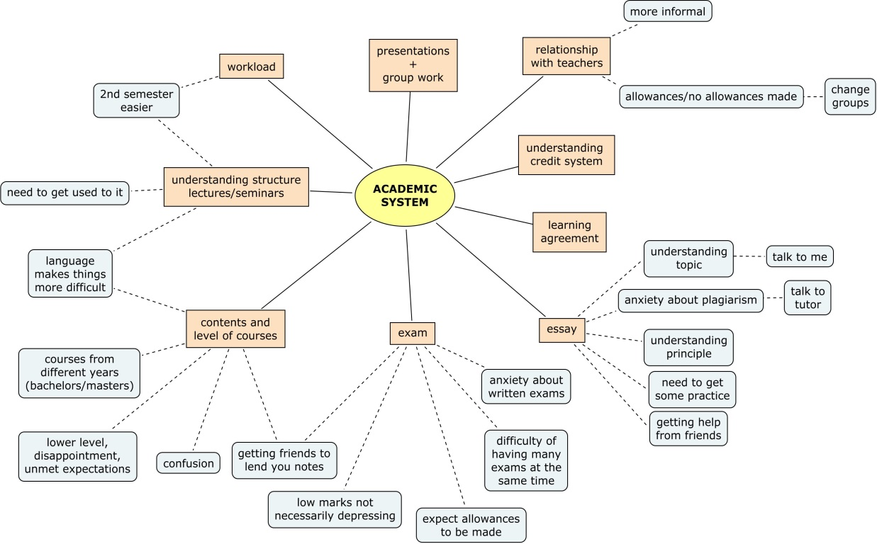

Attachment 5 (Task 4. Teaching 24h Erasmus life)

Using the following grid, provide peer feedback and assessment to each group on their lesson. The grid is inspired by the “plus/delta method” (Helminski & Koberna, 1995). It invites you to identify three positive points in the group lesson, and three areas that could be changed/improved according to how well the learning outcomes were met. Use a scale from 1 to 10, where 1 is ‘weak’ and 10 is ‘strong’.

Title of lesson:

Names of group/participants:

Three things that were good about the lesson: | Three things that could be improved:

Attachment 6 (Task 4. Teaching 24h Erasmus life)

This is a self-assessment grid to evaluate your learning throughout the activity. Look back to your journal entries and reflect on what you have learnt along the way. Tick a box, and provide examples of some reflections contained in your journals. Don’t forget to report the dates of the journal entries: they might help you to focus on your learning process.

Outcomes | I can do it without efforts | I can do it sometimes | I can do it sometimes but with lots of efforts | This is an objective I would like to reach
- Interpret their opinions on the academic systems also in the light of their awareness of how communication in academic communities is shaped by differing histories, expectations and attitudes towards learning.

- Analyse and describe their own emotional states and reactions and assign reasons to them beyond easy attributions to cultural differences.

- Demonstrate willingness to engage with the local environment and the people who inhabit it.

- Interpret how their capabilities in using another language affects their self-image (and their capacity to project it), as well as their feelings of belonging.

