 | Do not manually edit this table.
Title | Dance and the Hollywood Musical
Keywords | Dance, Hollywood, Musical, Feuer, Film, Art
Description | Activities involve some reading, listening, watching and reflecting on the concepts of mass art and folk art in Hollywood musicals. Year 3 undergraduates, Higher Education Level 6.
Version | 04/12/2012
Status | final
Restrictions | yes
Description | Creative Commons Attribution-NonCommercial-ShareAlike 3.0 Licence.
Objectives | No Objectives metadata
Author | Inma Álvarez, adapted from Sherril Dodds’ materials (2011).
Organisation | University of Surrey
Date | 2012

Introduction to this learning package

In this learning package, we are going to explore the Hollywood musical through the work of film and television scholar Jane Feuer.

These materials are presented in seven sections which are divided in several activities. They provide a total of three and a half hours of independent work. You will need around 30 minutes to complete each section.



The activities involve some reading, listening, watching and reflecting on how the concepts of mass art and folk art may apply to the Hollywood musical and the forms of dance included in them.

You will be able to download the transcriptions of the podcasts (Word documents) and all the audio files (mp3) onto your computer or mobile device.

Saving your answers

If you wish to save your answers to the e-learning tasks and keep this information for further use, we suggest that once you have completed your answers on a page and seen the feedback, before you continue, save them in your computer (or in a pen drive) as a pdf by using the "Print to File" option.

To do this, right click on the page you would like to save and choose “Print”.
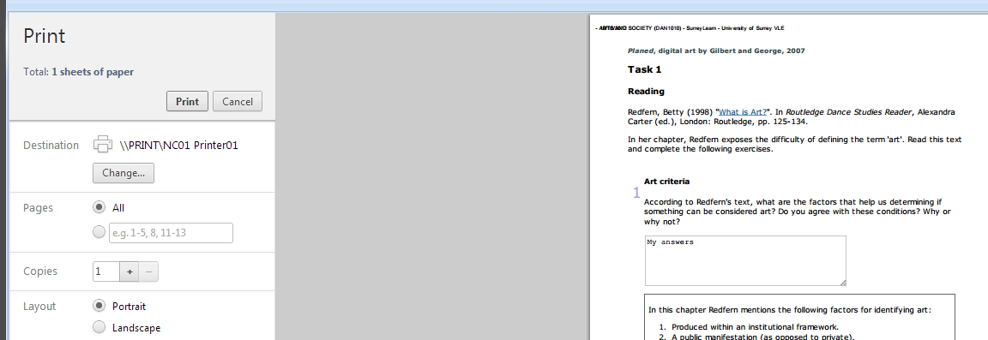

A new window will appear. From the options on the left, make sure your “Destination” is “Save as PDF”.
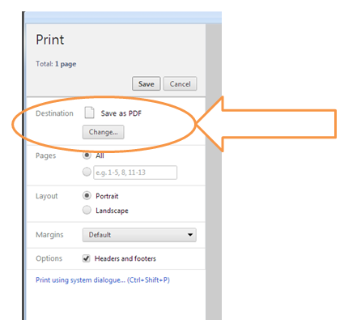

Famous performers

In this section you are going to learn about famous performers in Hollywood musicals. This is the longest section of the package; it will take you approximately 45 minutes to complete.

<boxtext>
Activity 1.1
First of all, read Jane Feuer’s chapter and then complete the tasks below.

Feuer, J. (1985) “Mass Art as Folk Art,” The Hollywood Musical. London: BFI, pp. 1-22.

Note that a previous version of this chapter is available online.

Feuer, Jane. “Mass art as folk art” (opens in a new window), Jump Cut. A Review of Contemporary Media, n. 23, oct 1980, pp.23-25.

 | Textentry1
Title | Identify famous performers in Hollywood musicals
Text | Make a note in the box below of the names of all the performers who featured in Hollywood musicals mentioned in this chapter.
Feedback | These are the names of the musical artists mentioned in the chapter:  - Al Jolson  - Maurice Chevalier  - Fred Astaire  - Judy Garland  - Gene Kelly  - Donald O'Connor  - Ginger Rogers  - Eleanor Powell  - Agnes de Mille (mainly a choreographer but also appeared in musicals)  - Bobby Van  - Jules Munshin  - (Frank) Sinatra  - Kay Kendall  - Michael Kidd  - Dan Dailey  - Cyd Charisse  - Leslie Caron  - Margaret O'Brien  - Mickey Rooney  - Jeanette MacDonald  Note that all other names refer to academics (Stuart Hall, Paddy Whannel, Claude Lévi-Strauss), actors (Charlie Chaplin), choreographers (George Balanchine, Eugene Loring, Agnes de Mille, Jerome Robbins, Martha Graham, Anthony Tudor, Charles Walters, Stanley Donen, Busby Berkeley), art critics (Edwin Denby, Henry Pleasants). The text also mentions the names of some of the characters in Hollywood musicals.

 | Textentry1
Title | Find out about famous performers in Hollywood musicals
Text | Choose one of the performers you identified in step 1 that you do not know much about. Go to the internet and find a picture and some information about that person. Copy the links and paste them in the box below together with the name of the artist you chose.
Feedback | All of these are very famous musical performers who feature in Wikipedia (links below open in a new window). You may have found other interesting pages about them in other websites.  - Al Jolson: http://en.wikipedia.org/wiki/Al_Jolson  - Maurice Chevalier: http://en.wikipedia.org/wiki/Maurice_Chevalier  - Fred Astaire: http://en.wikipedia.org/wiki/Fred_Astaire  - Judy Garland: http://en.wikipedia.org/wiki/Judy_Garland  - Gene Kelly: http://en.wikipedia.org/wiki/Gene_Kelly  - Donald O'Connor: http://en.wikipedia.org/wiki/Donald_O%27Connor  - Ginger Rogers: http://en.wikipedia.org/wiki/Ginger_Rogers  - Eleanor Powell: http://en.wikipedia.org/wiki/Eleanor_Powell  - Agnes de Mille: http://en.wikipedia.org/wiki/Agnes_de_Mille  - Bobby Van: http://en.wikipedia.org/wiki/Bobby_Van_(actor)  - Jules Munshin: http://en.wikipedia.org/wiki/Jules_Munshin  - (Frank) Sinatra: http://en.wikipedia.org/wiki/Frank_Sinatra  - Kay Kendall: http://en.wikipedia.org/wiki/Kay_Kendall  - Michael Kidd: http://en.wikipedia.org/wiki/Michael_Kidd  - Dan Dailey: http://en.wikipedia.org/wiki/Dan_Dailey  - Cyd Charisse: http://en.wikipedia.org/wiki/Cyd_Charisse  - Leslie Caron: http://en.wikipedia.org/wiki/Leslie_Caron  - Margaret O'Brien: http://en.wikipedia.org/wiki/Margaret_O%27Brien  - Mickey Rooney: http://en.wikipedia.org/wiki/Mickey_Rooney  - Jeanette MacDonald: http://en.wikipedia.org/wiki/Jeanette_MacDonald
</boxtext>

Introducing the context

This section is related to the introductory part of Feuer’s chapter. Here you will listen to a podcast in which you will hear about the differences between live performance and performing for the screen. This section will take you approximately 30 minutes to complete.

<boxtext>

Activity 2.1
Listen to this podcast (5:20 mins) in which you will hear about the context of Feuer’s key arguments in her introduction to the chapter. In the explanation, a few questions are asked and answered. Listen carefully and take notes in the boxes of the answers provided to those questions.

 | Flash
File | hollywood-musical-part-01-white.swf
Path | C:\Dance and Hollywood\swfs\
Width | 246
Height | 40
Autostart | False
Autoloop | False
Align | Left
Long description
Caption
Link to player | False

Download mp3 (audio file)
Download Transcription (Word file)

 | Textentry1
Title
Text | Why is it problematic to create a sense of live performance on screen?
Feedback | Because film is not a live medium but a recorded art.

 | Textentry1
Title
Text | What does Feuer mean by "the medium of film alienates the film audience", and how did it come about?
Feedback | Her suggestion is that the advent of cinema and movie stars marks the transition from folk art to mass art.  One of the characteristics of folk art is that there is no distinction between performers and audience and everyone participates in the live dancing moment.  The live presence of the performer is removed via the screen and the performance is not direct, but a mediated one.

 | Textentry1
Title
Text | So what does the musical attempt to do to counteract this alienation?
Feedback | Feuer suggests that the musical attempts to close the gap between the audience and the performer by pushing the notion of ‘community’ as an ideal concept.  Through a number of devices, the Hollywood musical tries to create a strong sense of folk community.
</boxtext>

<boxtext>

Activity 2.2
Now look at a clip from the film Swing Time. While you watch think about the extent to which you are drawn in as a viewer or feel alienated from what is taking place on screen. Make a note of your thoughts in the box below.

Watch the clip: Swing Time (2:27 mins) (opens in a new window)

 | Textentry1
Title
Text | To what extent are you drawn in Swing Time as a viewer or feel alienated from what is taking place on screen?
Feedback | This is a personal response. Different people would have felt differently about this scene.
</boxtext>

Bricolage versus engineering

This section is related to the second part of Feuer’s chapter entitled “Bricolage vs Engineering”. This section will take you approximately 30 minutes to complete.

<boxtext>

Activity 3.1
Before you listen to the podcast, answer the question below.

 | Textentry1
Title
Text | What does 'bricolage' mean to you?
Feedback | Here is a definition from the online Oxford Dictionaries (opens in a new window):  (In art or literature) construction or creation from a diverse range of available things.

Now, listen to this podcast (1:30 mins) and complete the questions below.

 | Flash
File | hollywood-musical-part-02-white.swf
Path | C:\Dance and Hollywood\swfs\
Width | 246
Height | 40
Autostart | False
Autoloop | False
Align | Left
Long description
Caption
Link to player | False

Download mp3 (audio file)
Download Transcription (Word file)

 | Textentry1
Title
Text | Take notes of the literal explanation given in the podcast about the concept of ‘bricolage’.
Feedback | The term ‘bricolage’ means 'tinkering' – it conveys the idea of making use of anything at hand– a kind of makeshift approach, making use of what's there.

 | Textentry1
Title
Text | What does 'bricolage' mean in the context of the Hollywood film musicals?
Feedback | It refers to the fact that performers make use of nearby props and anything at hand to create song and dance routines in their immediate environment.
</boxtext>

<boxtext>

Activity 3.2
Now look at a film clip from Singin’ in the Rain. As you are watching, think about the following questions. Annotate your thoughts in the boxes below.

Watch the clip: Singin’ in the Rain (3:13 mins) (opens in a new window)

 | Textentry1
Title
Text | How is bricolage at work in this number of Singin’ in the Rain and how does it mask the engineered effects and the design of the number?
Feedback | Marks of bricolage here are the use of the various objects in the room, the book, the curtain, the table, the chairs. The fact that all these props are common objects in an office room gives the impression that the action just emerges as it happens masking the engineered choreography.

 | Textentry1
Title
Text | To what extent are you convinced about the spontaneity of this sequence?
Feedback | It is not important whether you are convinced or not about the spontaneity of this sequence. What is important here is how you can express your opinions about it. For instance, you could point out that the coordinated tap dance scene on the table that moves on to the floor reveals an engineered choreography that reduces the sense of spontaneity.
</boxtext>

Non-choreography and non-rehearsals

In this section you will learn about how dance itself is employed in these musicals. This section will take you approximately 20 minutes to complete.

<boxtext>

Activity 4.1
First, listen to the podcast (1:32 mins) about Feuer’s explanations of dance illusions in Hollywood musicals and answer the question below.

 | Flash
File | hollywood-musical-part-03-white.swf
Path | C:\Dance and Hollywood\swfs\
Width | 246
Height | 40
Autostart | False
Autoloop | False
Align | Left
Long description
Caption
Link to player | False

Download mp3 (audio file)
Download Transcription (Word file)

 | Textentry1
Title
Text | What does Feuer mean by 'non-choreography' and 'non-rehearsal'?
Feedback | The concepts refer to a way of dancing that looks natural and easy. The impression is one of ease and spontaneity rather than labour and planning.
</boxtext>

<boxtext>

Activity 4.2
Look at this clip from It’s Always Fairweather. As you are watching, try to think about how this might illustrate Feuer’s ideas about ‘non-choreography’ and ‘non-rehearsals’. Annotate your thoughts in the box below.

Watch the clip: It’s Always Fairweather (4:12 mins) (opens in a new window)

 | Textentry1
Title
Text | How convinced are you that this sequence underplays the choreography at work?
Feedback | In this sequence there are a number of common gestures such as halting hands to stop a taxi, holding each other by the shoulders while walking, running actions.
</boxtext>

Amateurs and professionals

In this section you will hear about how the Hollywood musical aims at creating an illusion of amateurism. This section will take you approximately 30 minutes to complete.

<boxtext>

Activity 5.1
First, read the quote below and answer the following question.

“For a movie genre which itself represents professional entertainment and which is also frequently about professional entertainers, there seems to be a remarkable emphasis on the joys of being an amateur.”
(Feuer, 1982, p13)

 | Textentry1
Title
Text | What precisely does the word 'amateur' mean? Write first what you understand by this term and then look for a precise definition on an online dictionary and make a note of it in the box. Remember to copy the link to the source where you found the definition.
Feedback | You may have found these definitions in the Merriam-Webster dictionary (opens in a new window):  1: devotee, admirer  2: one who engages in a pursuit, study, science, or sport as a pastime rather than as a profession  3: one lacking in experience and competence in an art or science  Was your understanding similar to one of these?
</boxtext>

<boxtext>

Activity 5.2
Now listen to the podcast (1:33 mins) and answer the question below.

 | Flash
File | hollywood-musical-part-04-white.swf
Path | C:\Dance and Hollywood\swfs\
Width | 246
Height | 40
Autostart | False
Autoloop | False
Align | Left
Long description
Caption
Link to player | False

Download mp3 (audio file)
Download Transcription (Word file)

 | Textentry1
Title
Text | What is the etymology of the word 'amateur' according to Feuer?
Feedback | According to Feuer 'amateur' comes from the Latin 'amator' - meaning 'lover'. Within the context of the Hollywood musical, this means singing or dancing for the love of it, rather than singing or dancing for professional entertainment.
</boxtext>

<boxtext>

Activity 5.3
Let’s now look at this clip of The Harvey Girls. While you are watching, consider the question below.

Watch the clip: The Harvey Girls (8:23 mins) (opens in a new window)

 | Textentry1
Title
Text | How does the sequence cancel out its links to professionalism and commercialism?
Feedback | This musical is set in various settings of a small town in which the bartender, train driver and local population emerge naturally rather than appearing as professional entertainers.
</boxtext>

The folk community and the community backstage

In this section you will hear about how the Hollywood musical aims at creating a sense of community. This section will take you approximately 20 minutes to complete.

<boxtext>

Activity 6.1
Listen to the podcast (1:15 mins) and take notes below.

 | Flash
File | hollywood-musical-part-05-white.swf
Path | C:\Dance and Hollywood\swfs\
Width | 246
Height | 40
Autostart | False
Autoloop | False
Align | Left
Long description
Caption
Link to player | False

Download mp3 (audio file)
Download Transcription (Word file)

 | Textentry1
Title
Text | Write down the 3 devices mentioned in the podcast that, according to Feuer, contribute to build a sense of community or participation.
Feedback | Feuer refers to the following devices:  1. a ‘sing-along’ in which all of the characters participate or have a song that passes along various characters which is similar to the oral tradition of folk music.  2. the ‘backstage musical’ - the group effort of 'putting on a show' also extends to the audience through the feeling of a global community.  3. to draw upon folk themes, such as the ‘small-town girl’ coming to the big city to make her break, or perhaps the city is made to represent small town life.
</boxtext>

<boxtext>

Activity 6.2
Here is a final example from the film On the Town. While you are watching, think about the question below and annotate your thoughts in the box.

Watch the clip: On the Town (3:06 mins) (opens in a new window)

 | Textentry1
Title
Text | How does this clip offer the audience the feeling of a tightly knit community or sense of participation?
Feedback | It draws upon a folk theme of sailors stopping in a harbour and looking for new adventures playing tourist in New York. They are seen in all the landmark places of the city.
</boxtext>

Critique of Feuer
Here you have a final set of questions to consider. This section will take you approximately 30 minutes to complete.

<boxtext>

Activity 7.1
There are no right or wrong answers to these questions. They are meant to help you reflect on the issues you have learnt reading Feuer’s chapter and listening to these podcasts on the Hollywood musical.

 | Textentry1
Title
Text | How convinced are you that the audience would see the Hollywood musical as 'folk art'?
Feedback | Open answer.

 | Textentry1
Title
Text | Would audiences consider the likes of Fred Astaire, Ginger Rogers or Gene Kelly as amateurs?  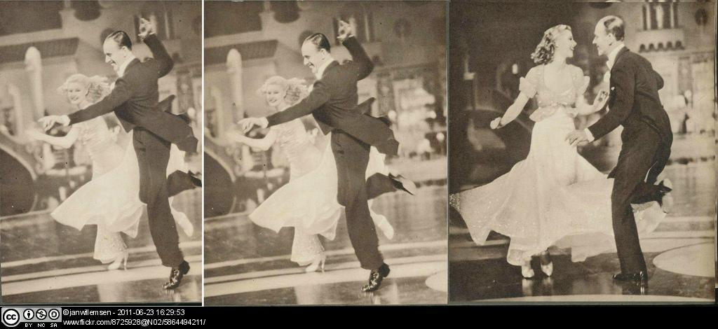
Feedback | Open answer.

 | Textentry1
Title
Text | In your opinion, does the Hollywood musical successfully mask its ‘engineered effects’?
Feedback | Open answer.

 | Textentry1
Title
Text | Would audiences of the 1930s and 40s have fallen for this illusion of ‘folk art’?
Feedback | Open answer.

 | Textentry1
Title
Text | What about contemporary audiences?  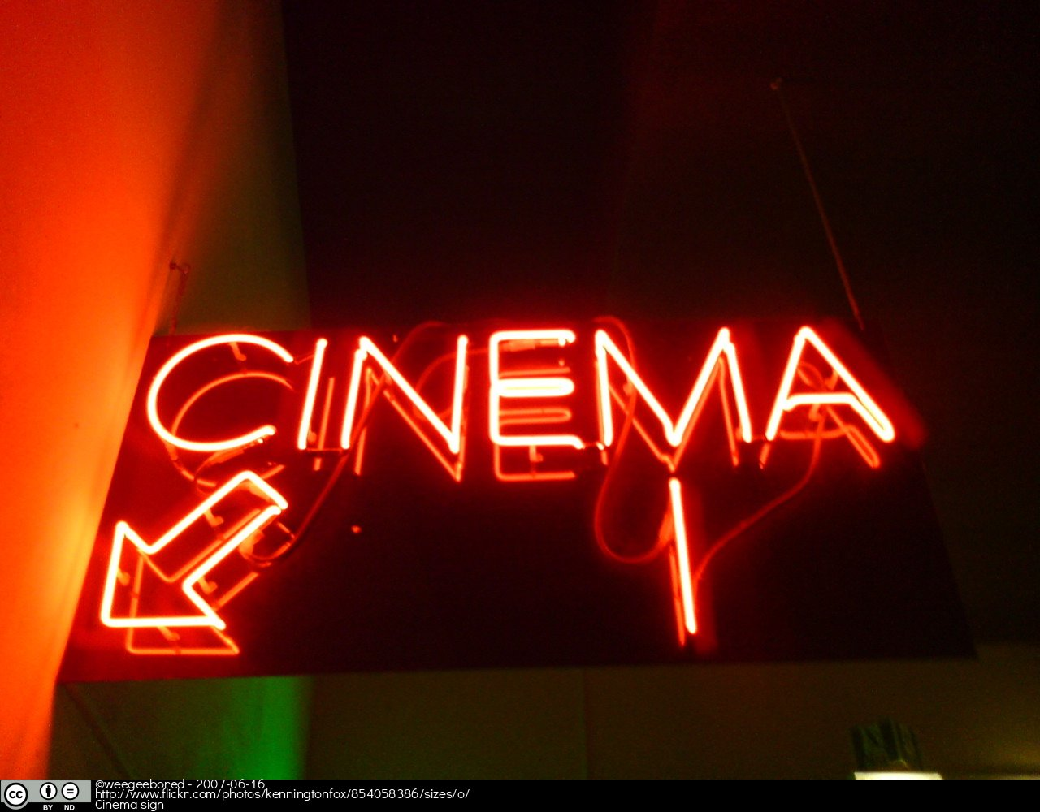
Feedback | Open answer.

 | Textentry1
Title
Text | What did you find useful about Feuer's article for looking at dance in the Hollywood musical?
Feedback | Open answer.

 | Textentry1
Title
Text | What well-known theorist talks about the way capitalism operates, particularly the idea that we are oppressed by this economic system of production?
Feedback | Karl Marx.  Remember: Feuer is basically arguing that, as a capitalist art form (i.e. we pay to watch Hollywood stars singing and dancing in musicals), the musical masks this through an illusion of ‘folk art’.
</boxtext>

Acknowledgements

Authors
Activities by Inma Álvarez (developed and adapted from Sherril Dodds’ teaching materials, 2011.)

Podcasts by Sherril Dodds, 2011.

Critical reading by Jane Chan and Sophie Klepacz.

Technical support by Rachel O’Callaghan, University of Surrey.

Images
All images in this learning package are Creative Commons. This is a full list with detailed references (web links where applicable open in a new window).

Introduction to this learning package
Photograph of film reels by Roman Soto (03/07/2003), available as Creative Commons Attribution at: http://www.flickr.com/photos/ninjanoodles/4757996264/

Critique of Feuer
Photograph of Fred Astaire and Ginger Rogers by janwillemsen (23/03/2011), available as Creative Commons Attribution-NonCommercial-ShareAlike at: http://www.flickr.com/8725928@N02/5864494211/

Cinema sign by weegeebored (16/06/2007), available as Creative Commons Attribution-NonDerivatives at: http://www.flickr.com/photos/kenningtonfox/854058386/sizes/o/

Mp3 files
Photograph of Fred Astaire and Ginger Rogers by Laura Loveday (23/07/2009), available as Creative Commons Attribution-NonCommercial-ShareAlike at: http://www.flickr.com/37624835@N03/3749192871/

Licence

This resource was released as an Open Educational Resource through the Contexts, Culture and Creativity: Enriching E-Learning in Dance project funded by JISC Strand A: Digitisation & Open Educational Resources.



All the podcasts and the text including the transcriptions are licensed under a Creative Commons Attribution-NonCommercial-ShareAlike License. Images are licensed as specified in the individual banner and the Acknowledgements page.



The JISC logo is licensed under the terms of the Creative Commons Attribution-Non-Commercial-No Derivative Works 3.0 UK: England & Wales Licence. All reproductions must comply with the terms of that licence.

The University of Surrey logo and the National Resource Centre for Dance logo are owned by the university and should not be produced without the express permission of the university.

