SPPO2650/2651 “The Spanish regional Melting Pot: the same old History?" Discussion board: Introduction to the socioeconomic and demographic reality of Spain and its Autonomous Communities. Deadline for contributions: 20/10/2014 by noon (12.00) – 10% of the mark for SPPO 2650 and 15% of the mark of the module for SPPO 2651.

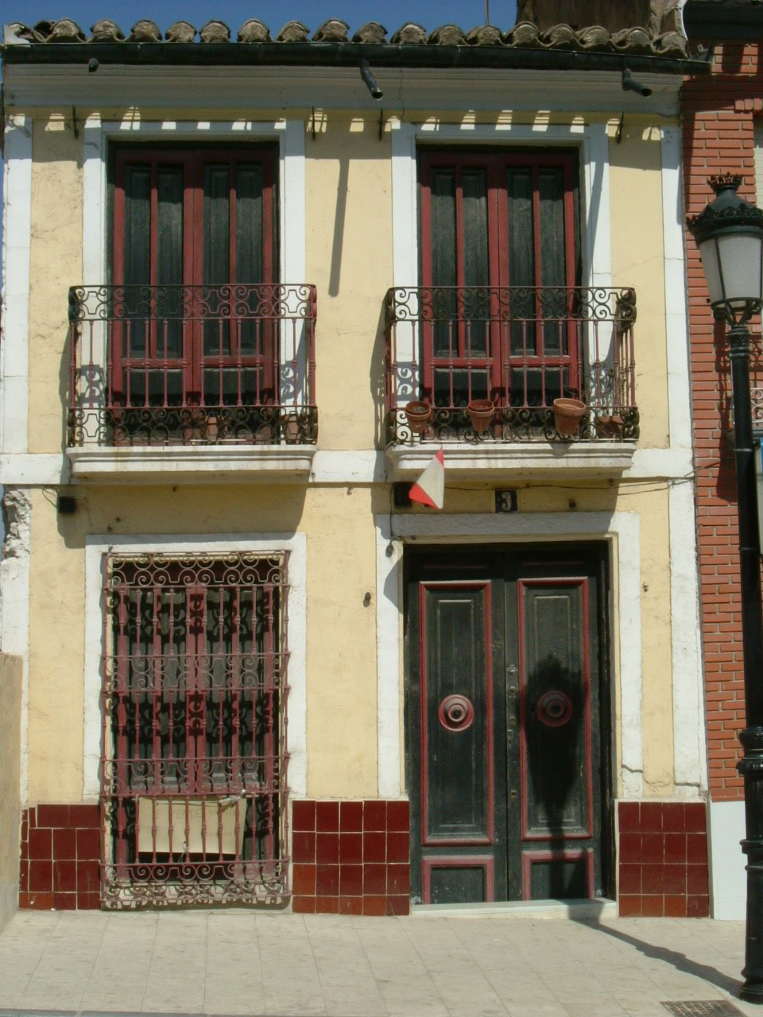
Each individual student will be given a role, either as a representative of the Government of an Autonomous Community or as a representative of the Spanish Central Government.

Aims and objectives of this Role Play - Online Seminar:

This online seminar is aimed at facilitating students’ interaction and co-operation in the process of understanding the complex socio-economic and demographic reality of Spain and its Autonomous Communities as well as the country’s political-territorial structure.

At the end of the seminar, students will be able to have a basic grasp of how the Spanish state is organised territorially, what services Autonomous Communities offer to their citizens and what challenges they face as a result of their specific size, population and economic conditions.

Situation:

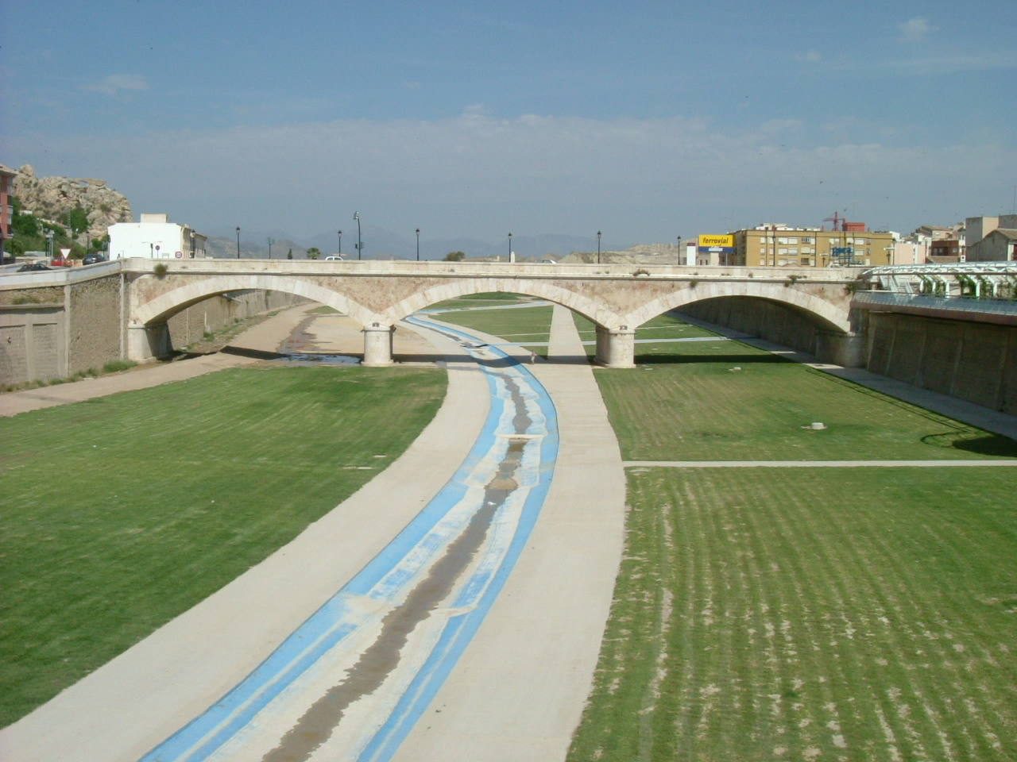
The Spanish Government is about to allocate around €47 billion to the Governments of the 17 Autonomous Communities of Spain. The cash comes from a special fund obtained from public borrowing. The purpose of this money, which will be released over a period of three years, is to help each Autonomous Community to cope with the effects of the current world economic crisis. The Governments of the Autonomous Communities will have absolute freedom to spend the money in building new infrastructure, improving the public services that they run, supporting local businesses or improving the level of social benefits that they offer to their population.

After bitter experiences over the last decades, with serious disagreements between the regions as to what criteria to follow for the allocation of funds, The Spanish Government, who has to take into consideration as much as possible the views of the Regional Governments before deciding how much to give to each one, has opened a period of consultation and negotiation with all of them. This time, the consultation and negotiation process will be done online, through our online debates, and there will be three different negotiating tables open for all the participants. The Government expects to reach the desired agreements over the next two weeks in a relatively smooth manner by adopting this new approach.

Negotiating Table 1 – Discussion Board 1 (Money to be allocated in this table: € 9,300,000,000)
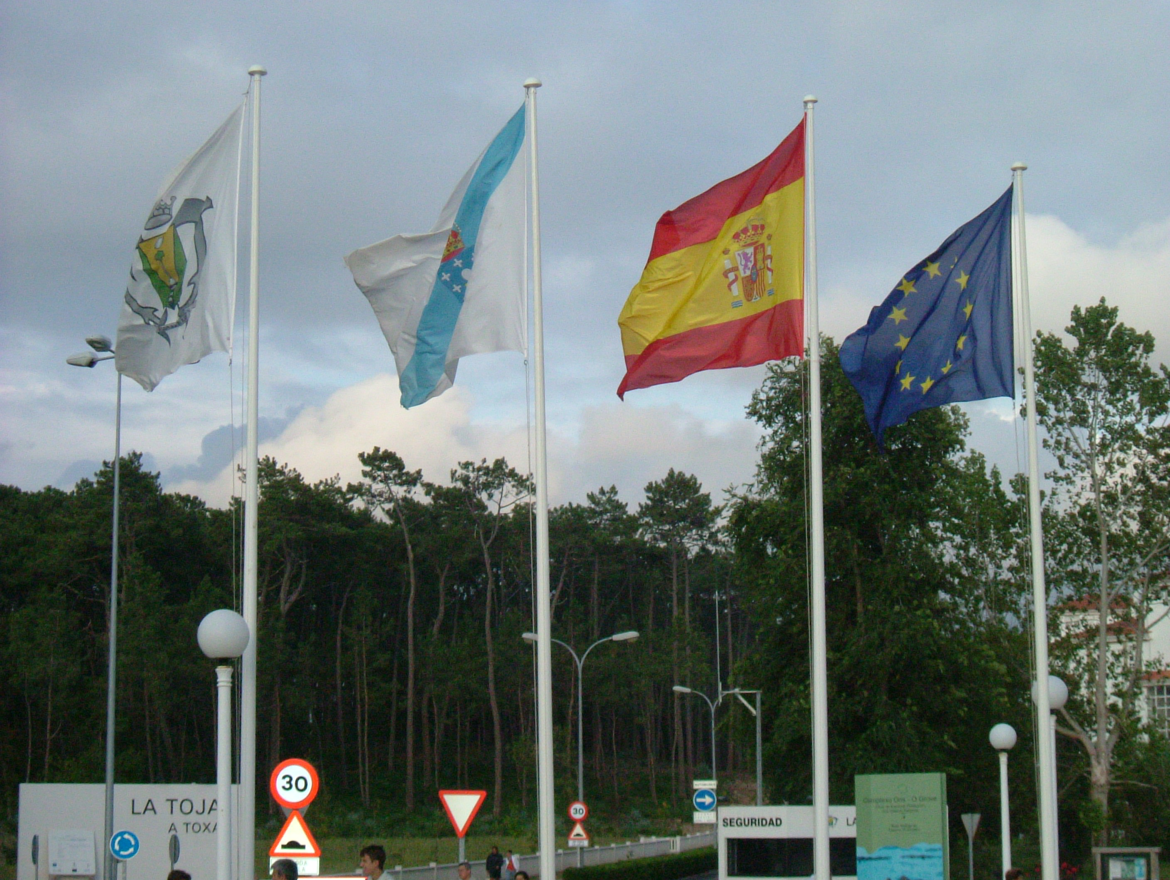
Participants:
A) Representatives of the following regions:
• País Vasco
• Navarra
• Galicia
• Asturias
• Cantabria
• Castilla-León
B) Plus some representatives of the Spanish Government.
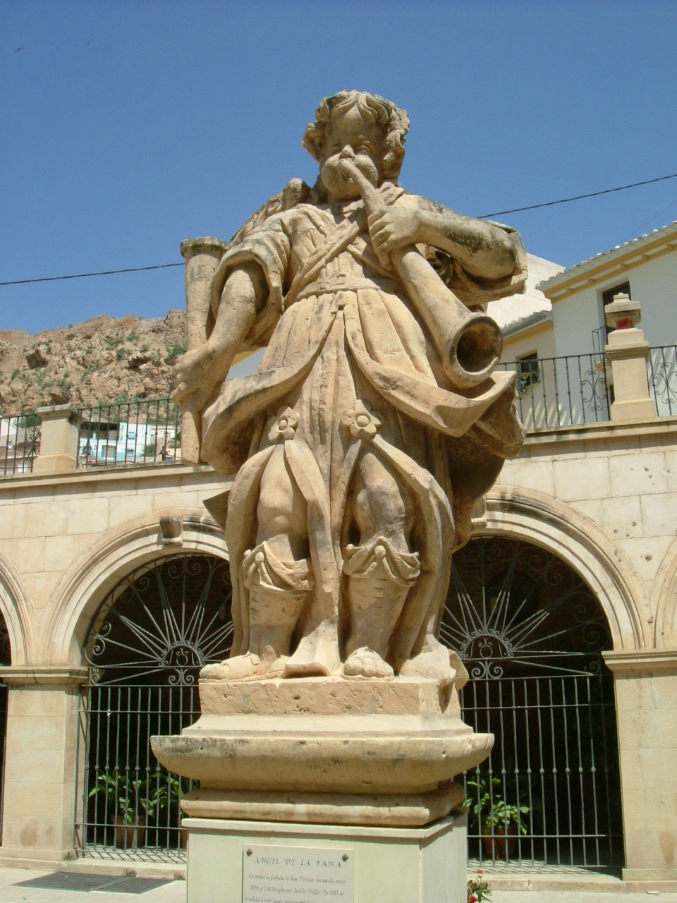
Negotiation Table 2 – Discussion Board 2 (Money to be allocated in this table: €19,000,000,000)
Participants:
A) Representatives of the following regions:
• La Rioja
• Castilla-La Mancha
• Aragón
• Extremadura
• Cataluña
• Madrid
B) Plus some representatives of the Spanish Government.
Negotiation Table 3 –Discussion Board 3 (Money to be allocated in this table: € 18,300,000,000)
Participants:
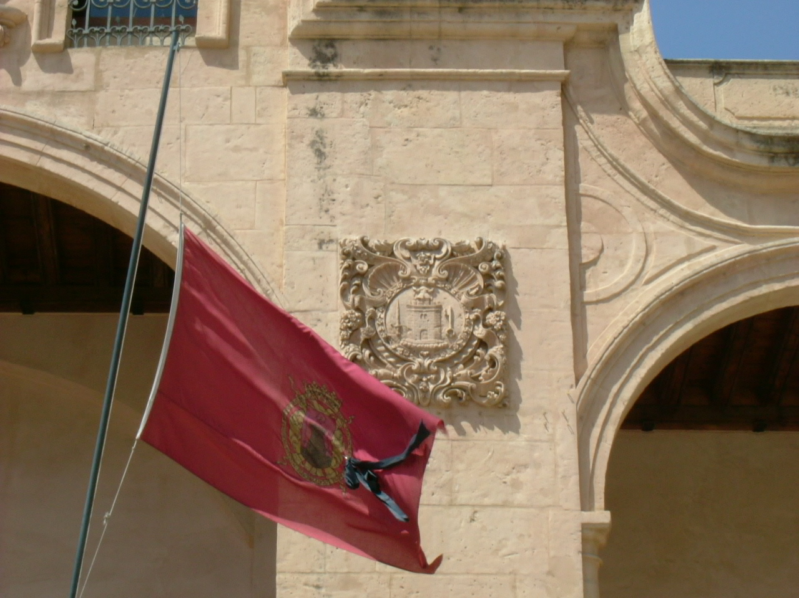
A) Representatives of the following regions
• Baleares
• Comunidad Valenciana
• Región de Murcia
• Andalucía
• Islas Canarias
B) Plus some representatives of the Spanish Government.

Please note that the two Autonomous Cities (Ceuta and Melilla) have already received some extra funds and are not included in the negotiation.

How to conduct the negotiation:

Each individual region has to put forward their arguments for the amount of money they think they are entitled to. As representatives of your own region, you should make financial proposals for your own region explaining briefly why and how you would spend the money. A number of reasons can be taken into account when applying for the funds, including the following:

• The population of each region;
• Specific social or economic problems of each Autonomous Community in comparison to other regions;
• The wealth of their population, (GDP per cápita - Gross Domestic Product per cápita - P.I.B. por habitante);
• The size of their economy (GDP - P.I.B.);
• The unemployment rate;
• The size of their territory;
• Any other relevant statistical data.

Participants can investigate about the specific needs of regions in newspapers, articles, books and other sources. Some of the key information for the discussion can be found in the online publication by the INE “España en cifras 2013”. This set of data is up-to-date and cannot be disputed in the course of the debate because it has been accepted by all parties as official. It includes information on population and basic economic indicators.
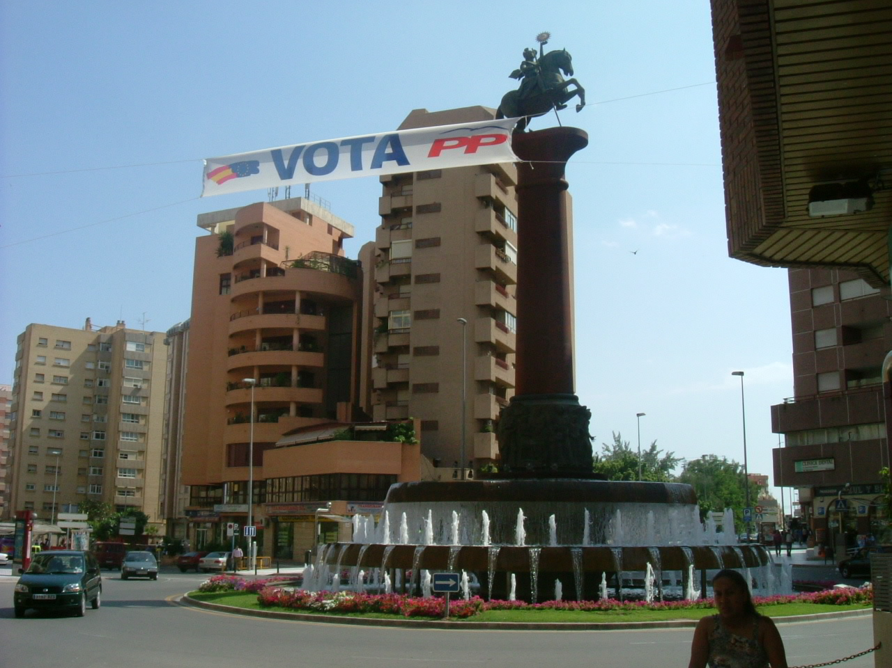
The students acting as representatives of the central Government will have to collate all the bids and information sent by the regions, which everybody else in the class will be able to see. They will then discuss with individual regions any counteroffers that may be suggested. The representatives have to reach an overall settlement without going over the limit of the budget for their negotiating table. They must ensure that absolutely every single region in their negotiating table agrees to the settlement.

Rules and responsibilities for participation in this online seminar:

• Contributions can be written in Spanish or English. It is your choice. If you write in Spanish, grammar or vocabulary mistakes will be taken into account only if they impede communication.
• Each message (thread) will have a maximum of 200 words. However, there is not a recommended amount of words for each message. All depends on what you want to say. There can be messages as simple and short as “Yes, the government of my region is happy with your offer”.
• You will receive a mark for the whole set of contributions to each online seminar. (This role play counts as online seminar one of the course)
• You are allowed and encouraged to read other colleagues' contributions in other negotiating tables and learn from them.
• Students will endeavour to be constructive, tactful and polite when dismissing other colleagues’ arguments or demands.

The assessment criteria for this online seminar are the following:

• Focus: How well you concentrate on your role and remit and whether a final agreement has been reached or not.
• Content: critical understanding of the demographic and socio-economic reality of Spain and the role of Autonomous Communities in Spanish Society, including reference to any relevant sources such as news items, articles or statistics.
• Interaction: the extent to which you engage constructively with other colleagues’ comments in order to agree, disagree or qualify those comments.
• Form: concision and clarity of expression.

Pictures and activity by Antonio Martínez-Arboleda. School of Modern Languages and Cultures. University of Leeds. 2008-2013

