IBL Exercise – Week 9 (Lecture 19) Early Modern Revolutions

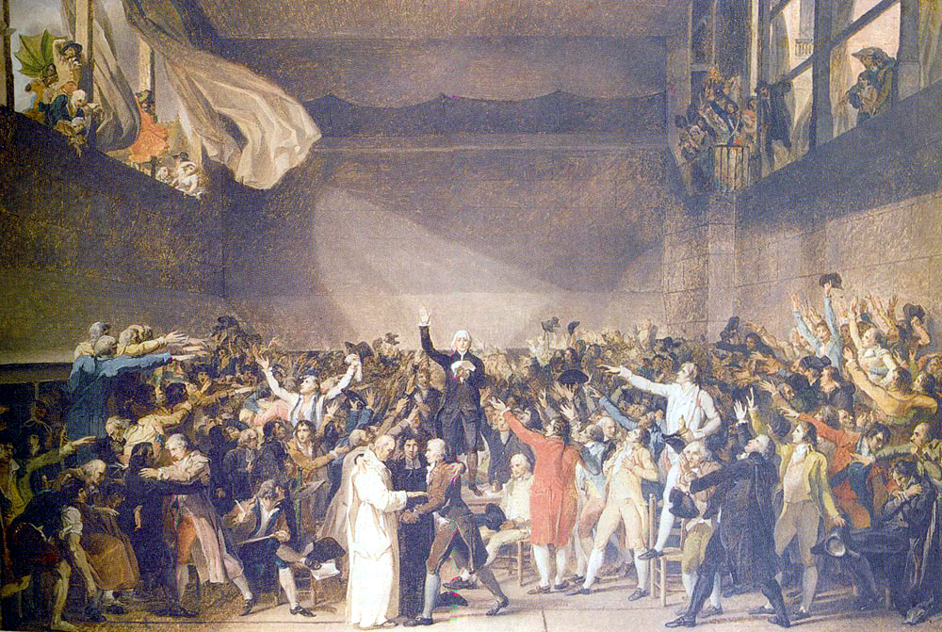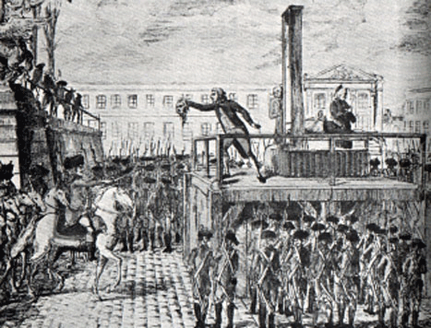

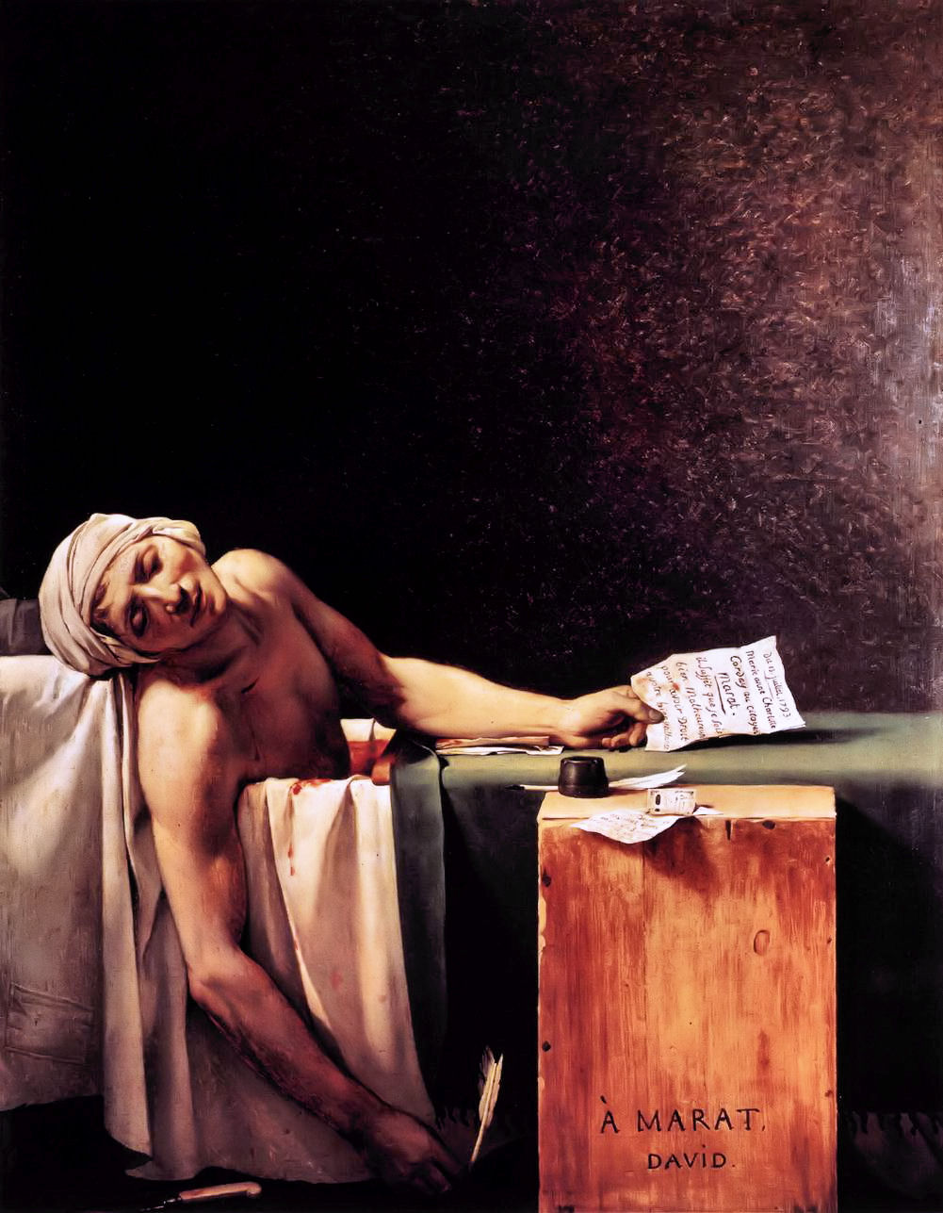

THIS EXERCISE IS IN ADDITION TO THE SET READING ON MOLE.

Oral Assessment in HST 112 seminars includes marks based on your oral contribution and preparation. This task is designed to facilitate your ability to contribute effectively in the seminar on Early Modern Revolutions.

1 – Find the main library website – http://www.shef.ac.uk/library click ‘Using the Library’ > ‘Find Subject Information’ > ‘Subject Guides’ > ‘History’ > ‘Internet Resources’. Use the INTUTE gateway (a great resource for finding reliable websites that are better than Wikipedia which you should avoid using at all times). Search for the ‘French Revolution’ and it will bring you to http://chnm.gmu.edu/revolution - An internet resource for the study of the French Revolution.

2 – BROWSE the timeline to familiarise yourself with the main events of the French Revolution. Then BROWSE the glossary and find the meaning of at least three of these terms. You will be expected to explain at least one in class:

BOURBON
BOURGEOIS/BOURGEOISIE
CAHIER DE DOLÉANCES
COMMITTEE OF PUBLIC SAFETY
COMMUNE
CONSTITUENT ASSEMBLY
CORDELIER CLUB
DIRECTORY
ESTATES-GENERAL
FRENCH REVOLUTIONARY CALENDAR
GIRONDIN
JACOBIN CLUB
LEGISLATIVE ASSEMBLY
MOUNTAIN
NATIONAL ASSEMBLY
NATIONAL CONVENTION
SANS-CULOTTES

3 – Also it will help you greatly to know who Jean-Jacques Rousseau, Abbe Sieyes, Robespierre, Georges-Jacques Danton, Jacques-Réné Hébert, Abbé Grégoire, Gracchus Babeuf and Napoleon Bonaparte were and their place in the events of 1789-1800. The Historical Dictionary of the French Revolution (Western Bank Library, 944.04H) is particularly useful for this kind of information.

4 – What events are depicted in the pictures?

