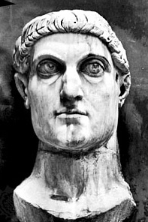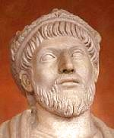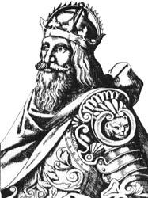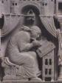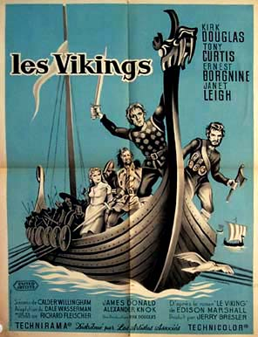
Week 2:Emperor Constantine
Revision: Pagans, Christians and Heretics in Medieval Europe
Next to each picture write one thing that you can remember about that topic. This will help to jog your memory and indicate what has entered your long term memory.

Week 3:Emperor Julian the Apostate

Week 4:King Clovis and the Franks

Week 5:Gregory the Great and the English

Week 6:The Viking Threat

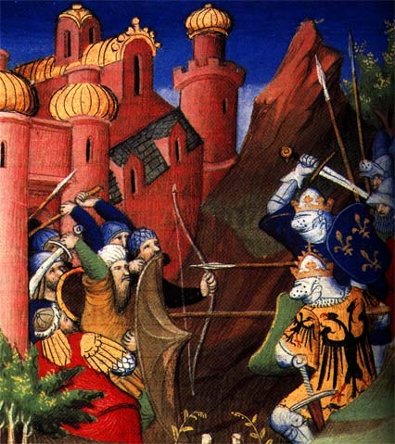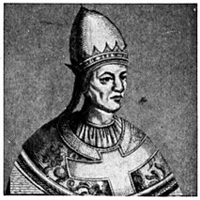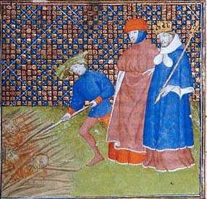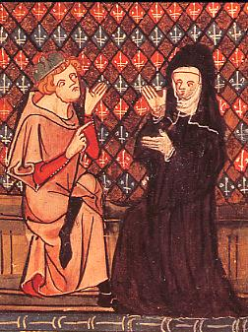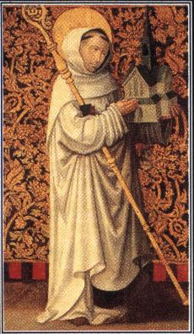

Week 7:Crusades
Week 8:Investiture Contest
Week 9:Twelfth Century Renaissance
Week 10:Cistercians: Prayer and Power
Week 11:Persecution

