Important Cites in the Middle Ages
Mark these cities on map below with a dot (write the city's name next to the dot). These were all important cities in the classical period or the middle ages. Next to the name of each city indicate in which modern country it is situated. Add in any more cities that you think are important.
City | Modern  Country | City | Modern  Country | City | Modern  Country
1. Paris |  | 2. Rome |  | 3. London
4. Marseilles |  | 5. Constantinople |  | 6. Lyon
7. Toledo |  | 8. Venice |  | 9. York
10. Jerusalem |  | 11. Avignon |  | 12. Barcelona
13. Florence |  | 14. Assisi |  | 15. Alexandria
16. Cordoba |  | 17. Athens |  | 18. Ephesus
19. Bologna |  | 20. Mainz
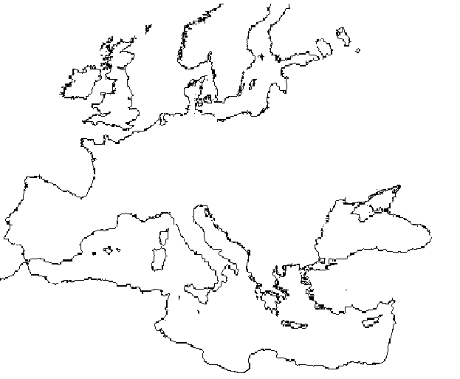
http://www.fordham.edu/halsall/maps/mapquiz.htm

