Week 2: Constantine
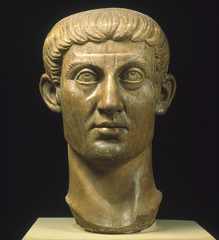
Constantine’s decision to convert to and promote Christianity in the opening decades of the fourth century had far-reaching consequences. In this seminar we aim to discuss why he did it, whether he really knew what he was doing and what the consequences were.

Questions to consider:
    - What are our sources for Constantine’s conversion and why are they difficult to use?
    - Is it possible to explain Constantine’s conversion in terms of the political advantages he could gain from it? Did Constantine really believe in Christianity?
    - What did Constantine do to promote the new religious order in the Empire?
    - Would the Empire have become Christian without Constantine? (Please will everyone come prepared to defend both sides of this argument).

Suggested reading:
You may like to consult some of the additional writings of Bishop Eusebius, but I suggest you start with:
- Eusebius, History of the Church transl. G. A. Williamson (Harmondsworth, 1965; rev. ed. 1989), books 9 and 10
- Eusebius, Life of Constantine transl. A. Cameron (Oxford, 1999) and online at http://www.fordham.edu/halsall/basis/vita-constantine.html: Book I: 1-13; 26-31; 36-44
Book II: 1-12; 20-28; 56, 61-73
Book III: 5-23; 48-50; 54-58; 64-66
Book IV: 8-28; 38-39; 56-64; 73-75
- Also, have a look in: Stevenson, J., A New Eusebius: Documents Illustrating the History of the Church to AD 337 (London, 1968, rev. ed. 1987)
- You may also like to try: Zosimus, New History transl. R. T. Ridley (Canberra, 1982); transl. J. Buchanan and H. Davis (San Antonio, Tx., 1967). Look up Constantine in the index.

For secondary reading, please consult some of the following:
Brown, P., The World of Late Antiquity (London, 1971), pp. 49-112
Brown, P., The Rise of Western Christendom (Oxford, 1996), chs. 2 and 3
Cameron, A., The Later Roman Empire (London, 1993), chs. 4 and 5
Fletcher, R., The Conversion of Europe (London, 1998), pp. 17-28
Jones, A. H. M., The Later Roman Empire, 284-602 (Oxford, 1964), ch. on Constantine
MacMullen, R., Christianizing the Roman Empire (New Haven and London, 1984), chs. 5 and 6

The above reading list is just a guide; there are other relevant materials in your course handbook, so have a look in there. You can also try keyword searches on the library catalogue and following up footnotes and bibliographies you encounter in books and articles.

