Week 5: Gregory the Great and the Conversion of the English
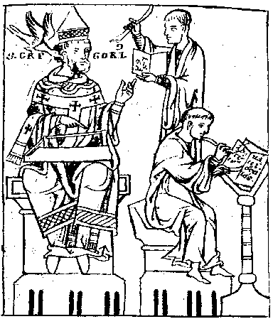
Thirteenth-century depiction of Pope Gregory the Great with the Dove of the Holy Spirit perched on his shoulder
The conversion of the Anglo-Saxons is relatively well-documented due to one of the most influential historical works - Bede’s Ecclesiastical History of the English People. In this seminar we will discuss the reasons for the sending of Gregory’s original mission, the ways in which missionaries were received by kings and the strategies they adopted to promote Christianity.

Key questions to consider:

    - Why did Pope Gregory the Great (c. 540-604) send a mission to the Anglo-Saxons?
    - What does Bede tell us about the conversion? Did he exaggerate or idealise its success?
    - Why were Anglo-Saxon kings willing to accept Christianity?
    - What was the role of kings in the conversion of the Anglo-Saxons?
    - How clear was the distinction between pagani and Christiani at this point? Is there evidence for syncretism? (You may like to think about the relevance of Sutton Hoo).

Suggested Reading:

Primary:
Obviously, Bede’s Ecclesiastical History of the English People is of great importance to this seminar, so please read the relevant sections on the Gregorian mission. Please use the edition by B. Colgrave and R.A.B. Mynors (Oxford, 1969) if possible as it contains the standard translation as well as the Latin. If you want to buy a copy of the Ecclesiastical History there is a relatively cheap Penguin paperback trans. by L. Sherley-Price.
There are other useful materials in Webb and Farmer, The Age of Bede (Harmondsworth, 1983), including Eddius Stephanus’ Life of Wilfrid.
Whitelock’s English Historical Documents (London, 1955) contains some of Gregory and Bede’s letters (numbers 161-163 and 170).
Secondary:
Angenendt, A., ‘The conversion of the Anglo-Saxons considered against the background of the early medieval mission’, Settimane di Studio del Centro Italiano di Studi dell’Alto Medioevo 32 (1986), 747-92 [Also in SLC OFFPRINTS]
Carver, M., (ed) The Age of Sutton Hoo: the Seventh Century in North-Western Europe (Woodbridge, 1992)
Carver, M., Sutton Hoo: Burial Ground of Kings? (London, 1998)
Goffart, W., The Narrators of Barbarian History, AD 500-800 (Princeton, 1988) [also an electronic resource]
Higham, N., The Convert Kings. Power and Religious Affiliation in Early Anglo-Saxon England (Manchester, 1997), chapters 1 and 2 in particular

Please turn over
Mayr-Harting, H., The Coming of Christianity to Anglo-Saxon England (London, 1991) (excellent book on this topic)
Markus, R., The End of Ancient Christianity (Cambridge, 1990)
Markus, R., Gregory the Great and His World (Cambridge, 1997)
Meens, R., ‘A background to Augustine’s mission to Anglo-Saxon England’, Anglo-Saxon England 23 (1994), 5-17
Page, R. I., ‘Anglo-Saxon paganism: the evidence of Bede’, in Pagans and Christians ed. T. Hofstra et al. (Groningen, 1995), pp. 99-129
Richter, M., ‘Practical aspects of the conversion of the Anglo-Saxons’ in P.Ní Chatháin and M.Richter, Irland und die Christenheit (Stuttgart, 1987) pp. 362-76
Wilson, D., Anglo-Saxon Paganism (London, 1992) [on order]
Wood, I., ‘The mission of Augustine of Canterbury to the English’, Speculum 69:1 (1994), 1-17.
Wood, I. N., ‘Some historical re-identifications and the Christianization of Kent’ in Christianizing Peoples and Converting Individuals ed. G. Armstrong and I. N. Wood (Turnhout, 2000), pp. 27-45

The above is just a guide, by now you should be directing your own reading and research. The course handbook contains an excellent bibliography, but you should not be afraid to find your own reading from other sources such as STAR and footnotes from books/articles. An important source for finding more articles is the International Medieval Bibliography which the university subscribes to online at: http://www.brepolis.net/ (click ‘enter databases’, then click ‘go’ for the International Medieval Bibliography).

