Week 6: The Vikings
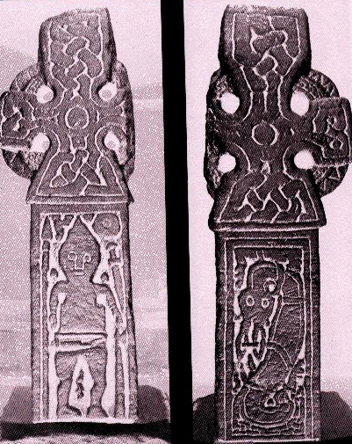
Middleton Cross (early 10th century). Possibly signifying the Christianisation of a viking warrior.

Key questions to consider:
- Who were the vikings? When and where did they attack?
- Why did they attack?
- How did their victims respond in the written sources? Should we believe everything we read?......
- What were the practical/military responses to the viking attacks?
- What impact did the vikings have on Christendom?

Suggested reading:
Primary:
The main primary sources for the Vikings are The Anglo-Saxon Chronicle (for England) and The Annals of St. Bertin and The Annals of Fulda (for Frankia). There are various translations of the Anglo-Saxon Chronicle, but the best is in D. Whitelock’s English Historical Documents. Both Frankish annals are in the library or on the web at http://www.medievalsources.co.uk/sources.htm. If you’re feeling adventurous, have a look at Alcuin’s letter to the monks of Lindisfarne which can be found in D. Whitelock, English Historical Documents no. 194. If you feeling really adventurous, have a look at Alcuin’s poem On the Destruction of Lindisfarne in P. Godman, Poetry of the Carolingian Renaissance (London, 1985), pp. 126-139.

Secondary:
Coupland, S., ‘The rod of God’s wrath or the people of God’s wrath? The Carolingian Theology of the Viking Invasions’, Journal of Ecclesiastical History 42 (1991), 535-554.
Coupland, S., ‘The fortified bridges of Charles the Bald’, Journal of Medieval History 17:1 (1991), 1-12.
Fletcher, R., The Conversion of Europe (London, 1997), chapter 11
Foot, S., ‘Violence against Christians? The Vikings and the Church in the ninth-century England’, Medieval History 1:3 (1991), 3-16
Halsell, G., ‘Playing by whose rules? A further look at Viking atrocity in the ninth century’, Medieval History 2:2 (1992), 2-12.
Page, R. I., “A most vile people’: early English historians on the Vikings’, The Dorothea Coke Memorial Lecture in Northern Studies (1986), 3-30
Radford, C. A. R., ‘The later pre-conquest boroughs and their defences’, Medieval Archaeology 14 (1970), 83-103
Reuter, T., ‘Plunder and tribute in the Carolingian Empire’, Transactions of the Royal Historical Society 5 series 35 (1985), 75-94
Schoenfeld, E. J., ‘Anglo-Saxon burhs and continental burgen’, Haskins Society Journal 6 (1994), 46-66
Wallace-Hadrill, J.M, ‘Vikings in Francia’ in his Early Medieval History (Oxford, 1975)
Wormald, P., ‘Viking studies: whence and whither?’ in R. T. Farrell (ed.) The Vikings (London, 1982), pp. 128-153.

