Week 10: Heresy and the Cathars
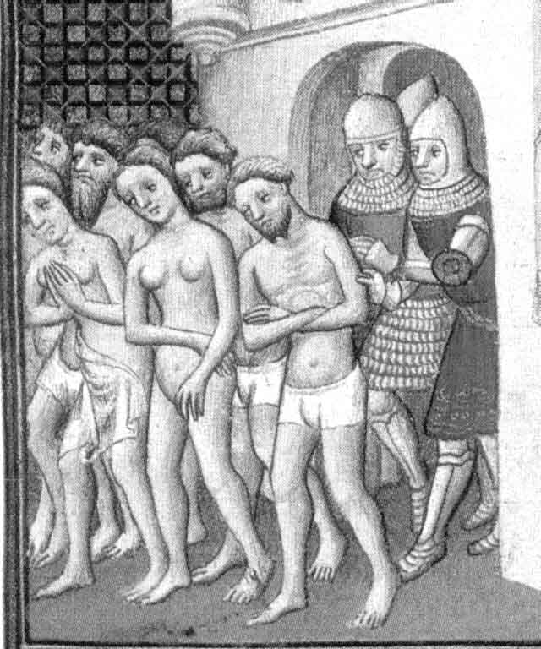
Cathars being expelled from Carcassonne in 1209

Questions to consider:

- How did heresy obtain such a grip in parts of Christendom in the late 12th century? Where did Catharism take hold?
- What were the principles of Catharism? How did these make it so attractive? How did these differ from orthodox teachings?
- What action did the Catholic Church take against the Cathars? Why did church authorities feel that this was necessary to take this action?
- How successful was the church in countering the Cathar heresy?

Suggested reading:

Primary sources:
There are sources in E. Peters, Heresy and Authority in Medieval Europe: Documents in Translation (London, 1980); R. I. Moore, The Birth of Popular Heresy (London, 1975), nos. 29, 37, 39; W. L. Wakefield and A.P. Evans, Heresies of the High Middle Ages (London and New York, 1969, revd. 1991).

Secondary sources:
Abels, R. and Harrison, E., ‘The participation of women in Languedocian Catharism’, Medieval Studies 41 (1979), 215-251
Barber, M.,The Cathars: Dualist Heretics in Languedoc in the High Middle Ages (Harlow, 2000)
Biller, P., ‘Through a glass darkly: seeing medieval heresy’ in The Medieval World ed. P. Linehan and J. L. Nelson (London, 2001)
Costen, M., The Cathars and the Albigensian Crusade (Manchester, 1997)
Hamilton, B., ‘The Albigensian Crusade and heresy’ in The New Cambridge Medieval History V (c. 1198-c.1300) ed. D. Abulafia (Cambridge, 1999), 164-81
Lambert, M., Medieval Heresy: Popular Movements from the Gregorian Reform to the Reformation (Oxford, 2002)
Lambert, M. D., The Cathars (Oxford, 1998)
Le Roy Laudrie, E., Montaillou: Cathars and Catholics in a French Village, 1294-1324 (London, 1978
Moore, R. I., Formation of a Persecuting Society (Oxford, 1990), pp. 11-27 and use index for ‘Cathars’
Pegg, M. G., ‘On Cathars, Albigenses, and Good Men of Languedoc’, Journal of Medieval History 27 (2001), 181-95 [Available electronically]

O’Shea, S., The Perfect Heresy (London, 2000). This is aimed at a ‘popular’ market so should be used with care (do not use it in any essays on the topic!), but it is also quick and easy to read.

You should also consult the course bibliography (pp. 39-40) for more reading on this topic.

