Week 11: Cistercians – Prayer and Power

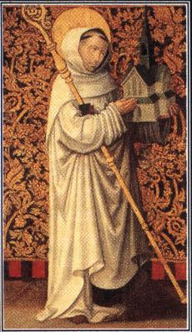

A Cistercian ‘White Monk’

During the late-eleventh century there was a proliferation of new religious orders throughout Christendom. In this seminar we will aim to establish the reasons for this growth and will focus on the Cistercians in particular. We will discuss where, how and why the Cistercian movement grew up and whether or not they adhered to their strict rules of poverty and isolation.

Key questions to consider:

1. Why was there a proliferation in new forms of religious life in the decades around 1100?

2. What is the Rule of Saint Benedict (6th century)? How did it influence these new religious orders (with particular reference to the Cistercians)?

3. What was ‘different’ about the Cistercians? Have a look at Bernard of Clairvaux’s attack on the Benedictine Cluniacs in his Apology and his arguments with Peter the Venerable.

4. What role did the laity play in the evolution of the Cistercian Order? Do these developments demonstrate an abandonment of the Order’s principles of poverty and isolationism? Was the Order a victim of its own success?...

5. What was the role of women in the general revival of monastic life? Why did the Cistercian Order initially refuse to recognise female ‘Cistercian’ communities?

Primary reading:
For primary reading, you may find The Cistercian World : Monastic Writings of the Twelfth Century ed. and trans P. Matarasso (Harmondsworth, 1993) useful.

Suggested secondary reading:
There is a wealth of secondary reading material on medieval monasticism – the following is just a guide. There is an on-line project about the Cistercians in Yorkshire (run by Prof. Sarah Foot) and you should find the section on Cistercian life especially helpful: http://cistercians.shef.ac.uk/

Bouchard, C. B., Holy Entrepreneurs: Cistercians, Knights, and Economic Exchange in Twelfth-Century Burgundy (Ithaca and London, 1991)
Berman, C.H., The Cistercian Evolution: the Invention of a Religious Order in Twelfth-Century Europe (Philadelphia, 2000)
Brooke, C. N. L., The Monastic World, 1000-1300 (London, 1974). Good for photos!
Burton, J. E., Monastic and Religious Orders in Britain (Cambridge, 1994)
Cantor, N., ‘The crisis of western monasticism, 1050-1130’, American Historical Review 66 (1960/1), 47-67
Grundmann, H., Religious Movements in the Middle Ages (London, 1995)
Knowles, D., Cistercians and Cluniacs (London, 1955) [pamphlet]
Lekai, L.J., The Cistercians: Ideals and Reality (Kent, Ohio, 1977)
Lawrence, C.H., Medieval Monasticism: Forms of Religious Life in Western Europe in the Middle Ages (London, 1989)
Leclercq, J., The Love of Learning and the Desire for God: a Study in Monastic Culture, transl. C. Misrahi (New York 1962; numerous editions) [also an Ebook]
Newman, M.G., The Boundaries of Charity: Cistercian Culture and Ecclesiastical Reform, 1098-1190 (Stanford, California, 1996)

