Week 12: Persecution

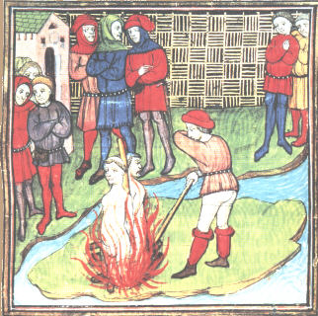

Burning of heretics

The new millennium heralded a new age of intolerance, persecution and inquisition. In this seminar we will try to establish why a climate of persecution emerged c. 1000-1300; what sorts of people were subjected to persecution and the manner in which these groups were treated by the Church, secular rulers and the general populous. We will also touch on issues that we have addressed throughout the module in order to draw these themes together in preparation for the end of semester examination.

Key questions to consider:

- Definitions: What is ‘persecution’? What is ‘heresy’? How is ‘heresy’ different from ‘paganism’?
- Think back through the module entire: what groups of people were subject to persecution? Why? Try to draw some commonalities between these very different groups.
- What (or who) does R. I. Moore argue was responsible for the rise of persecution, 950-1250? How convincing is his ‘thesis’?
- Why was the Church so concerned about heresy? Was it ever under serious threat from heretics such as the Cathars?
- What methods did the Church use to combat heresy?
- Why did the Jews experience increased levels of mistrust and persecution in this period?

Primary reading:
Please will everyone have a look at some of the inquisition records of Jacques Fournier (http://www2.sjsu.edu/depts/english/Fournier/jfournhm.htm or use the link from WebCT). You may also find J. R. Marcus, The Jew in the Medieval World: a Sourcebook, 315-1791 (New York, 1969) useful.

Suggested secondary reading:
Abulafia, A. S., (ed.), Religious Violence between Christians and Jews: Medieval Roots, Modern Perspectives (Basingstoke, 2002)
Abulafia, A. S., ‘From Northern Europe to Southern Europe and from the general to the particular: recent research on Jewish-Christian co-existence in medieval Europe’, Journal of Medieval History 23 (1997), 179-190 [ONLINE]
Chazan, R., ‘The deteriorating image of the Jews’, in Christendom and its Discontents: exclusion persecution and Rebellion, 1000-1500 ed. S. L. Waugh and P. D. Diehl (Cambridge, 1996), pp. 220-233
Cohen, J., ‘The flow of blood in medieval Norwich’, Speculum 79 (2004), 26-65
Fletcher, R., The Conversion of Europe (London, 1998), chapters 13 and 14.
Given, J. B., Inquisition and Medieval Society (London, 1997)
Hamilton, B., The Medieval Inquisition (London, 1981)
Langmuir, G., ‘Thomas of Monmouth: detector of ritual murder’, Speculum 59 (1997), 820-846. [ONLINE].
Le Roy Ladurie, E., Montaillou : Cathars and Catholics in a French village, 1294-1324 (Harmondsworth, 1980)
Moore, R. I., The Formation of a Persecuting Society: Power and Deviance in Western Europe, 950-1250 (Oxford, 1990)
Wakefield, W. L., Heresy, Crusade and Inquisition in Southern France (London, 1974)

