Week 10: Twelfth-Century Renaissance
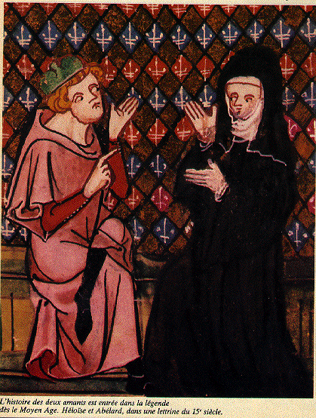
Abelard and Heloise
The Twelfth-Century Renaissance is significant as a period in which Christian scholars engaged with philosophy and the nature of the individual before God. In this seminar we will look at the first two autobiographies written since the late-fourth century as well as exploring important intellectual changes in the twelfth century that arose as a result of Crusades.
Key questions to consider:
- What did the ‘Twelfth-Century Renaissance’ mean? (see J. Le Goff).
- Why are the autobiographies of Abelard and Guibert of Nogent important? Do they mark a ‘discovery of the individual’?
- Why did everyone dislike Abelard? What does this tell us about learning and intellectualism at the time?
- Does Heloise’s fate tell us anything about the role of women in the Renaissance?
- What did Europe learn from its Renaissance?

Primary reading:
Read chapters 1-6 of Guibert de Nogent’s Autobiography. You can find Peter Abelard’s Historia Calamitatum (his autobiography) at: http://www.fordham.edu/halsall/basis/abelard-histcal.html. Please read chapters 6-9. For Heloise’s first letter see http://www.fordham.edu/halsall/source/heloise1.html

Secondary reading:
There is a section in the bibliography in your handbook on the Renaissance, so consult that for wider reading.
Baldwin, J. W., The Scholastic Culture of the Middle Ages (1971)
Benson, R.L., and Constable, G., Renaissance and Renewal in the Twelfth Century (Oxford, 1982; 2nd ed., London and Toronto1991)
Brooke, C.N.L., The Twelfth-Century Renaissance (London, 1969)
Bynum, C.W., ‘Did the twelfth century discover the individual?’, Journal of Ecclesiastical History, 31(1980), 1-17
Constable, G., The Reformation of the Twelfth Century (Cambridge, 1996)
Le Goff, J., ‘What did the Twelfth-Century Renaissance mean?’, The Medieval World, eds P. Linehan and J.L. Nelson (London, 2001), 635-47
Luscombe, D and Evans, G.R., ‘The twelfth-century renaissance’, Cambridge History of Medieval Political Thought c.350-c.1450, ed. J.H. Burns, (Cambridge, 1988), 306-38
Morris, C., The Discovery of the Individual, 1050-1200 (1972; 2nd ed., 1987)
Morris, C., ‘Individualism in twelfth-century religion’, Journal of Ecclesiastical History, 31 (1980), 195-206
Swanson, R. N., The Twelfth Century Renaissance (Manchester, 1999)

