Week 8: Anglo-Saxon (and Irish) Missions to the Continent

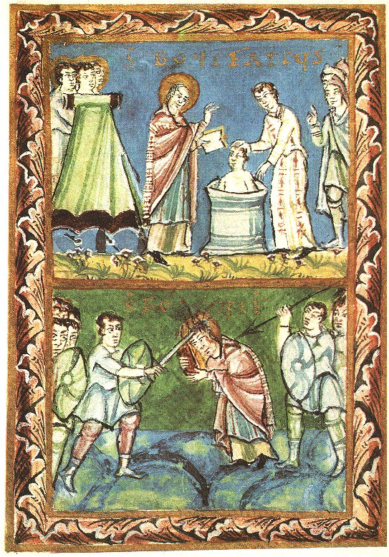

Boniface baptising and martyrdom (754). MS illustration from Sacramentary of Fulda, 11th century.

Questions for Consideration:
- Why did so many Anglo-Saxons go to the continent to become missionaries?
- What strategies did they use to combat paganism?
- How important were kings in continental missionary work in the early eighth century?
- What problems are there in the source material for understanding the Anglo-Saxons’ missionary work?
- To what extent is it fair to call Boniface ‘the greatest Englishman’? (see Reuter)

Suggested reading:
Primary:
Please see pp. 20-26 in the sourcebook for a large range of source extracts and pp. 11-12 of the course handbook. We have a particularly rich field of surviving primary information on the missions/missionaries.
Willibrord: see relevant sections in Bede’s Ecclesiastical History and Alcuin’s Life of Willibrord in Talbot, C. H., The Anglo-Saxon Missionaries in Germany (London, 1954).
Boniface: Willibald’s Life of Boniface (in Talbot).
Folk superstitions: Indiculus superstitionem in Dutton, P. E., Carolingian Civilisation. A Reader (Peterborough, Ontario,1993).

Secondary:
See pp. 32-35 in course handbook. By far and away the best book on this subject is Levison (1946); Brown (1996 and 2003) are good, as is Fletcher.
Charles-Edwards, T., ‘The social background to Irish peregrinatio’, Celtica 11 (1976), 43-59. [in SLC Offprint]
Honée, E., ‘St Willibrord in recent historiography’, in P. N. Holstrop & H. McLeod (eds.), Missions and Missionaries (Woodbridge, 2000), 16-31.
Levison, W., England and the Continent in the Eighth Century (Oxford, 1946)
Reuter, T., ‘St Boniface and Europe’, in T. Reuter (ed.), The Greatest Englishman (Exeter, 1980), pp. 69-94.
Sullivan, R., ‘The Carolingian missionary and the pagan’, Speculum 28 (1953), 705-40.
Wallace-Hadrill, J. M., ‘A background to St Boniface’s mission’, in his Early Medieval History (Oxford, 1975), pp. 138-54.
Wood, I., ‘Missionaries and the Christian frontier’, in W. Pohl, I. Wood & H. Reimitz (eds.), The Transformation of Frontiers: From Late Antiquity to the Carolingians (Leiden, 2001), pp. 209-18.
Wood, I., The Missionary Life: Saints and the Evangelisation of Europe 400-1050 (Harlow, 2001).
Yorke, B., ‘The Bonifacian mission and female religious in Wessex’, Early Medeival Europe 4 (1998), pp. 145-172 (on the role of women in the A-S missions to Germany).

