Week 11: Concepts of Conversion
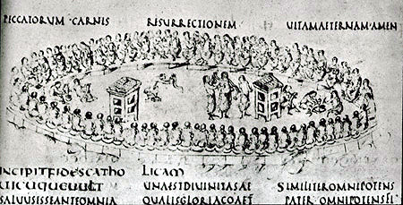

Utrecht Psalter, possibly showing the Council of Nicaea. Francia, c. 825-50
Please come to this seminar prepared to discuss the wide and deep-ranging issues connected to the conversion of early medieval Europe. Before the class, try and highlight what you think are the most important themes that we have examined over the past few weeks and come prepared to discuss them with the rest of the group. It is also an excellent opportunity to sound out your ideas before the exam, so make the most of it!

Some questions you might like to consider are:
- Methods of conversion to Christianity. Think about the ‘big’ issues – when, how, why did the peoples of early medieval Europe convert? Who converted them?
- How did methods of conversions differ? You may like to think about the differences between the attempts to convert the continental Saxons and the conversion of the Anglo-Saxons.
- Who wasn’t converted to Christianity? Think about Anskar’s failed mission to Scandinavia.
- What about members of the lower levels of society-do we know anything about their religious beliefs?
- What were the effects of conversion? What social changes did Christianity bring to early medieval Europe?

Suggested reading:
This week it may be a good idea to read some of the things that you’ve been meaning to read but have never gotten round to! Also have a look at some of the more general secondary reading on pp. 13-17 of the course handbook. For primary source reading, consult the section at the back of the sourcebook (pp. 34-38) on cults and superstitions. Bishop Rimbert’s Life of Anskar is available online at www.fordham.edu/halsall/basis/anskar.html (it’s not very long and some passages can be skim-read).

Andersson, T., ‘Heathen Sacrifice in Beowulf and Rimbert’s Life of Ansgar’, Medievalia et Humanistica 13 (1985), pp. 65-74
Cuscack, C., The Rise of Christianity in Northern Europe 300-1000 (London, 1999), chapter 1 (conversion in general); chapter 6 (Anskar)
De Jong, M., ‘Religion’, in R. McKitterick (ed.) The Early Middle Ages: Europe 300-1000 (London, 1999)
Fletcher, R., The Conversion of Europe (London, 1997), chapter 8
Flint, K., The Rise of Magic in Early Medieval Europe (Oxford, 1991), chapters 8-9
Jolly, K. L., Witchcraft and Magic in Europe: The Middle Ages (London, 2002)
Karras, R., ‘Pagan Survivals and Syncretism in the Conversion of Saxony’, Catholic Historical Review 72:4 (1986), pp. 553-572 [SLC OFFPRINT]
Stevenson, J., ‘Christinaising the northern barbarians’ in Nordsjoen. Handel, Religion of Politik J. F. Kroger and H. R. Naley (eds) (Stavanger, 1995), pp.162-184 [OFFPRINT IN SLC]

