A (very) quick guide to CorelDRAW
CorelDraw is probably the best tool available through the university for creating your own diagrams and images. It is a vector based drawing package. While Corel Photopaint created bitmaps (solid lumps of data), CorelDraw uses lines (known as vectors). One result of this is that a CorelDraw image uses about the same amount of memory as a simple word document. You can also incorporate text, symbols, photographs and complicated shading or fills into your drawing. This obviously begins to increase the size of the file.

At a basic level, the vectors (lines) which CorelDraw uses are simply joining a series of points (known as nodes), by manipulating the nodes it is possible to make virtually any shape at all. What follows will guide you through the basic steps to create a diagram in CorelDraw and then to export it to a JPEG so that it can be included in your thesis. One of the features of CorelDraw is that there are often many ways to achieve the same result. Only by using the program is it possible to become more adept at using it and to gain better results. So don’t despair if it seems alien or impossible to use at first, it’ll make more sense after a while.

The workspace
When you make a new CorelDraw document you will see a white screen with an area delineated in the centre of it. This area is equivalent to a sheet of A4 paper. You can change the size of the paper and the units of measurement you are working in (inchs, cm, mm, etc.) from drop down menus at the top of the page.

Like PhotoPaint the main toolbar lives at the lefthand side of the screen. The basic tool is the top button, known as the PICKTOOL, by clicking on this and then on a blank area of the screen you will return to this basic state.

The PICKTOOL is also used to select objects by clicking on them or to select several objects by dragging and drawing a box around them.
You can hover the cursor over the other buttons to find out their function.
Text
The 11th button down, which looks like a capital ‘A’ allows you to add text to your page. Select this and the click anywhere on the page.

A cursor will now appear and you can begin typing as you would in Word, type you full name, with a return between each name. This type of free writing is known as artistic text.

Now select the PICKTOOL. The text will now be surrounded by 8 black squares, clicking and dragging these allow you to resize the text, or to stretch it.

The menubar along the top of the screen (called the PROPERTY BAR) will now have changed to include options for different fonts and paragraph settings.

Choose a font you like, select ‘Centre’ orientation and set the font size to 36.

The other type of text is known as paragraph text.
Select the ‘A’ button and left-click and drag a box on the page, this creates a TEXTBOX similar to one you would use in Powerpoint, type your address in this box with a return between each element.

Now select the PICKTOOL and change the font to something you like and the size to 24.
Then click and drag the squares around the TEXTBOX so that the writing fits within it.

If you want to change the writing, double click on the TEXTBOX.
You can also cut and paste text from Word into a TEXTBOX which is helpful when designing a poster.

You can set the text to a default setting, e.g Arial 10. by selecting the ‘A’ button.
Then before you click anywhere, change the font type, alignment and size to what you want.
A dialogue box will open asking if you want to apply these settings to Artistic or Paragraph text. Select both and click OK.

Now go to the TOOLS drop down menu at the top of the screen and select
TOOLS→SAVE SETTINGS AS DEFAULT
Your text settings will be the same in all future documents.
This procedure can also be applied to line thicknesses and colours which will come onto next. It is a good way of avoiding having to change things to your preferred settings each time you do something.
If you don’t select SAVE SETTINGS AS DEFAULT, the changes will only apply to this document.

Moving objects
Select the PICKTOOL and then click on one of the text object you have created. As well as being surrounded by the squares which allow you to resize objects, there is a cross in the centre of the selection. Left-click and hold this and drag the text around.

You can also move objects with the cursor keys.

If you left-click again the square will change to arrows.
Click and hold one of the arrows to rotate the selection around the central circle.

If at any point you don’t like what you have done press undo

It is also possible to move, rotate and resize objects more systematically by entering values into the PROPERTY BAR at the top of the page.

Creating Objects
You can create objects using the 5th button down the toolbar. This is known as the FREEHAND TOOL and allows you to draw freehand. Other buttons further down have a variety of preset shapes which you can experiment with.

Select the FREEHAND TOOL

Left-click and hold and move the mouse to draw a wavy line.

Left-click, release and the click again somewhere else on the page to draw a straight line. If you do a double-click on the second click, you can continue the line.

Select the PICKTOOL and click on the first line you drew.
Hold down CTRL and click on the second line, you can now move, stretch, rotate and alter both of the lines. Press delete to erase them.

Select the FREEHAND TOOL and try to draw a square box around the text that you have created. The last point (node) should be as close to the first one as you can manage. If the text is a long way apart then use the PICKTOOL to select one of them and move them next to each other to make it easier.

Your box is probably not perfectly square, don’t worry. You could have used the RECTANGLE TOOL (7th button down) but that would have been boring.

Nodes
Select the PICKTOOL and select your box.
Now select the button below it, this is called the SHAPE TOOL.

The four corners of the box will have a little point on them, this is the node from which the line is made which makes the box.

Left-click on a node and move it around and change the shape of the box.

You can move all of the nodes around until the box is square, or move them elsewhere to create a random shape.

You can add more nodes by double-clicking on the line, or delete an existing node by double-clicking on it.

The PROPERTY BAR will now have changed again to various node controls. You can experiment with these at some point.

Colours, Fills & Outlines
These are controlled using two buttons, the OUTLINE TOOL and the FILL TOOL which are located at the bottom of the toolbar.

Using the PICKTOOL select the box/shape which you have drawn around the text.
The PROPERTY BAR will now change again because you have selected a line.
Select the dropdown menu marked HAIRLINE and change the thickness of the line.
The drop down menus to the left of this allow you to create dashed line and add arrows to the ends of the lines.
You can also select the OUTLINE TOOL from the toolbar for further options

The basic colour palette is arranged down the right-hand side of the screen
With your box/shape selected.
Right-click on a colour to change the outline colour.
This command works for all objects with outlines. If you don’t want an outline right-click on the white box with a diagonal cross at the top of the palette.

Now left-click on a colour to FILL the box/shape with a colour.
If nothing happens, don’t worry, the line is probably not joined up.
You can auto join-up by pressing this button on the PROPERTY BAR
Or, you can move the separated nodes together and combine them.

The box/shape will now be covering your text.
This is because it was created after the text. CorelDraw order objects in the order in which they were created.
But you can change this.
Select the box/shape with the PICKTOOL
Then select
ARRANGE→ORDER→TO BACK OF PAGE
The text should now reappear because you have moved the newest object (the box/shape) behind the older objects (the text).

Fountain Fills
CorelDraw also allows you to create complex fills of different colours and patterned fills of different types, for example brickwork.

All of these can be accessed from the FILL TOOL button at the bottom of the left hand tool-bar

You can also change the colour and outline of the text in the same way as normal shapes.
Try doing this until you are happy with the colours of your text and the colour surrounding it.

Exporting your drawing as a JPEG
The easiest way to get your CorelDraw creation into your thesis is by turning it into a JPEG BITMAP. To do this you have to EXPORT the contents of the CorelDraw image. When you do this, CorelDraw will transform your vector image (made from lines and objects) into a bitmap (a solid mass of data). Once you have exported your image as a JPEG you will not be able to alter the IMAGE using CorelDraw. It is best to keep a JPEG copy and a CorelDraw copy in case you want to make changes later, then you can simply re-export and overwrite your JPEG file.
Save the CorelDraw image (CorelDraw files will show an ending in .cdr).

Now you need to select all the objects for export.
You can select things in the same way as other programs by clicking with the PICKTOOL and the holding down CTRL and clicking another object.
To select everything on the screen. Either;
Left-click and drag a box around everything,
Press CTRL+A (select all),
EDIT→SELECT ALL

You should have selected three objects - the box/shape, your name, your address.
A message will show on the STATUS BAR at the bottom of the screen
- “3 objects selected on layer 1”

Now select
FILE→EXPORT
The following dialogue box will appear
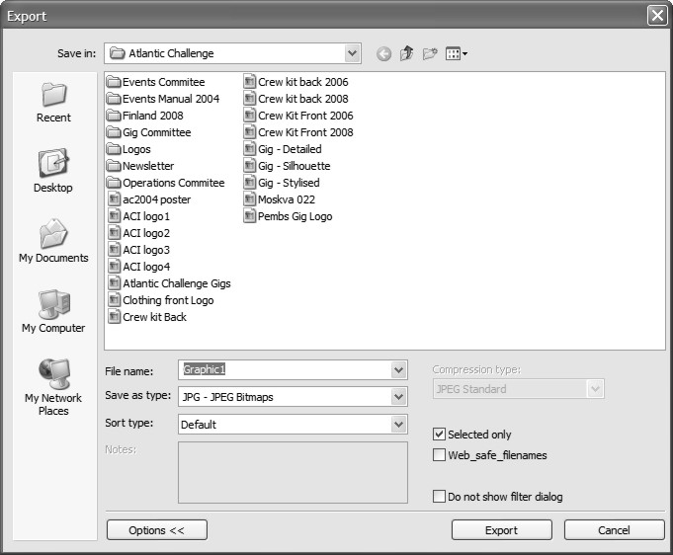
If you only have options for FILE NAME and SAVE AS TYPE then click OPTIONS to reveal the rest of the box.
Give your Image a name
and select JPG-JPEG Bitmaps from the SAVE AS TYPE menu.
Now click the box that says SELECTED ONLY. This will export what you have selected, rather than the whole page. Now click EXPORT.

A new dialogue box will appear called ‘Convert to Bitmap’
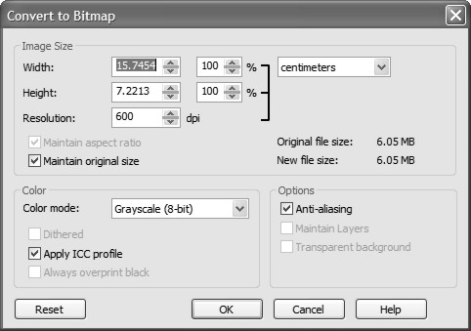
This allows you to specify the settings for your JPEG export.
Enter either 400 or 600dpi for the resolution, 400 dpi is probably ample for most things.
select maintain original size (this is very important if you are working with scale drawings)
Colour Mode gives you various options including Grayscale or if you are working in colour then select RGB colour (24-bit)
Select OK.

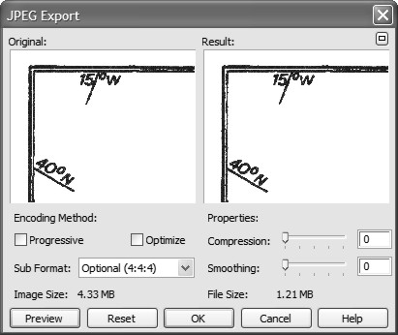
You will now see the same JPEG EXPORT box as from PhotoPAINT.
Set the SUB FORMAT to
‘Optional (4:4:4)’
and the compression and smoothing to 10.
Select OK.

The JPEG Image will now be in the file and ready to be used in your Thesis.

You can also export CorelDraw images as Pdf’s
Select
FILE→PUBLISH TO PDF
The following dialogue box will appear
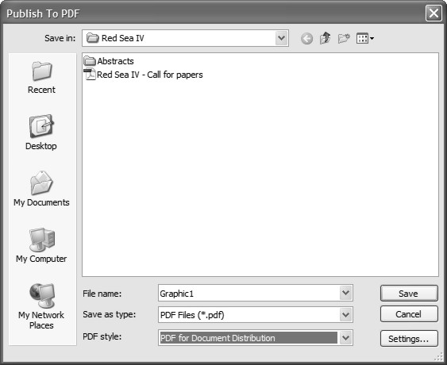
By accessing the SETTINGS button you can influence what part of the image is exported and at what resolution. The principles are the same as
for a JPEG.

There are also some preset options in the PDF style menu.

