Using EEBO for Shakespeare studies

EEBO is a database which gives you access to images of every page of every book printed in England before 1700. In addition, there is an ongoing programme to make the text of every page of every book electronically searchable. The result is an amazingly powerful research resource, so powerful indeed that it needs a bit of playing with to get the best out of it. The following exercises pose some questions you might have about Shakespeare’s A Midsummer Night’s Dream, and shows you how to use EEBO to come up with some answers.

1. Logging in to EEBO 2
2. Finding a document 3
3. Navigating around a document 6
4. Writing it up 8
5. Using title keywords 10

1. Logging in to EEBO

Go to the Learning Centre, start up internet explorer, and open http://eebo.chadwyck.com. You can get at EEBO from your home computer, but it requires setting up, and will be slow to run, because of all the images it uses; the best way to start getting at it is in the Learning Centre.

You’ll get to a front page, with a black menu on the left-hand side. Click on "search", and you will get to a page that looks like this:

There are a series of boxes into which you can enter things to look for. On the screenshot above, I’ve also circled in red the “Search: Basic” button, which is useful. If you tie yourself in a knot at any point, you can select this link and start over.

OK, you've successfully logged on to EEBO. You've completed the first exercise, and might choose now to have a play and see what you can make it do.

2. Finding a document

Let's start with a practical research question, of the sort that might arise while working on a text for an essay: what did the title-page look like in the first edition of A Midsummer Night’s Dream?

If you're not logged in to EEBO, log in to EEBO, and get to the Search Screen, as described in Exercise One. We’ll leave alone, for the moment, the box just marked “Keyword(s)”, and think about using the other boxes to answer this question.

We could look for texts that have an author called “Shakespeare” (by entering “Shakespeare” in the “author keywords” box), and the word “dream” in the title (by entering “dream” in the “title keywords” box). Try this out. I found this got me three texts, all relating to later adaptations of A Midsummer Night’s Dream by other people, and all interesting in their own right - you could certainly do an essay comparing adaptation and source. But you can’t see the 1600 edition which we know exists, because we’ve read about it in the introductions to our modern editions. So we can use the “back” button on the browser to get back to the previous page, and come up with another strategy.

We know that EEBO contains (more or less) every page of every book printed in Britain before 1700, so the 1600 Midsummer Night’s Dream must be in there somewhere. And down at the bottom there’s a box marked “limit by date”. So: erase “dream” from the “title keyword(s)” box, and search instead for works with “shakespeare” as an author printed from the year “1600” to the year “1600”.

Every time you do something like this on EEBO, you discover something interesting. There are thirteen publications which EEBO associates with Shakespeare in that year, ranging from John Bodenham’s Belvedere (a collection of memorable quotations, many taken from Shakespeare) to The True Tragedie of Richarde Duke of Yorke, a play published anonymously, but which library catalogues have often ascribed to Shakespeare because of its subject-matter. This in itself is a fascinating snapshot of Shakespeare’s reputation and profile in the year 1600. But there, at number 7 on my list, I see

7. Shakespeare, William, 1564-1616.
A midsommer nights dreame As it hath beene sundry times publickely acted, by the Right honourable, the Lord Chamberlaine his seruants. Written by William Shakespeare., Imprinted at London : [By Richard Bradock] for Thomas Fisher, and are to be soulde at his shoppe, at the signe of the White Hart, in Fleetestreete, 1600
Bib Name / Number: STC (2nd ed.) / 22302 ; Greg, I, 170(a). /
No. pages: [64] p.
Copy from: Henry E. Huntington Library and Art Gallery

When you’re working with an example like this, most of these terms are reasonably self-explanatory. First comes the main author name, and the dates of birth and death. (These, of course, have been added by library cataloguers over the centuries, and picked up by EEBO: that’s why, for instance, the anonymous True Tragedie appears on the list). The full title follows, in old spelling. And this is why we didn’t locate this record at the first attempt. You can cross-check this. Go back, take off the date limits, and look for author keyword “Shakespeare” and title “dreame”, and you’ll get this. And that search also nets you a funny-looking 1619 version which I’ll be going back to my modern printed edition to find out more about.

Back to looking at that record.

7. Shakespeare, William, 1564-1616.
A midsommer nights dreame As it hath beene sundry times publickely acted, by the Right honourable, the Lord Chamberlaine his seruants. Written by William Shakespeare., Imprinted at London : [By Richard Bradock] for Thomas Fisher, and are to be soulde at his shoppe, at the signe of the White Hart, in Fleetestreete, 1600
Bib Name / Number: STC (2nd ed.) / 22302 ; Greg, I, 170(a). /
No. pages: [64] p.
Copy from: Henry E. Huntington Library and Art Gallery

OK, well, I see the EEBO record just transcribes the title-page of the book, with that interesting information about where it was published etc. Bib Name/Number I’m not going to worry about for the moment. No. pages speaks for itself - the number of pages in the book is [64], the square brackets telling me that the cataloguer has had to count them because this book hasn’t got the modern convenience of page numbers. And Copy from doesn’t concern me, beyond noting that if I wanted to go and lay hands on the original that EEBO have photographed, I’d have to go to the Huntington Library in California. What I actually want to do is to look at the pages of this book.

To the left of the “7” at the start of this entry, you’ll see various little icons. Click on the one that depicts a camera.

Your screen should look like this:
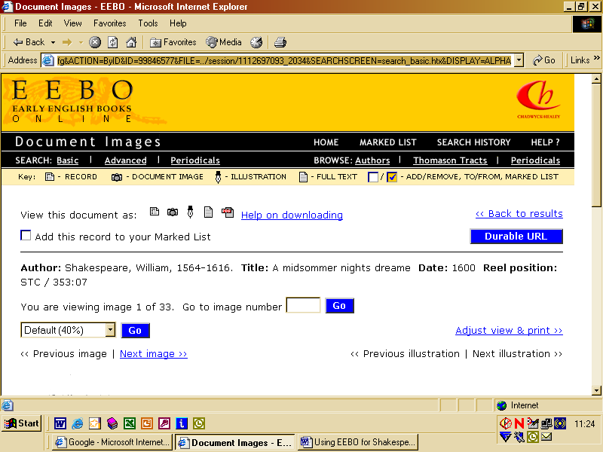

If you scroll down to the lower half of this page, you should see the title-page of the first edition of A Midsummer Night’s Dream. Is it at all different to what you'd expect from a modern title-page of the play? If you want to jump ahead into the next task, try using the “Previous image” and “Next image” links which you can see at the bottom of the screenshot above to page through the images. This concludes the second exercise.

3. Navigating around a document

This exercise will show some more ways of navigating through and working with the content. I’m curious about how the first printed version does the stage directions. In my modern edition, for instance, at 5.1.207, the stage direction reads Enter Bottom as Pyramus, Flute as Thisbe, Snout as Wall, Starveling as Moonshine, and Snug as Lion; a trumpeter before them. There’s a note saying that this is altered, by the modern editor, from how it appears in the 1600 quarto. Using EEBO, we can check this out for ourselves. First of all, we need to find the 1600 A Midsummer Night’s Dream on EEBO. You can use your knowledge from the first and second exercises to do that. You’ll get, in due course, to the page you’ve seen before:

"You are viewing image 1 of 33". Each EEBO image is, in effect, a photo of an open book, comprising two pages, so we might guess that there are around 66 pages in the quarto. One way to move through it is to hit "next image", "next image" repeatedly, but we can also cheat - we can type in "Go to image number", and guessing Act Five to be towards the end of the book, might start looking around opening 27, say, for our scene. (Try this).

This works fine, and for most of the 100,000 books on EEBO, it's the only way to navigate around them. But with around 10,000 of those books, including this one, we have another weapon in the arsenal. Look on the screen for the phrase: "View this document as:", followed by, in this case, five little icons. The fourth of these, the little sheet of paper, if you click it, brings up -

What we have here is a keyboarded version of all the text from the 1600 play. As you scroll through it, you use the "View Document Image" link at any point to bring up the corresponding picture of the page. Using this, you can scroll rapidly through the play to find the scene, and to find the stage direction in Act Five Scene One. Just to remind you - the version in the modern edition reads

reads Enter Bottom as Pyramus, Flute as Thisbe, Snout as Wall, Starveling as Moonshine, and Snug as Lion; a trumpeter before them.

What changes have the modern editors made from the stage direction as it appears here?
4. Writing it up
If you want to tell anyone what you've seen, you need to describe what you've looked at. Obviously, you can describe this book using the information at the top of the screen: William Shakespeare, A Midsommer Nights Dreame (London, 1600). But what page are you on? There are three ways of referencing this:
1) Page numbers would be the usual way, but this book hasn't got any of them.
2) A bit of a cheat would be to refer to the "image number" – thus, this double-page spread is "image number" 28 of the 33 images which make up EEBO's record of the book. This would work well assuming that the reader of your work was themselves using EEBO, but if they weren't – for instance if they were using the microfilm, or if they had a paper facsimile of this quarto – it would be a nuisance. The same goes for the "durable URL" – if you press the button marked "durable URL", EEBO generates a web address which identifies this page exactly, which is handy for you but which won't help a reader who's not got EEBO.
3) The gold standard, though, is the "signature". When early modern printers were assembling a book, they would identify each group of pages – "gathering" – by a letter of the alphabet or a symbol. Typically, the first four leaves of the main text, that is the first eight pages, might be signature "A", the next four leaves might be signature "B", and so on. This illustration, from image 5, shows a typical signature mark in this quarto:

Identify the corresponding mark four pages further on. The page with the "A" on is, by convention, called "A1r", that is, the first page of the gathering A, and the "recto" – the front side of it. The page overleaf – that is, the one that appears on the left-hand side of a double-opening – is identified as "A1v", or "verso", indicating that it's the back side of A1r. The next page is identified as "A2r", the front side of the second page in the gathering A, and so on until A4v, which is the last page of gathering A, the left-hand side of a double opening of which the right-hand side is B1r.
Signatures are more complex than this brief account indicates: they can come in sixes or eights, not necessarily fours; they can sometimes be interrupted by leaves that don't fit the pattern; and instead of the usual alphabet to identify each gathering, printers often use multiple letters (for longer books) or typographical symbols. Nonetheless, this is enough to identify the signature of the page of the book where we find the stage direction.
You might want to print out the page for future reference. You can just use your browser's "print" command, but that prints out not just the image of the page of the book, but the EEBO logo and all the other clutter you see on your screen. If you press the button marked "adjust view and print", you get better results, because you only print out the image.
The usefulness of this can be seen in the extract from an imaginary essay below, which puts together everything we've used so far:
...The amusement during the mechanicals' play, then, lies in the tension between the identities of the mechanicals themselves, and the roles that they play in Pyramus and Thisbe. Modern editions reflect this by describing them on their entry in Act 5 Scene 1 both in terms of the roles they play and in terms of their "real" identities":
Enter Bottom as Pyramus, Flute as Thisbe, Snout as Wall, Starveling as Moonshine, and Snug as Lion; a trumpeter before them.
- William Shakespeare, A Midsummer Night's Dream, ed. Stephen Orgel (Oxford, 2000), 5.1.207
But the first quarto offers a more disturbing stage direction, which treats Pyramus, Thisbe, and the rest, as if they were real:
Enter Pyramus, and Thisby, and Wall, and Mooneshine, and Lyon.
- William Shakespeare, A Midsommer Nights Dreame (London, 1600), G4v, cited from EEBO.
The first edition of A Midsummer Night's Dream insists that, during their play, the "real" identities of the mechanicals are secondary to the identities that they assume for that play...
EEBO, then, is potentially a very useful tool for writing essays.
5. Using other fields

We've explored using EEBO to do things with the text of A Midsummer Night's Dream: in this exercise we look at using another field to do things to help in writing essays about the play.

What did Renaissance authors think about dreams in general?

You could do a keyword search for "dreams". This produces every occasion when EEBO finds the word "dreams" in a text; "Your search produced 6144 hits in 1726 records", so this is clearly too much information for our purposes. We could look for "dreams", or perhaps even better for "dream*", in the "title keyword" field. That'd give us a list of all the texts EEBO has a record of in which that word is part of the title.

Do this.

That produces 220 records, perhaps rather more than we want. We could limit them by date - hit the back button, find the "Limit by date" boxes, put "1620" in the To: box, and press "Search".

That produces a rather more manageable list of 40 texts. Just scanning the titles, do we see anything in common between different items on the list? Any recurring types of dream? Are dreams seen as positive things, or as negative pieces of foolishness? Even an exercise as simple as listing the adjectives associated with "dreams" in this list of titles can be an interesting exercise: what are the different associations of "dreams" in this period? Are dreams seen as positive, or negative things in this period?

Here are some quick ways of exploring the documents to find out what there might be of use in there: number 39, William Vaughan's Approved directions for health, for instance. This is quite a long document - how does one find out if there's likely to be anything of use in there? Well, the chances are good that there's a table of contents - you can find it just after the Preface, on openings 3-5 - and it's worth checking if the volume ends with an index (this one doesn't). The Preface allows you to find this text's section on dreams. In the case of this text, because EEBO has a full-text transcription of it (as seen in Exercise 3), you could use an alternative short cut: click on the icon to bring up the full-text transcription [do this] and then use "Edit, Find" to search through the web page for every occurrence of the word "dream" [do this]. Either method will quickly bring you to pages 58-62, this book's rather short and matter-of-fact description of what causes dreams (garlic, mainly, it seems) - but also that extraordinary statement that "Dreames are either tokens of things past, or significants of things to come. And surely if a mans minde be free from cares, and he dreame in the morning, there is no doubt, but the affaires then dreamed of will truely come to passe." If I were writing an essay on dreams in A Midsummer Night's Dream, I might well want to use this quotation: to say that even the medical books of Shakespeare's day seem to talk quite routinely about dreams being prophetic. [Using the worked example from the previous exercise as a template, construct a footnote for this quotation].

