
Care with tagging: metadata for HumBox resources.
The list of tags in the HumBox browse menu has grown significantly as the project has developed. Whilst this is a reflection of the variety of resources uploaded, it is important to remember that the purpose of tagging is to help users find the resource, not to supplement or duplicate description information. Tagging is important for the longer term searching and visibility of resources, but it is wise to be selective and clear in our choices to ensure we avoid an unwieldy and confused browser list. If you browse the HumBox site by keywords/tags you will see that a number of very individual tags, along with similar terms/duplications and even typo’s are included in the list: this could put off new users of the repository. The browser page is currently being revised to offer more relevant options (including subject disciplines) that will make browsing more user-friendly if we have clear and relevant keywords.
It would be helpful to consider the following simple points when tagging new resources, and revisit your existing resources to improve the metadata:
- Focus your tagging on what is most important about the resource: themes and disciplines.
  - Avoid using more than ten tags.
  - Ukoer is set as an automatic tag and cannot be deleted.
  - At the very least, select the relevant Subject Centre tag (Oerhist, Oereng, Oerprs or Oerllas), plus discipline tags relevant to the resource from the list below, to help build a useful selection of key subjects:
History | Languages | Philosophy | English literature
Classics | Linguistics | Theology | English language
Archaeology | Area studies | Religious studies | Creative writing
 |  | Hps

- When adding tags take the time to view the predictive text that appears and select a keyword that already exists if it is suitable. Admittedly the existing options don’t appear until after you’ve typed in the whole keyword, but an extra couple of seconds could avoid unnecessary duplications and errors ... and please check spellings!
- In terms of formatting: HumBox automatically capitalises the first letter of each word and puts the rest in lower case; it is not necessary to hyphenate or underscore between words in a single tag.
- Select tags that sum up the main content of the resource: it is not necessary to set up tags for terms, dates, names, etc that already appear in either the title or description of the resource: all this metadata is picked up in free text searching.

Below is an example of how the metadata for a resource has been set up to give the user the information they need effectively and efficiently.
The description expands on the title, giving relevant detail about origin and usage.
The title clearly outlines the form and content of the resource.

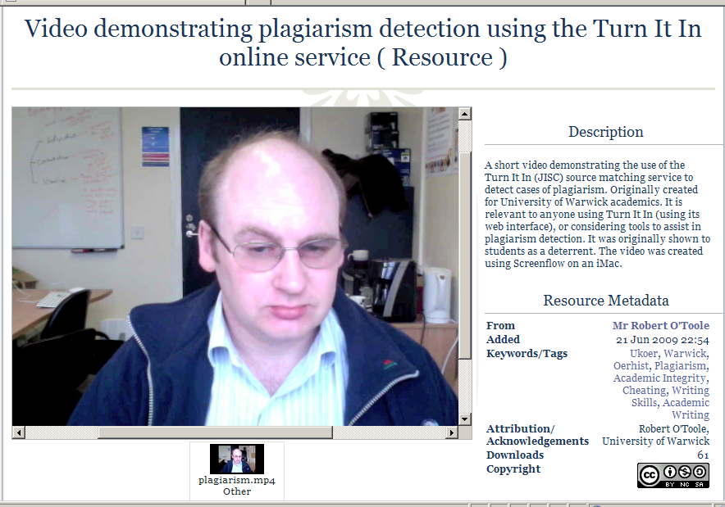

Resource metadata ... the keyword tags list the necessary project words (Ukoer and Oerhist), plus the terms that best describe the themes of the resource. Only the word ‘plagiarism’ is repeated, but this is the main emphasis of the resource and important for browsing.
The author AND institution have been cited in attribution/acknowledgements ... if relevant, you may also consider including your department

