The Spanish Regional Melting Pot: the Old Same History? (SPPO 2650)
Discussion Board: BBC programme on Spanish identity – Table 3.
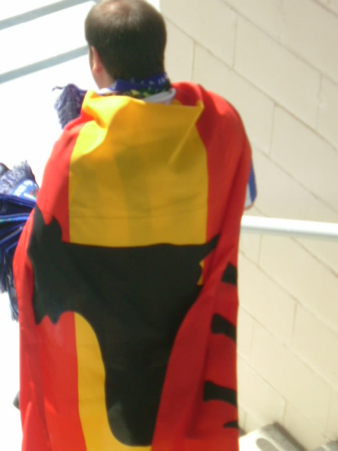
Deadline for contributions: 15 May 2012 (11.59 pm). 25% of the mark of the module for SPPO 2650. (This activity is not for SPPO 2651 students).

The BBC has decided to produce a one-hour TV documentary about national identity in Spain in the 21st Century. This documentary is part of its new series on Europe, which will be on air for 2014.

As you know, the BBC is committed to covering all the contents offered in its cultural and educational programmes in an engaging and accessible way whilst following the best academic advice and presenting the different viewpoints in a balanced and impartial way. That is the reason why the Producer of the series has commissioned a report to a group of leading experts in Spain (the students of this module) who will have to outline some key aspects of the programme.

The Producer of this BBC programme has asked you to look at the following questions in particular:

- Possible title of the programme, which has to be sufficiently representative of the content of the programme yet attractive. Provide an explanation for your decision.

- Who would you interview for the programme (experts, politicians, members of the public, representatives of organisations) and why?

- As it is a documentary in which the presenter walks around in different open and indoor spaces, what places in Spain would you choose for the recordings? Explain why.

- You will also have to produce a 150-words text which will serve as an introduction to the programme. The text must represent accurately the tone, approach and content that you think the programme should have.

Your response will have to comply with the following requirements:

-It has to be the result of the work and the negotiation between the different members of your group.

-All the discussions between members of the group must be carried out online, using the discussion board set up by the tutor in our Blackboard Virtual Learning Environment.

-The programme has to take an impartial, plural and objective perspective.

-The programme must represent the sociological and political reality of contemporary Spain in an non-romanticised way.

Assessment

Every team will receive a general mark for the quality of the proposal (Mark 1).

There will be also an individual mark related to the intensity and quality of the contributions of each individual. (Mark 2).

The final mark for each student in this activity will be the average mark between Mark 1 and Mark 2.

Assessment Criteria for Discussion Board Contributions

Content: critical understanding of the linguistic/socio-national reality of Spain, including reference to any relevant sources such as academic sources, news items or statistics.

Interaction: the extent to which you engage with other colleagues’ comments in order to agree, disagree or qualify those comments.

Form: concision and clarity of expression. Appropriate referencing.

Picture and activity by Antonio Martínez-Arboleda. 2009-2012

