‘Illustrating your PhD – working with images’

A picture paints a thousand words, except when it is badly conceived and reproduced, in which case you will have to waste a load extra words in explaining the image to the reader or listener. Maps, diagrams, photographs, etc. can all play an important part in explaining or underpinning the arguments running through your thesis. Well produced images can create an impression of professionalism running through the document. Badly produced images can do the opposite. It is worth spending a small amount of time on each one to ensure that it is as good as it can be. Although this may create extra work in the short term, it will probably be worth it in the long run.

The advent and availability of digital technology means that it is now a simple matter to store and reproduce images many times over, without losing any quality. The same images that appear on the pages of your thesis can be easily inserted into papers given at conferences or published in journals. This helps to create a consistent set of images which people will associate with you and your work, a bit like your own personal brand.

Software
In order to acquire/create and process images you will need the appropriate form of software. For manipulation of scanned images, photo-editing software is required. These are usually called names such as Photopaint or Photoshop, a basic piece of software exists in Windows XP called Microsoft Photo Editor. To create you own images you will need some sort of graphic design software. Again, there is a basic version in Windows XP called Paint. Although the Windows XP programs are OK for very basic work, they are limited in power. The university subscribes to a licence agreement from a company called Corel, who produce a graphics suite with both photo editing and graphic design software included. Corel software can be downloaded from ISS at https://www.software.soton.ac.uk/

The latest version available for PC is CorelDRAW Graphics Suite X3. ISS do not currently offer Corel software for Apple Macs or Vista users. You will need to download the application to your computer and then burn it to a CD before installation. Full instructions and access codes are on the ISS link above.
Generally speaking, most graphics software operates along similar lines, so if you become familiar with CorelDRAW, you will probably be able to use similar applications such as Adobe Illustrator or Adobe Photoshop.

Scanning an Image
Most scanners come with their own software, which will be installed when the scanner is first connected to the computer. In some cases you can just place your image on the scanner and press the ‘Scan’ button on the front. Alternatively you can scan the image via the photo editing software.
In Corel Photopaint X3:
If opening from new, simply select ‘Acquire Image’ from the intro menu, otherwise
FILE→ACQUIRE IMAGE→SELECT SOURCE
Select the scanner that you wish to use from the list (only the ones installed on the computer will be shown) click OK.
Then
FILE→ACQUIRE IMAGE→ACQUIRE
This will take you to the scanner dialogue window where you will need to select the settings used to scan your image. The settings chosen here can have a big impact on the end quality of your image. There are two main settings which you need to be concerned with;
- Colour Mode. This simply tells the scanner whether or not to scan in Colour, Grayscale or Black & White. You will usually want to select Colour or Grayscale. Black & White produces two-tone images which are not usually very useful. If the image to be scanned is not a colour image then select Grayscale.
- Resolution. This sets the dpi (dots per inch) of the image. The higher the dpi, the higher the reproductive quality of the image and the more memory it will require. Choosing the right dpi is a balancing act between these two factors. Most publishers require images to be of 600dpi quality, so although a scanner might offer 1200dpi there is little point in using this setting. In reality a setting of 400dpi is fine for most images.
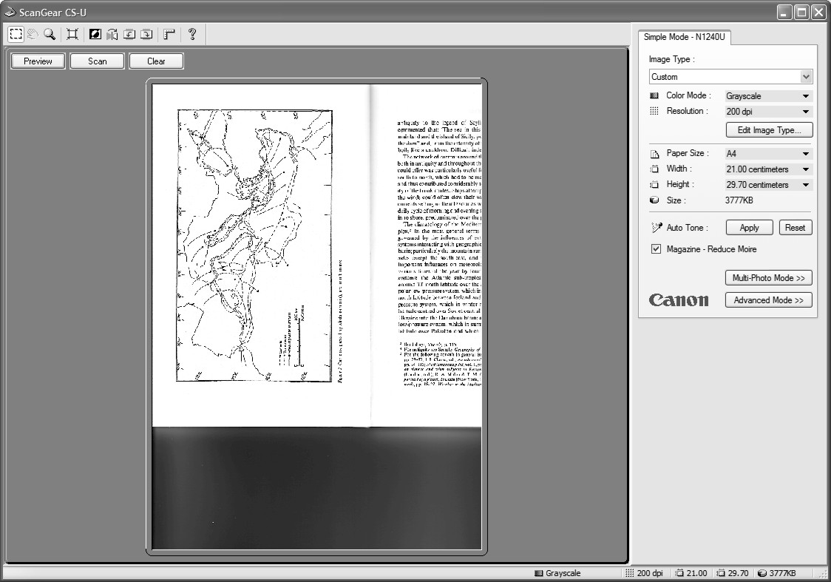
Example of a scanner dialogue box, note the colour mode and resolution setting menus.
Most scanners will offer a PREVIEW of the image. Select this now.

The scanner will now produce a preview of the whole sheet of paper which it can see. You can choose to select a smaller area, usually be clicking and dragging a window with the left mouse button. Once you have selected the area you wish to scan, or if you are happy with the whole image (the image can be cropped down later) select SCAN.
The scanned image will now appear as a window in Corel Photopaint.

Now go to the section on Saving the image (Below) before you change anything.

Tidying up the Image
In some cases the image may have scanned perfectly. It may aligned correctly and there may be no imperfections. However, quite often there will be problems with the image including;
- The inclusion of unwanted areas of the scanned page.
- Alignment or orientation being wrong.
- Smudging or patches on the image.
- Writing showing through from the page behind
All of these can be simply corrected in Corel Photopaint.
Like many programs, Photopaint uses a magnifying glass button (located on the left-hand toolbar) to take you to a viewing control panel which enables you to view all, or part of your document/image. The same options can be found in the VIEW menu located along the top of the screen.

Cropping
It is quite common for the scanned image to produce unwanted areas of the original. These can be removed by cropping them.
From the left hand toolbar, select the 2nd button down (Mask Tool).
Click and hold the left mouse button to drag a box around the area of the image which you would like to use.
The selected area will remain white, while the area outside the selection (Mask) will go Pink.
If you get it wrong just press CTRL + R to remove the mask.

Now select
IMAGE→CROP→CROP TO MASK
This will crop the image to the limits of the selection you have made. There are other shapes and sizes of Masks which you can also experiment with.

Alignment & Orientation
Your scanned image may not be correctly orientated, for example you may have had to put a book on its side to get it in the scanner. Or the image was held at a wonky angle. If this has happened the image will need to be rotated until it is the right way up.

To rotate the image 90° clockwise select
IMAGE→ROTATE→90° CLOCKWISE
This menu also allows you to rotate the image 180° if you have scanned upside down, or 90° anticlockwise.

If the image is still not straight you may have to use smaller increments
IMAGE→ROTATE→ROTATE CUSTOM
This opens a dialogue box which allows you to make fine adjustments until you are happy that the image is straight/level/how you like it.
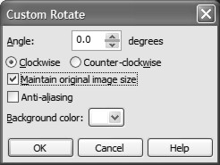
This box allows you to choose the amount of rotation and also the direction. The default background colour is white. It is a good idea when doing custom rotations to select ‘maintain original image size’, especially if you are working with scale drawings.

Cleaning up the image
Scanned images may often have small imperfections which occur as part of the scanning process. The most common of these is for text from the reverse of the page which you have scanned to be showing through in the background. This can be easily removed. Select
ADJUST→TONE CURVE

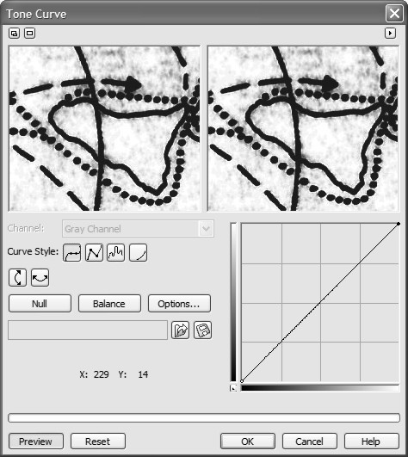
This brings up a dialogue box which allows you to alter the tone of the image.
Move the top-right end of the line ro alter the white levels.
Move the bottom-left end of the line to alter the black levels.
The current image is shown in the left-hand box and a preview of the altered image in the right-hand box.
You may have to change the tone curve more than once to reach the optimum setting.

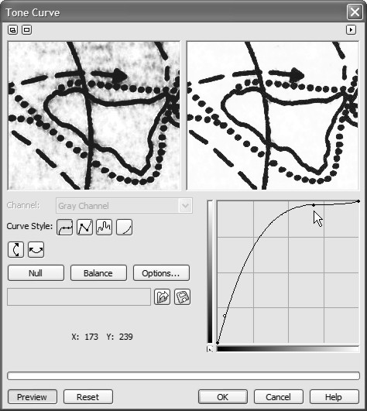
Altering the curve in this way will remove much of the background smudging and noise.

You may need to move both ends of the curve in a single go to get the best result. It will be different for each scan that you make.

If you don’t like the results, press RESET or simply cancel and start again.

Removing Items
There may also be areas of the Image which you wish to remove or alter within the overall limits of your crop; pencil marks, annotation, scales, etc.
Select the EYEDROPPER tool (5th down on the left-hand toolbar).
Move the cursor over the image and you will notice it change to an eyedropper pippet, this is accompanied by a square to show you the colour you are over, and a pair of numbers.
The EYEDROPPER allows you to select the background colour and then use it to paint over unwanted areas with that colour.
To select a pure white colour the numbers should say ‘255’ above ‘100’.
Left click.
This is also a good way of checking if you did the TONE CURVE operation correctly. If the background is not pure white with these numbers it may show up as speckles when you print, which does not look good.

Now select the PAINT TOOL (11th button down).
This allows you to add the colour you just selected with the EYEDROPPER to your image.
The cursor will have changed to a paintbrush nib.
The characteristics of this can be changed in a toolbar which will have appear just above your image on the screen (see below).
This allows you to select different sizes and shapes of paint brushes for the job.

Click and hold down the LEFT button and drag the cursor around the screen.
As you paint, your selected colour should cover what is already on the Image.

Try removing the scale from the map.

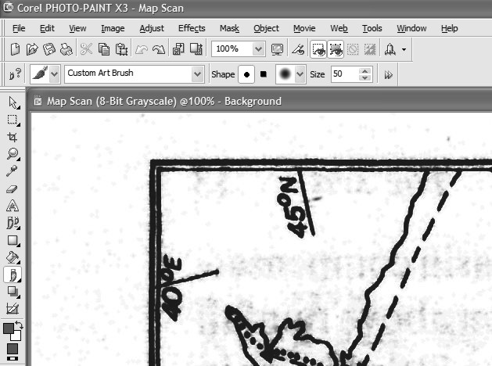

The pre-scanned image of the Mediterranean should now look like this;
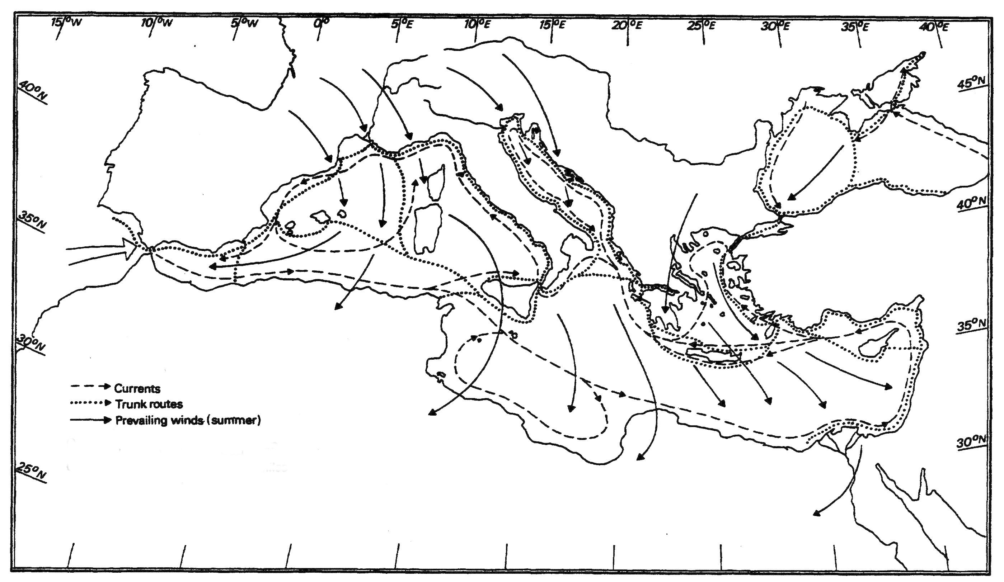

Saving and Storage
Which format for saving
Now you have tidied up the image to the point where it can be used it must be saved. There are a variety of formats which can be used and different people prefer different formats. The most widely used format is called a JPEG and is recognised by nearly all programs.
FILE→SAVE AS
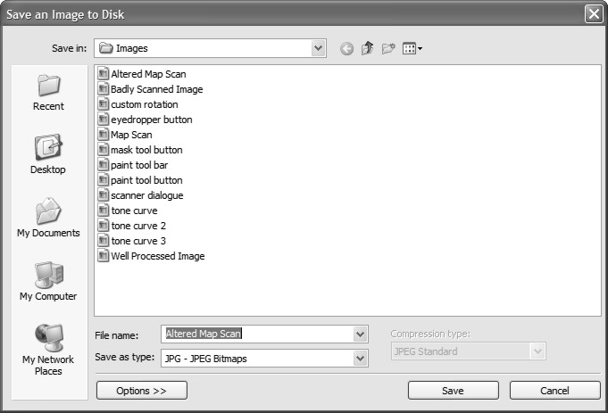
This brings up the Save As Dialogue box which works in the same way as in programs such as word or excel. Select where you want your file to be stored and enter a file name. From the drop down menu next to ‘Save as type:’ select ;JPG - JPEG Bitmaps’ from the list.
The program may inform you that ‘Masks will not be saved in this format’
Click OK.
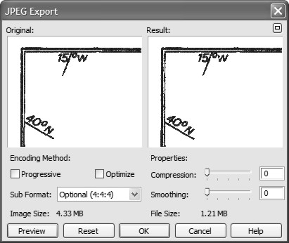
You will now reach the JPEG export box. This controls the settings which make your image into a JPEG.
In the drop down menu next to ‘sub format’ select ‘Optional (4:4:4)’, this maintains the best quality.

Check the end product by pressing PREVIEW and comparing the two images in the left and right window.

This will also tell you what the eventual file size will be.

You can reduce the file size further by increasing the level of compression.
Try changing it to 10 and then press PREVIEW to see the difference.

Remember that increasing the compression, reduces the image quality, try not to go much beyond 20 if you can.

You can also smooth the image here if the lines are a little jagged.

Click OK

Storage
Be sure to back up your work. Recreating a series of images can be hugely time consuming and in some cases may be impossible. It is well worth investing in a memory stick or portable hard-drive and getting into the habit of backing up your whole PhD at the end of the day or week. Memory is so cheap to buy that it should not be a problem having to store large numbers of high quality images. Although CD’s may seem like a cheaper option, they are not always guaranteed to retain data over a long period of time (several years). It is better to spend the extra effort creating and storing high resolution images now and avoid having to deal with low quality images in the future.
Copyright
Copyright © is the automatic right that arises when an individual creates a piece of work, the work can be literary, artistic, dramatic, musical, typographical, a sound recording or a film. The individual or collective who authored the work will exclusively own it, unless it was produced under employment, in which case the employer retains copyright.

Under UK copyright law, it is an offence to perform any of the following acts without the consent of the owner:

- Copy the work.
- Rent, lend or issue copies of the work to the public.
- Perform, broadcast or show the work in public.
- Adapt the work.

The author of a work, or a director of a film may also have certain moral rights:
- The right to be identified as the author.
- Right to object to derogatory treatment.

Copyright exceptions and academic work
There are exceptions to these basic restrictions and this is known as ‘Fair Dealing’. Fair dealing is a term used to describe acts which are permitted to a certain degree without infringing the work, these acts are:
- Private and research study purposes.
- Performance, copies or lending for educational purposes.
- Criticism and news reporting.
- Incidental inclusion.
- Copies and lending by librarians.
- Acts for the purposes of royal commissions, statutory enquiries, judicial proceedings and parliamentary purposes.
- Recording of broadcasts for the purposes of listening to or viewing at a more convenient time, this is known as time shifting.
- Producing a back up copy for personal use of a computer program.
- Playing sound recording for a non profit making organisation, club or society.
- (Profit making organisations and individuals should obtain a license from the Performing Rights Society.)

The first of these exceptions means that copyrighted work can be reproduced for the purpose of academic research and study. In all cases there is a proviso that;
- The use is deemed acceptable under the terms of fair dealing.
- That the quoted material is justified, and no more than is necessary is included.
- That the source of the quoted material is mentioned, along with the name of the author.

So if you use a diagram or quote from another piece of academic work it is fine, as long as you acknowledge the source and the author. It must be referenced like everything else. If you are using somebody else work in a fully published article or book it is better to get their permission to do so. You don’t have to, but it is polite!

It is also normal practice in academic work to acknowledge where certain elements of an image may have originated. So if you redraw a map or diagram rather than simply reproducing it you should acknowledge this. Although it may look different, the origin of the information contained in the image is with another person. This is usually done by writing ‘after’ in front of the reference, so a figure caption might read;
Figure One. Map showing the location of Quseir al-Qadim (after Blue 2007: Fig 1).

Copyright Duration
Copyright does not last for ever. In most countries the copyright will expire after a certain amount of time and the work will pass into the public domain. This is usually timed from the death of the author. So in the UK copyright lasts for 70 years after the death of the author. This means that you can reproduce, without restriction the work of someone who had died prior to Jan 1st 1938. However, the reality of academic work dictates that all sources have to be referenced, so you would still have to acknowledge the author and source. The expiration of copyright does explain why very old versions of images, such as iconography from the classical world are popular, because they are free from copyright. It is not possible to claim copyright of a work, by publishing it, once it has passed into the public domain. It is now freely available for everyone to use.

Different countries, different laws
Copyright law is not the same in every country. But it has been established that the law which applies is the one for the country where the breach of copyright occurs. So if a piece of work created in the USA is illegally reproduced in the UK, it is UK rather than US copyright law which is applied. An international agreement covering copyright law has been established, known as the Berne Convention.

A series of fact sheets covering everything to do with UK copyright law can be found at
http://www.copyrightservice.co.uk/copyright/p01_uk_copyright_law

‘Do’s & Don’ts’
- Don’t try to fit everything on a single image, a crowded image can become impossible to understand, even worse it may be misunderstood.
- Make sure you keep text to a size where it can still be understood. Don’t make it so small it cannot be read, or so large that is dominates the image and detracts from everything else.
- Although some fonts may look very exotic or interesting, they can be hard to read for some people. It is often better to stick to the tried and tested such as Times New Roman or Arial.
- Remember that images are often reproduced at a smaller scale, bear this in mind when labelling diagrams or selecting the initial font sizes.
- If you do create scale drawings, use a ruler scale, rather than just writing 1:10 etc. If the drawing is enlarged or reduced a written scale becomes useless. A ruled scaled will always stay in proportion.
- The use of colour can greatly improve an image, but remember that you will to print it in colour for it to be effective.
- Not all people have programs such as CorelDraw, if you need to send someone a diagram then ensure that it is a JPEG or a PDF.
- Don’t forget the caption. This is the explanation that is likely to become associated with your image so make sure that it says everything it needs to.

