Hewing the Rough Stone: Masonic Influence
in Peter the Great’s Russia, 1689-1725

In the 1770s and 1780s Freemasonry in Russia flourished in a variety of guises. Despite the significant differences between allegiances they shared a common symbolic language. As Douglas Smith has noted, in his study on Freemasonry and society in eighteenth-century Russia, the general metaphorical aim of Russian Freemasons was ‘to reshape the rough stone so that its original surfaces became unrecognizable: no longer covered with unhewn and jagged surfaces, it was to be “scoured, planed…and smoothed out”’. In other words, the symbolic language of the Masonic craft was adopted to express the goal of transforming the rough and base character of an uninitiated individual into a refined, virtuous and morally upright Freemason.
Thus, in light of the emphasis placed on “working the rough stone” among Russian Freemasons in the latter half of the eighteenth-century, it is extremely intriguing to study the personal seal adopted by Peter the Great (1672-1725) from at least as early as January 1714.
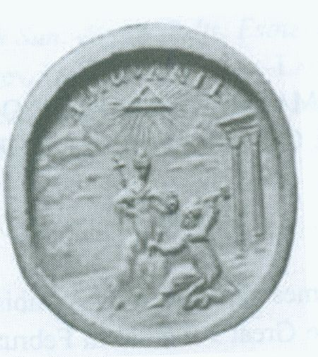
Fig. 1: Personal Seal of Peter the Great, dating from 1711-1712. Source: Sapunov & Ukhanova, p.29. An original copy of the seal can be found in the State Hermitage Museum, St. Petersburg.

The central motif of the seal shows a mason-king hewing a feminine, regal figure, replete with orb and sceptre, from a rough stone. This image draws on the Pygmalion myth, as narrated by Ovid in the tenth book of Metamorphoses, in which the Cypriot king carves a beautiful ivory statue. Enamoured with his own creation, Pygmalion asks the gods to animate his ‘ivory maiden’, which they agree to do. Peter the Great was well aware of the Pygmalion story, as recited by Ovid. In Symbola et Emblemata, commissioned in 1705 by the Russian monarch, for example, one finds an emblematic depiction of the myth.
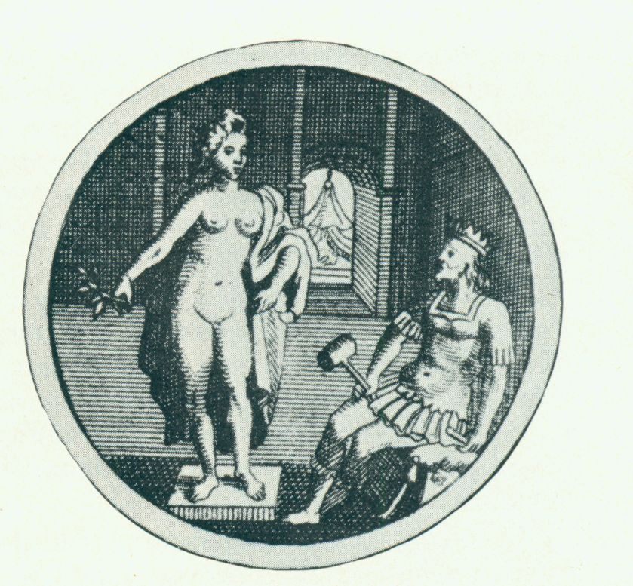
Fig. 2: An Image of Pygmalion and Galatea from Symbola et Emblemata (Amsterdam, 1705), No. 750, p.251.

The Masonic symbolism contained in this ancient myth was not lost on the nineteenth-century American Masonic scholar J.D. Buck, who in 1869 wrote:

These great truths…are like a Divine Image concealed in a block of stone (the rough ashlar), which many artisans assail with mallet and chisel…perchance, to release a distorted idol. Only the Perfect Master can so chip away the stone as to reveal in all its grandeur and beauty the Divine Ideal, and endow it with the breath of life. Such is the building of character. The fable of Pygmalion and Galatea is, after all, more real than history.

I would argue that the so-called “Divine Ideal” being hewn in Peter the Great’s seal is Russia, with the monarch portraying himself as a mason-king capable of transforming the country from its previous crude and base condition. Indeed, the sermon delivered by Feofan Prokopovich at Peter the Great’s funeral in 1725 exalted the monarch as a skilled mason-sculptor: ‘All of Russia is your statue, from you it is recast…and in your emblem it is not falsely portrayed’.
Other motifs clearly visible in the seal also add to its Masonic character. The two columns standing to the right of the mason-king, for example, strike one as being evocative of the pillars of Jachin and Boaz that stood at the entrance to the Temple of Solomon. According to the Bible (I Kings 7:21), Hiram of Tyre cast these pillars, and it is said that Israelite rulers of the House of David were crowned at their base. These Solomonic pillars play a pivotal role in Masonic tradition. Moreover, I would argue that their presence in Peter the Great’s seal suggests that the Russian monarch consciously perceived himself as a worthy heir to the House of David in his attempt to establish a New Jerusalem in Russia.
It is important to bear in mind that Peter the Great’s embrace of Masonic-style symbolism arose at a time when St. Petersburg had become the new Russian capital and was emerging as one of the great European cities. Thus, not only was the city awash with stonemasons applying their craft, but its rise from the boggy landscape on the banks of the River Neva also fuelled Peter’s perception of himself as a divinely ordained monarch.
Further Masonic-style imagery can be seen in the upper section of the seal, where one can see a radiant all-seeing eye that also contains the Tetragrammaton, or Hebrew name of God. Significantly, it has been noted that this striking combination was first utilised in Russia in the prints for Peter the Great’s seal. In other words, Peter the Great was not simply drawing on a pre-existing baroque tradition present in Russia, but was consciously forging a new visual symbolic language. The divinely sanctioned nature of Peter the Great’s “masonic” mission is stressed by the Latin word “Adiuvante” that adorns the uppermost section of the seal. In combination with the Tetragrammaton, this word signifies that the task of working the rough stone will be carried out “with God’s help”.
A somewhat inverted version of the image on Peter the Great’s seal was also frequently used after the victorious conclusion of the Great Northern War in 1721, when the monarch assumed the title of Emperor and Father of the Fatherland. In a circular relief produced to commemorate the Russian victory, for example, one can see a mason hewing a male monarch from rough stone. In addition, it is once again possible to note a distinctive arch, a radiant all-seeing eye and the Latin word “adiuvante”, as well as a ship. Crucially, one can also view a depiction of the angel of victory reaching up to crown the monarch as emperor, symbolising that Peter the Great had finally been carved into his perfected form as the ruler of Russia.
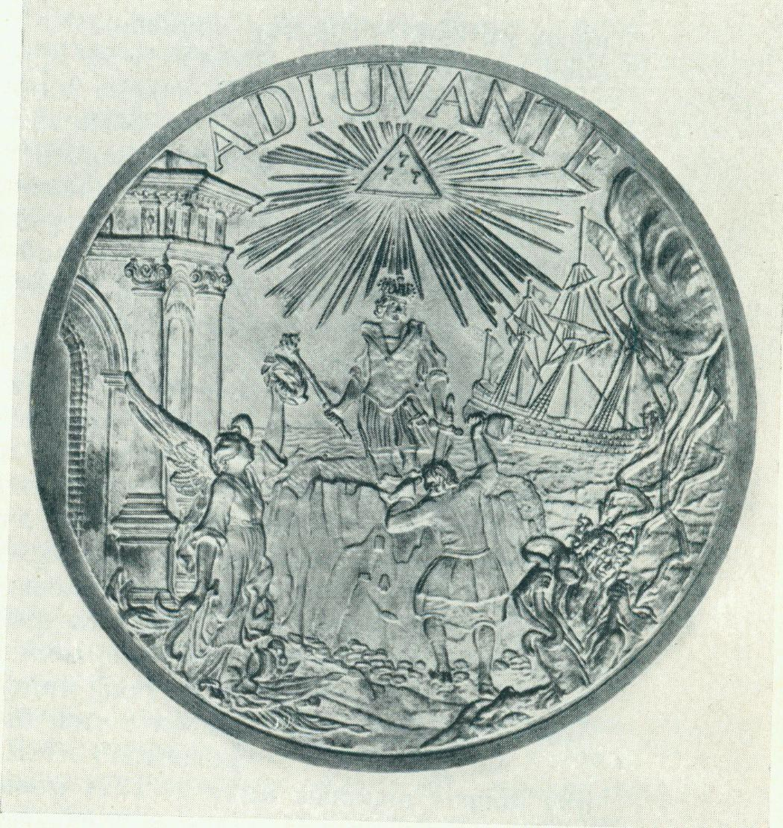

Fig. 3: A Circular Relief by B.C. Rastrelli and A.K. Nartov (?), dating from between 1723-1729. Source: Sapunov & Ukhanova, p.34. An original can be found in the State Hermitage Museum in St. Petersburg.

Moreover, it is also extremely significant that the Tetragrammaton has been replaced within the radiant sun by three 7’s. In official celebrations held to mark the Nystad peace treaty much was made of the fact that the Great Northern War lasted for twenty-one years and was divided into three significant periods. On New Year’s Day 1722, for example, Feofilakt Lopatinskii stressed in an official speech that God favoured odd numbers when orchestrating earthly affairs. Four weeks later Prokopovich made reference to the prophetic calculations of Ezekiel, Daniel and John in regard to the length and division of the war and contemplated the significance of the number of the trinity.
Given the subject matter of the central motif in the circular relief it is worth noting that the numbers three and seven hold special significance in Masonic symbolism. In Albert Mackay’s Encyclopedia of Freemasonry, for example, the author describes that ‘in Freemasonry the tenary is the most sacred of all the mystical numbers’, citing the three degrees of the craft, as well as the fact that there are three principal officers in a lodge. Mackay also notes that ‘seven is a sacred number in Masonic symbolism’ and that ‘in the earliest instructions of the eighteenth century it was said that a lodge required seven to make it perfect’. In addition, the author refers to the mystical significance of the number seven in relation to the seven liberal arts, the seven steps of the winding stairs, the seven days of the week, the ancient belief in the seven planets and the seven notes of the musical scale.
Thus, I would argue that Peter the Great’s personal seal, as well as the various prints, reliefs and busts that subsequently adopted a similar theme, provide visual evidence of an outlook seemingly in accord with Masonic symbolism. Indeed, Peter the Great’s utilisation of Masonic-style symbolism in the 1710s and 1720s occurred precisely at a time when Freemasonry began to flourish in Britain and set down foundations in Continental Europe. Hence, it begs the question of whether Peter the Great was consciously aware of the Masonic symbolism inherent in his personal seal.
Since the nineteenth-century a host of Russian and Western scholars have addressed the question of whether Peter the Great himself was actually a Freemason, yet have overlooked the powerful visual symbolism present in many prints and designs commissioned by the Russian monarch. What is more, little attention has been paid to the similarities between the common reformative goals of Freemasonry and Peter the Great’s efforts to bring about cultural, religious, philosophical, social and political transformation in Russia.
Instead, scholars have been drawn to two particular legends attesting that Peter the Great was initiated into the Craft during his travels to Western Europe. According to one legend, Christopher Wren initiated Peter the Great into Freemasonry in 1698, that is, during the Russian monarch’s three-month residence in London. The other principal legend recounts how Peter the Great brought back a Masonic statute to found a lodge on the island of Kronstadt, in the Gulf of Finland, after his second Grand Embassy in 1717. In support of these legends it is customary to point to the fact that Russian Freemasons in the last quarter of the eighteenth-century were known to sing G.R. Derzhavin’s ‘Song to Peter the Great’ and to revere his name in lodges.
Whilst these legends are undoubtedly seductive, I would argue that they have actually deflected attention from more persuasive evidence suggesting Masonic influence at the Petrine court. Indeed, in 1998 Lindsey Hughes — the outstanding scholar of Petrine Russia — wrote that the study of Freemasonry and fraternalism in the reign of Peter the Great ‘requires further investigation’ as ‘evidently there existed a number of overlapping groupings and activities’ which she argued may have influenced the Russian monarch.
In support of this sentiment it is worth considering how Peter the Great’s attempts to radically recast his subjects, to borrow Prokopovich’s apt phrase, along Western European lines was in harmony with the broad goals of eighteenth-century Freemasonry. In simple terms these goals stressed civic responsibility, politeness, virtue, loyalty to the crown, Christian values and education. Peter the Great’s radical programme of reforms embraced precisely such goals, including the establishment and active promotion of new associative public forms. Douglas Smith has stressed the crucial role played by Freemasonry in Russia in the second half of the eighteenth-century, in terms of developing a “public sphere” parallel to the rise of an absolutist state. Drawing on the pioneering work of Jürgen Habermas and on the research of Margaret Jacob, Smith has powerfully demonstrated the role of new associative forms (salons, coffeehouses, learned societies, fraternal clubs etc.), alongside the growth of a print culture, in forging Russia’s public sphere and civil society.
Whilst new associative forms, including Freemasonry, did flourish in Russia in the second half of the eighteenth-century, their enthusiastic progenitor was Peter the Great. The absolute monarch was the driving force, for example, behind the creation of Russia’s first newspaper (Vedomosti) in December 1702, as well as the dramatic expansion in the output of the country’s printing presses. During his reign he also commissioned the publication of an etiquette manual, The Honourable Mirror of Youth (Iunosti chestnoe zertsalo) (1717). This manual prescribed a list of sixty-two rules that young children should follow, including how to behave at weddings and dances. The tsar also sought to actively encourage his servitors to adopt new forms of social interaction. Most noticeably, he issued an Act of Assembles on 26th November 1718, which outlined the establishment of French-style salon-assemblies. The decree stipulated that any decently dressed person was free to attend an assembly at the residence of a private individual, where they were positively encouraged to dance, smoke, play cards and chess and listen to instrumental music; all forms of entertainment previously viewed by conservatives as “devilish”.
Alongside attending these new assemblies, the public were also encouraged to visit the St. Petersburg Kunstkamera- Russia’s first museum. Indeed, at the official opening in 1719, visitors in decent attire were permitted to enter without cost and were tempted by offers of complimentary coffee, wine and vodka. These public initiatives went hand-in-hand with sweeping educational reforms, which included the foundation of various pedagogical institutions and the Academy of Sciences in 1724. Furthermore, Peter the Great promoted the ideal of meritocratic service to the state, when he introduced a Table of Ranks in 1722, which consisted in fourteen hierarchical grades for both military and civil positions. As Marc Raeff has stated, ‘Masonry offered a parallel or equivalent to the Table of Ranks in public service’.
Furthermore, in addition to these general features, which I would argue were in broad harmony with the ideals of Freemasonry, I will now examine a number of factors that I believe reinforce the case that Peter the Great would have been well aware of the Masonic symbolism inherent in his personal seal. Firstly, I will outline Peter the Great’s enthusiastic sponsorship of various fraternal societies and assemblies in Russia from the early 1690s until his death in 1725. Crucially, these secretive and/or exclusive bodies were open to — indeed thrived because of — participants from Western Europe, particularly from Britain.
Secondly, I will argue that direct Masonic influence was brought to the Petrine court by way of a Jacobite network centred around the pivotal figure of Dr. Robert Erskine (1677-1718), Peter the Great’s chief physician, as well as being a privy councillor and the first director of the St. Petersburg Kunstkamera. Evidence suggests that key members of this Jacobite network in Russia were Masons, who were not only able to operate in St. Petersburg but were also able to draw in a senior servitor (and relative of) Peter the Great into their brotherhood.

(1) Fraternalism in Petrine Russia

In the early 1690s Peter the Great instigated the establishment of the so-called All-Mad, All-Jesting, All Drunken Assembly (sumasbrodneishii, vseshuteishii, vsep’ianeishii sobor). This notorious institution constituted a mock church hierarchy and a mock-court led by an appointed ‘prince-pope’ (kniaz-papa) and ‘prince-caesar’ (kniaz-tsesar) respectively. Both bodies functioned according to a strict hierarchical structure, with appointed metropolitans, sacristans, deacons, sub-deacons, a dean, secretaries and lighters. Peter the Great assumed the relatively lowly rank of ‘Protodeacon’ in the assembly.
The assembly also enlisted various entertainers, including twelve ‘thundering stammerers’ (groznykh zaik), bird-like singers, Russian minstrels (known as skomorokhi), jesters and fools (duraki). One such durak was a mad Frenchman, that Peter the Great had acquired from the king of Poland, who was known as Vymenka, or officially as Cardinal and Prince Vymeni, King of the Samoyeds.
Females were also permitted to take part in the mock assembly, the most prominent of whom was Daria Gavrilovna Rzhevskaia (the wife of Ivan Rzhevskii), who in 1712 was granted the title of ‘princess-abbess’ (kniaz’-igumen’ia). In 1717 she was promoted to the rank of ‘arch-abbess’ (arkhi-igumeniia), and was lauded by the new prince-pope, Peter Buturlin, for her drinking ‘exploits’ before the assembly. Besides the arch-abbess, the assembly also contained Mother Superiors (igumen’i), deaconesses (diakonisy), nuns (monakhini) and ‘servants of Bacchus’ (sluzhitelei Bakhusa).
In addition to a strict mock-hierarchy, the assembly also displayed a number of other distinctive features. It embraced crude and blasphemous language, for example, which still retains the power to shock those of a more sensitive disposition. All members of the assembly were given nicknames, which more often than not contained the Russian word “khui”, which translates as penis. Thus, Peter the Great’s nickname was Pakhom-Pikhakhui, whilst Archdeacon Stroev was known as Idinakhui- a phrase still used in Russia today to crudely inform someone to go away.
The assembly was also awash with Bacchanalian symbolism. Drunkenness and dissipation were championed in the guises of Ivashka Khmel’nitskii and Eremka respectively. Moreover, the Roman god Bacchus played a central role in the rituals and ceremonies of the assembly. For example, at the so-called conclave to elect a new prince-pope on December 28th 1717 the assembled members began by striking up a song to Bacchus, before then beseeching the god to help them in the task ahead. Further exclamations pronounced the attendees to be ‘the uttermost devotees and first sons of our father Bacchus’.
In general, despite the abundance of parody and mockery unleashed in the assembly, it was a hierarchical body marked by defined rituals, ceremonies and regulations that sought to direct the behaviour of members. Interestingly, the assembly also functioned in both the private and public spheres. All meetings of the assembly, for example, were concealed from the gaze of the public. However, on festive occasions, such as weddings, Christmas and Shrovetide, the members of the assembly took to the streets of Moscow and St. Petersburg in grand, carnivalesque processions that openly mocked the church and old Muscovite traditions.
What factors contributed to the birth of the All-Mad, All-Jesting, All-Drunken Assembly in the 1690s? It seems probable that Peter the Great’s rise to power in 1689, in place of his half-sister, the regent Sophia, was of critical importance, along with witnessing the election of Patriarch Adrian in 1690. However, it is also likely that the young tsar’s frequent visits to the foreign quarter (nemetskaia sloboda), in Moscow- particularly to the residences of Patrick Gordon (1635-1699) and Franz Lefort (1656-1699)- introduced him to new forms of fraternal bonding and drunken revelry. This is easy to imagine if one bears in mind the fact that locals referred to the area in the late seventeenth-century as the “drunken quarter” (p’ianaia sloboda).
It is impossible to ascertain the precise degree of foreign influence on the foundation of the mock assembly in the early 1690s. However, it is fascinating to note that a parallel fraternal organisation run by foreign residents in Russia — predominantly from Britain — was in existence from at least as early as the first decade of the eighteenth-century. In January 1706, Charles Whitworth, the British Representative in Moscow, wrote of the activities of a ‘Brotherhood…as true as pleasant’, where ‘a great glass of wine sanctified the occasion’.
In all likelihood this “Brotherhood” referred to the so-called Bung College, or British Monastery. It is not known precisely when the Bung College was established, but the first firm evidence of its existence dates from August 10th 1709. It was on this date that a warrant was issued in Kiev, which informed the British Metropolitan in Moscow that a certain William Lloyd had been promoted from the rank of deacon to archdeacon. The warrant was signed by Protodeacon Piter and Archdeacon Gedeon Shakovskii; in other words Lloyd’s promotion had been authorised by Peter the Great himself, along with Prince Iurii Fyedorovich Shakovskoi, a fellow member of the mock assembly. This indicates that the Bung College was subordinate to the All-Mad, All-Jesting, All-Drunken Assembly, but highlights the close links between the two fraternal organisations. These tight bonds are reinforced by the fact that in a letter from 6 March 1708 Peter the Great lists ‘British arkhierei’, that is members of the highest orders of the Russian Orthodox Church, among the members of the All-Drunken Assembly.
The similarities between the Bung College and the All-Drunken Assembly become apparent if one consults an ‘Announcement’ (Ob’iavlenie) and ‘Register’ (Reestr) of the former body, which was written on April 20th 1720. In this document it is stated that the ‘All-Mad Brotherhood’ of the British Monastery meets on Dvorianskaia Street, opposite the home of Peter Buturlin (d. 1724), the ‘prince-pope and prince bacchus’. The announcement proceeds to state that ‘in this monastery…the brotherhood of the all-mad assembly reside in common according to the law of Bacchus’.
In total fifty-five members are listed as belonging to the ‘All-Mad Brotherhood’- a figure which includes four female cooks. Fifteen religious positions are given, as well as fifteen other posts (including an orator, a solicitor-general and a keeper of the seraglio). Other specified roles include a bag-piper, and, controversially, a cunt-piper (kont-piper). Of the forty-six named brothers of the college, twenty-eight were British, among whom are listed Sir Henry Stirling (named as the Professor and Doctor of Civil Law) and Henry Farquharson (named as the Professor of Mathematics). Both these men were Scottish Jacobites — a theme I shall return to shortly.
The regulations of the college stipulate that members of the ‘All-Mad Brotherhood’ are to wear a green leek in their hats. Moreover, in order to honour the prince-pope they made a flag, on which was drawn a green onion and an image of St. David. The regulations also outline a series of four punishments for brothers who violate the ‘law of Bacchus’: (1) the president of the brotherhood is to strike his hand on the bare buttocks of the guilty party: (2) the guilty brother is to be tossed in a blanket; (3) cold water is to be poured down the sleeves of the guilty party so that it emerges from the trousers; (4) two hungry ducks are to be set upon an offender, whose penis has been smeared with egg yolk and oats.
The existence of the All-Mad, All-Jesting, All-Drunken Assembly and the Bung College were contemporaneous with similar blasphemous and mock fraternities in Western Europe. In France, for example, the Order of the Grape (l’Ordre de la Grappe) was founded in Arles in 1693, and by 1703 had established lodges in Paris, Cologne, Berne, Milan and as far afield as Constantinople. This bacchanalian order had a Grand Master, officers and a Council of Order, along with certificates and seals for its new initiates. Furthermore, a select group of young aristocrats formed a secret society called the Regiment of the Calotte in 1702. The calotte was a small, grey cap worn by members, which they adorned with little bells, butterflies, rats and weathervanes. The society chose Momus — the Greek god of ridicule and mockery—
as their patron. As with the All-Mad, All-Jesting, All-Drunken Assembly, the French society met in secret in order to carry out their rituals and ceremonies and performed acts of ridicule in the public sphere.
Significantly, both the All-Mad, All Jesting, All–Drunken Assembly and the Bung College also bear many similar features to the Knights of Jubilation, which was active in The Hague from at least as early as 1710. Margaret Jacob has written extensively on this secret society, which she argues had a decidedly Masonic character, highlighting the combination of its playful, bawdy exuberance alongside a ritualised and hierarchical brotherhood governed by a series of regulations.
Furthermore, a fascinating insight into the proliferation of secret clubs in England at this time can be gleaned from Ned Ward’s The Secret History of Clubs, published in London in 1709. This wonderful satirical work mixes documented clubs (The Yorkshire Club of Northern Tykes, the Mollies Club and the Kit Kat Club) with seemingly fictitious societies (the most notable of which include the Farting Club and the No-Nose Club). However, despite this blurring of fact and probable fiction, The Secret History of Clubs throws valuable light on the extent to which secret clubs had become designated spaces for the expression of bawdy and blasphemous sentiments. In this regard it is fitting to quote the scathing words of Ward himself, in his opening remarks on clubs in general, which he states have flourished in England since the middle of the seventeenth-century:
For notwithstanding their formal Orders, exemplify’d at large by some Scrivener’s Apprentice, and Ostentatiously hung up in Lacquer’d Frames, as the Laws of the Society; the ridiculous Chaplets that Crown the empty Noddles of their officious Stewards, and Adorn their Temples like Fiddlers in a Musick-Booth; their honorary White-Wands, which like a Church-Wardens Pew, they wear as Badges of their fanatical Authority; contemptible Ceremonies, which heretofore have been frequently supported in all such sort of Bacchanalian Communities, presuming thereby to Govern one another with such a solemn Decorum, as might preserve Peace, Unity, and Sobreity; and punish all Immorality and Prophaness, by Pecuniary Amercements, that they might have the more to be Drunk with at their next Quarterly Festival…the principal Felicities that ever were enjoy’d by the giddy Members and Promoters of such Suck-Bottle Assemblies, have been inebrious Health-Drinking and impertinent Tittle-Tattle.

The first club described by Ward in his history — the Vertuoso’s Club — purportedly met to ‘propagate New Whims, advance Mechanick Exercises, and to promote Useless, as well as Useful Experiments’. Moreover, a brother of this ‘Teeming Society’ was respected according to ‘the Searches he had made into the Misteries of Nature’ and by their ‘vain pursuit of the Philosophers-Stone’.
This withering attack on a club allegedly linked to the Royal Society in London echoes the rumours and suspicion associated with the Neptune Society in Peter the Great’s Russia. Little is known about the activities of this society, which initially met in the Sukharev Tower in Moscow — home to Russia’s first mathematical and navigation school and the country’s first observatory. According to various nineteenth-century accounts, members of the society engaged in experimental science, with Peter the Great acting as overseer, whilst the orator was Feofan Prokopovich. Other members included Henry Farquharson and Jacob Bruce who both shared Jacobite loyalties, as well as various other prominent Russian officials.
Alongside these fraternal societies Peter the Great also established the chivalric Order of the Holy Apostle Andrew the First Named on his return from his Grand Embassy in the autumn of 1698. Interestingly, knights of this Order, which ranked as the most prestigious honour in Petrine Russia, were also central figures in the All-Mad Assembly. The first knight of the order, Fedor Alekseevich Golovin (1650-1706), for example, was also the ‘Drunken Protopresbyter’ in the Mock Council. Jacob Bruce, of Scottish descent was also a knight of the order, whilst participating in the All-Mad Assembly and allegedly being a member of the Neptune Society. In other words, inclusion in the brotherhood of the All-Mad Assembly and the Neptune Society was a definite sign of the monarch’s trust and favour.
Peter the Great’s enthusiastic patronage of the All-Mad Assembly, the Bung College and the Neptune Society does not provide direct evidence of Masonic influence at the Petrine court. However, they do demonstrate a court culture orchestrated by the monarch that was permeated with a spirit strongly reminiscent of Freemasonry in the early eighteenth-century. It is important to remember that the bacchanalian antics of the All-Mad Assembly and the Bung College — even when carried out in the public sphere — were not simply forms of carnivalesque anti-behaviour borrowed from popular culture. True, the inherent possibilities granted by the collapse of conventional boundaries at traditional periods of festive carnival did enable the societies to display their bacchanalian spirit on the streets. However, one should remember that these riotous antics did not cease at the end of the festive period; rather they returned to the private sphere, where initiates continued to act in the same manner among their select peers.
Moreover, the All-Mad Assembly and the Bung College adopted a highly codified and hierarchical form of behaviour among themselves that went against the chaotic spirit of liminality associated with popular carnival periods. The intrinsic importance of order in the brotherhoods of the All-Mad Assembly and the Bung College is demonstrated by the strict regulations set out by the societies reinforced by a series of prescribed punishments and fines for offenders.
Thus, these societies were an entirely innovative phenomenon in Russia, and, I would argue, thrived on the dynamic interaction between Russian courtiers and Western — particularly British — residents. The significance of this complex interaction should not be underplayed, as it reveals that Russian court culture was at the forefront of the development of fraternal societies in Europe. In other words, it did not lag behind Western Europe in any sense; a fact highlighted by noting that both the All-Mad Assembly and the Bung College significantly pre-date the infamous Hell-Fire Club in England.
What is more, judging by the description of Masonic lodges in Russia in the 1750s given by Ivan Perfil’evich Elagin (1725-1793), who was one of the preeminent Russian Masons in the second half of the eighteenth-century, it appears that there was little to distinguish them from the earlier fraternal societies of the Petrine era. He wrote, for example, that lodge meetings were simply ‘an amusement for people who want to entertain themselves, sometimes inexcusably and indecently’ and for brothers who wanted to indulge in shouting ‘unintelligible and disharmonious songs at the ceremonial banquet, to become intoxicated on good wine…and to end this dedication to Minerva with a worship to Bacchus’. Such behaviour was entirely in the spirit of the bacchanalian atmosphere of the societies promoted by Peter the Great, and on this count alone it would seem entirely appropriate that some Russian Masons chose to raise a glass to the tsar and to revere his name in song.

(2) Robert Erskine and the Jacobite Network in Petrine Russia

The most compelling evidence of direct Masonic influence at the Petrine court centres on a Jacobite network based around the influential figure of Dr. Robert Erskine (1677-1718). Erskine arrived in Russia in 1704, having undertaken medical studies in Edinburgh, Paris and Utrecht and after being made a Fellow of the Royal Society in 1703. By the time of his death, in 1718, the Scot had arguably become one of the most powerful of Peter the Great’s trusted advisors: he was the tsar’s chief physician, was head of the entire medical chancellery, had been appointed the first director of the St. Petersburg Kunstkamera and library and in 1716 had been made a privy councillor. In short, he held enormous sway over the Russian monarch; a fact not overlooked by his Jacobite kinsmen.
Erskine emanated from one of the most influential families in Scotland, and was the first cousin of the Jacobite leader John Erskine, the Earl of Mar (1675-1732). From surviving documents it seems that Robert Erskine did not engage in any Jacobite activities in Russia between 1704-1714. However, events conspired in 1714 to bring Erskine into the Jacobite fold. Firstly, in May 1714 George Mackenzie was appointed British Resident in St. Petersburg, having previously been secretary in charge of affairs in Poland between 1710-1714. In all likelihood Mackenzie’s new position was dictated by political manoeuvrings by the Earl of Mar, who at the time was British Secretary of State and a member of the Privy Council. From subsequent correspondence it is clear that Mackenzie was a loyal agent acting on behalf of the Earl of Mar.
The death of Queen Anne on 1st August 1714 and the subsequent coronation of George I on October 20th shattered the Earl of Mar’s powerbase. Not only did he lose his position as Secretary of State, but also Mackenzie’s new post was also immediately thrown into question. This helps us to understand the context of a letter sent by Mackenzie to Mar from St. Petersburg on 29th October 1714, only nine days after the coronation of George I. Mackenzie emphasizes his precarious position by stating that ‘I stand however as yet unconfirmed and lean so far on Court stile, as the event may support me’. It is fortunate for historians that in Mackenzie’s haste to despatch his letter he forgoes the procedure of encrypting the document: ‘I hope [you] will excuse that I don’t as I ought put it under a covert’. Consequently, we are able to study an astonishing document that suggests a Masonic network of Scottish Jacobites was able to exert influence at the Russian court via the lofty position of Robert Erskine and, crucially, by drawing on the diplomatic services of a fellow Russian brother. The implications of this document are considerable, especially if one considers the fact that Freemasonry is generally considered to have only entered Russia in 1731, with the first Russian Freemason only being initiated in Paris in 1737. Hence, it is worth quoting at length:
St. Petersburg, ye 29th of October o.s 1714.

My Lord,- To the very best of Guarantys there is stil allow’d time according to the circumstances, or nature of the principals, for whose sake these are enter’d into; ‘tis true that within a ffortnight thence and less, you were to expect a letter from Dr. Areskine; tho’ it may not so soon appear to your Lordp. both of us has acted with the utmost good faith, for there’s above a week, that he gave Mr. Naroskin a letter of Recommendation to your Lordp. he is chambellan and Relation of the Czar, and has the advantage to be destin’d the Bearer of an answer to a letter, our Monarch wrote this Prince from Hanover; as he is to have several other matters given him in charge, whereof, wtout breaking throw the Masson Word, I hope, as to a Bror Mechanick of his Czarian Maty, it will as yet be allow’d me to acquaint you so far, that he is to carry, say they, a sea Compass to our King: the value of that present is that ‘tis of this Prince’s own gradation, and the box of his own turning. what the other things may be? Are also Joyners’s work; but not being so compleat a Carpenter as to let out all the cunning, without being seen, your Lordp. having so long ago pass’t the Essay Master will enough be apprized of it there, before the whole is come to a walding.

In the fifth line of the above letter Mackenzie clearly explains that Robert Erskine has written a letter of recommendation to his cousin, the Earl of Mar, on behalf of a ‘Mr. Naroskin’, a ‘chambellan and Relation of the Czar’. The individual mentioned by Mackenzie is Semyon Grigor’evich Naryshkin (c. 1680s-1747), whose father, Grigorii Filimonovich (?-1706), was a first-cousin once-removed of Natalia Kirillovna Naryshkina (1651-1694), Peter the Great’s mother.
The letter correctly states that Naryshkin was a chamberlain (komnatnii stol’nik) of the tsar. Moreover, he was one of the thirty-five so-called “volunteers” who accompanied Peter the Great on his Grand Embassy to Western Europe in 1697 and 1698. Indeed, Naryshkin was a member of a smaller group of the volunteers, whose foreman (desiatnik) was Petr Mikhailov, that is, Peter the Great. The Russian monarch left England in April 1698, but Naryshkin stayed on in order to further his education. In 1699 the young student continued his education in Berlin, from where he wrote to the tsar keeping him updated on his progress.
On completing his studies Naryshkin became a general adjutant to the tsar and in 1708 was awarded the prestigious rank of Captain in the Lifeguards of the Preobrazhenskii Regiment. Significantly, Peter the Great also began entrusting sensitive diplomatic missions to Naryshkin. The tsar’s envoy, for example, spent much of 1711 in Italy and Germany, meeting Cosimo de Medici III (1642-1723) in Florence and then being charged with enlisting craftsmen into Russian service. Furthermore, in 1712 Naryshkin travelled to Copenhagen on behalf of the tsar, where he met with King Frederick IV (1671-1730), and the following year he was sent to Vienna in order to conclude a treaty uniting Russia and the Hapsburg Empire against the Ottoman Turks.
On the accession of George I to the British throne, Naryshkin was charged with travelling to England in order to congratulate the Hanoverian monarch on behalf of Peter the Great. Yet, Mackenzie’s letter also reveals two additional sub-texts to Naryshkin’s official mission. Firstly, he was being employed as a Jacobite courier, who was ‘to be destin’d the Bearer of an answer to a letter, Our Monarch’. Secondly, a distinct Masonic sub-text is revealed in Mackenzie’s letter, which suggests that not only is he a Mason, but that both the Earl of Mar and Naryshkin, who is referred to as a ‘Bror Mechanick of his Czarian Majesty’, are also members of the brotherhood.
The reference to not ‘breaking throw the Masson Word’ incorporates Mackenzie into a Scottish Masonic tradition dating back to at least the first half of the seventeenth-century. As David Stevenson has noted, the Mason Word lay ‘at the centre of the esoteric activities described in the [Masonic] catechism’. The first printed reference to the term dates from 1638, when Henry Adamson of Perth wrote a poem, entitled The Muses Threnodie, which states:

For we the brethren of the Rosie Crosse:
We have the Mason word and the second sight,
Things for to come we can foretell aright.

The ritualistic importance of the Masons’ Word in Scottish Masonry is testified by the so-called Edinburgh Register House MS. of 1696. This manuscript explains ‘the forme of giving the mason-word’, as well as elaborating upon ‘the grand secret…of giving the mason-word’ and providing ‘some questions that masons use to put to these who profess to have the mason word’.
Further evidence linking the Earl of Mar to Scottish Masonry relates to Mackenzie describing how his lordship had ‘so long ago pass’t the Essay Master’. According to David Stevenson an essay consisted in ‘an exercise in designing a house to a given basic specification and constructing a scale model of it’. Thus, it effectively connected the mason with architecture and was only something to ‘to be undertaken rather later in the mason’s career’ and was set for a ‘a privileged minority’ who ‘went on to become mason burgesses and (on approval of an essay) masters of the incorporation’. Hence, it would seem from Mackenzie’s letter that the Earl of Mar was a high-ranking Mason.
As far as I am aware no documentary evidence exists that directly links Robert Erskine with Masonry. However, Mackenzie’s letter of October 1714 seems to reveal that Erskine was a pivotal member of a Scottish Jacobite network that included Masons and that had attracted a Russian courtier into the Craft. What is more, in the aftermath of the unsuccessful Jacobite Rebellion of 1715, led by the Earl of Mar, Robert Erskine facilitated the enlistment into Russian service of a coterie of Jacobite exiles who were, or went on to become, either Freemasons or members of Masonic-style fraternities.
In enlisting Jacobite exiles, Erskine took full advantage of being in the Low Countries and France during 1716 and 1717, where he was accompanying the tsar on his second tour of Western Europe. The new Jacobite recruits into Russian service at this time included Sir Henry Stirling, 3rd baronet of Ardoch (1688-1753), who was Erskine’s nephew. As mentioned earlier, Stirling was a member of the Bung College. Moreover, Stirling went on to become one of the select “Brother Knights” of the The Most Ancient, the Most Illustrious and Most Noble Order del Toboso, after it was founded in 1731. The Order had a designated Grand Master and was entirely made up of Jacobites, of whom at least five were also known to have been Freemasons. The Order seems to have been geographically spread across Europe, but with distinct centres of activity in Rome (at least 7 members) and Russia (at least 5 members). Significantly, Erskine had enlisted all five of the Russian contingent of the Order into service in the country: Sir Henry Stirling, Captain William Hay, Admiral Thomas Gordon, Rear Admiral Thomas Saunders and Captain Robert Little. In February 1732 Hay sent ‘two rings of the order of Toboso to Stirling and Gordon, from Rome, and informed his friends that ‘after drinking the healths of the Royal Family’, they have ‘a fair meeting on the green fellows’.

(3) Conclusion

It was through Robert Erskine’s close relationship with Peter the Great that a Jacobite network was able to prosper in Russia after 1714. The esteem in which Erskine was held by the tsar is highlighted by the Scot’s funeral, held in St. Petersburg on January 4th 1719, which was accorded full state honours. According to an eye-witness account of the funeral, ‘Peter gave some marks of the esteem he had for the deceased, and at the same time shewed particular favour towards his relation Sir Harry Stirling’. The monarch also ‘followed the corpse carrying a burning taper…as far as the [funeral] vault’.
Thus, given Erskine’s links with the Masonic circle of the Earl of Mar, Mackenzie and Naryshkin, it is entirely plausible that this grouping had some influence in court circles. Indeed, Naryshkin was a prominent courtier up until 1718, when he was implicated in the affair of the Tsarevich Aleksei, who was accused of various charges (including treachery). The journal of Peter the Great’s favourite, Aleksandr Menshikov (1673-1729), contains many references, for example, to ‘General Adjutant Gospodin Naryshkin’ dining with him in 1716.
This influence would arguably have not been possible without at least the tacit support of Peter the Great. Indeed, one can ask what would Peter the Great have objected to if he had become aware of a Masonic powerbase at court? After all, his personal seal is awash with Masonic-style symbolism. Here is a mason-king hewing his country into a perfected form. On hearing of Peter’s death, Aaron Hill (1685-1750), the English playwright, theatre manager and Freemason, wrote that the monarch ‘new-moulded’ his countrymen. This is a fitting eulogy for a monarch-craftsman, who in establishing new forms of public association, behaviour and etiquette, alongside wholesale government reform, sought to embody the Masonic ideal of smoothing the rough stone.
Moreover, Peter was a passionate sponsor of fraternal brotherhoods during his reign, which were closely integrated with a foreign (mainly British) society. Masonic notions of chivalry were also completely in keeping with Peter the Great’s promotion of the knightly Order of the Holy Apostle Andrew. What is more, the practical foundations of masonry, combined with its mythical and biblical ontology, matched Peter the Great’s own worldview. The Russian monarch is rightly famed for his practicality; yet he was also acutely aware of what he perceived as (or certainly wanted others to view as) his divine mission as a king continuing the work of the House of David. This duality bears a striking resemblance to Freemasonry as it developed at the start of the eighteenth-century. In concluding, I would argue that further studies on the influence of Freemasonry in Petrine Russia, as advocated by Lindsey Hughes, would not only help to broaden our understanding of Russia in this age, but would also help to increase our knowledge of the early pan-European nature of the fraternal brotherhood.

For detailed studies on the forms of freemasonry that developed in Russia in this period, see Douglas Smith, Working the Rough Stone: Freemasonry and Society in Eighteenth-Century Russia (DeKalb: Northern Illinois University Press, 1999); A. N. Pypin, Russkoe masonstvo. XVIII i pervaia chetvert XIX v. (Petrograd: OGNI, 1916). Also see, Natalie Bayer, ‘Spreading the Light’: European Freemasonry and Russia in the Eighteenth Century (PhD thesis: Rice University, 2007).
Smith, p. 41.
The seal is present on a document relating ‘to the matter of Gospodin Kornilus Kreus’, or in other words, Vice-Admiral Cornelis Cruys (1665-1727). See V. Iu. Matveev, ‘K istorii vozniknoveniia i razvitiia siuzheta “Petr I, vysekaiushchii statuiu Rossii”’ in B.V. Sapunov and I. N. Ukhanova (eds.) Kul’tura i iskusstvo Rossii XVIII veka: novye materialy i issleovaniia, (Leningrad: “Iskusstvo”, 1981), p. 28. However, Matveev argues that the seal actually dates from 1711-1712, and was designed by F. Kh Bekker. The seal is also present on a letter written by Peter the Great on 21st January 1723, from Preobrazhenskoe Palace. It is described in the following manner: ‘The seal upon the Czar’s original letter bears no arms, but a device. Two figures in the foreground, one of whom, wearing an imperial crown, is seated and wields a hammer, driving a chisel into wood or stone, out of which has been hewn the greater part of the second figure, which is erect, and also wears an Imperial crown, with robes and sceptre. In the background is a view of houses and shipping. Overhead is a triangular emblem of the Deity with the motto “Adjuvante”’. See Historical Manuscripts Commission, Reports on the Manuscripts of the Earl of Eglinton, Sir John Stirling-Maxwell, Bart. , C.S.H.Drummond Moray, Esq. C.F. Weston Underwood Esq. & Sir Wingfield Digby Esq. (London, 1885), p.164.
See Symbola et emblemata (Amsterdam, 1705), No. 750, p.251.
J.D. Buck, Mystic Masonry Or the Symbols of Freemasonry and the Greater Mysteries of Antiquity (Whitefish, Montana: Kessinger Publishing, 1992) pp. xxx-xxxi.
V.P. Grebeniuk (ed.), Panegiricheskaiia literature petrovskogo vremeni (Moscow: “Nauka”, 1979), p. 298.
Bernard E. Jones, Freemasons’ Guide and Compendium, (London: Harrap, 1979), p. 358.
For a more detailed analysis of this theme, see Robert Collis, The Petrine Instauration: Religion, Esotericism and Science at the Court of Peter the Great, 1689-1725 (Turku: University of Turku Press, 2007), pp. 321-61.
Matveev in Sapunov and Ukhanova (eds.), p. 30.
Grebeniuk, p. 256.
Grebeniuk, pp. 265-66.
Albert G. Mackay, Encyclopedia of Freemasonry: And Its Kindred Sciences Comprising the Whole Range of Arts, Sciences and Literature as Connected with the Institution (Whitefish, Montana: Kessinger Publishing, 1999), p. 930
Mackay, pp. 930-2.
Pypin, p. 83.
M. N. Longinov, Novikov i moscovskie martinsty (St. Petersburg: MVD Rossii, 2000), p. 111.
Pypin,, pp. 88-9; Longinov, p. 111; A. G. Cross, ‘British Freemasons in Russia during the Reign of Catherine the Great’, Oxford Slavonic Papers, 4 (1971), p. 43.
Lindsey Hughes, Russia in the Age of Peter the Great, (New Haven: Yale University Press, 1998), p. 251.
Smith, p. 55. Also see Jürgen Habermas, The Structural Transformation of the Public Sphere (Boston. Massachusetts: MIT, 1989); Margaret C. Jacob, The Radical Enlightenment: Pantheists, Freemasons and Republicans, Second Edition (Morristown, New Jersey: The Temple Publishers, 2003
The original text of The Honourable Mirror of Youth is available on-line. See http://historydoc.edu.ru/catalog.asp?cat_ob_no=13059&ob_no=12770. Viewed on 24.2.2009.
Hughes, pp. 267-8.
Jakob von Storcksburg Staehlin, Original Anecdotes of Peter the Great (New York: Arno Press & The New York Times, 1970), pp. 95-6.
Marc Raeff, Origins of the Russian Intelligentsia: The Eighteenth-Century Nobility (New York: Harcourt, Brace and World, 1966), p. 161.
‘Shutki i Potekhi Petra Velikago. Petr Velikii- kak iumorist, Russkaia Starina, June 1872, pp. 875-7; Oleg Usenko, ‘Strasti u trona’, Rodina, No. 8, 2000. Available online at: http://www.istrodina.com/rodina_articul.php3?id=1479&n=26. Viewed on 10.2.09.
N.M Moleva, ‘”Persony” vseshuteishego sobora’, Voprosy Istorii, No. 10, (1974), p. 210; Hughes, p. 252.
Shutki i Potekhi, pp. 874-5.
Usenko. Online version.
Shutki i Potekhi, p. 868.
A document of 23rd April 1723, for example, lists members of the assembly who were being ‘disobedient’ and who were living in ‘unruly fashion’ in Moscow. See Shutiki i Potekhi, pp. 875-6; Hughes, p. 257.
A.G. Cross, ‘The Bung College or British Monastery in Petrine Russia’, Study Group on Eighteenth-Century Russia Newsletter, 12 (1984), p. 15.
Letter of 4 February/24 January 1706: British Library, Strafford Papers, Add. MSS. 31128, f.34.
S.F. Platonov, ‘Iz bytovoi istorii Petrovskoi epokhi. i Bengo-Kollegiia ili Veilikobritanskii monastyr v S. Peterburge pri Petre Velikom’, Izvestiia Akademii nauk SSSR, seriia: istoriia, Nos. 7-8 (1926), pp. 531-2.
Platonov, p. 533; Cross, 1984, p. 16.
See Platonov, pp. 528-32.
Platonov, p. 528.
For the full membership list of the Bung College in 1720, see Platonov, 528-9. For further information on the membership of the college, see Cross, 1984, pp. 17-21. Sir Henry Stirling was admitted to the Faculty of Advocates in Edinburgh in 1710. See Chamberlayne, John, Magnae Britanniae notitia: or, the present state of Great Britain, II (London, 1727), p. 48.
Platonov, p. 531.
Thierry Zarcone, ‘French Pre-Masonic Fraternities, Freemasonry and Dervish Orders in the Muslim World’, Freemasonry and Fraternalism in the Middle East, Sheffield Lectures on the History of Freemasonry, Vol. I (2009), pp.15-52. Provence was also the home of the Order of the Boisson and the Méduse. See Zarcone, pp.18-21.
Dorothy S. Packer, ‘”La Calotte” and the 18th-Century French Vaudeville’, Journal of the American Musicological Society, Vol. 23, No.1 (Spring 1970), p. 61.
Jacob, pp. 165-70.
Ned Ward, The Secret History of Clubs (London, 1709), p. 2.
Ward, p. 12.
Ernest A. Zitser, The Transfigured Kingdom: Sacred Parody and Charismatic Authority at the Court of Peter the Great (Ithaca: Cornell University Press, 2004), p. 185. Other members of both orders included Peter the Great himself, Gavriil Ivanovich Golovkin, Anikita Ivanovich Repnin, Fyodor Matveevich Apraksin, Pyotr Pavlovich Shafirov, Aleksandr Danilovich Menshikov and Jacob Bruce. For a membership list of the Unholy Council. see Zitser, pp. 185-90. For a list of the knights of the Order of St. Andrew initiated during the reign of Peter the Great, see N.N. Bantysh-Kamenskii, Spiski kavaleram rossiiskikh imperatorskikh ordenov Sv. Andreia Pervozvannogo, Sv. Ekateriny, Sv. Aleksandra Nevskogo i Sv. Anny s uchrezhdeniia do ustanovleniia v 1797 godu ordenskogo kapitula (Moscow: Truten, 2005).
The earliest reference to the existence of the Hell-Fire Club occurs in 1719, when a print appeared entitled The Diabolical Maskquerade: the Dragon’s Feast as acted by the Hell-Fire Club, at Somerset House in the Strand. For more on the Hell-Fire Club, see Evelyn Lord, The Hell-Fire Clubs: Sex, Satanism and Secret Societies (New Haven: Yale University Press, 2008), pp. 45-73.
For more on Elagin, see Smith, pp. 24-6.
I.P. Elagin, ‘Zapiski o masonstve I.P. Elagina’, Russkii arkhiv, Book I, (1866), pp. 593-4. Thanks to Dr. Natalie Bayer for this reference.
D.G. Kirby, ‘The Balance of the North and Baltic Trade: George Mackenzie’s Relation, August 1715, The Slavonic and East European Review, Vol. 54, No. 3 (Jul. 1976), p. 429.
Robert Paul, ‘Letters and Documents Relating to Robert Erskine, Physician to Peter the Great, 1677-1720’, Miscellany of the Scottish History Society, Second Volume (1904), p. 411.
Paul, p. 410.
Smith, p.19.
Paul, pp. 408-9.
For a full list of the volunteers on the Grand Embassy, see D. Guzevich & I. Guzevich, Velikoe Posol’stvo, (St. Petersburg: Feniks, 2003), pp. 261-6.
Pisma i Bumagi Imperatora Petra Veilikogo, Vol. I, (St. Petersburg-Moscow, 1887), p. 78.
Novii Entsiklopedicheskii Slovar, Vol. XX, (Moscow, 1916).
David Stevenson, The Origins of Freemasonry: Scotland’s century 1590-1710 (Cambridge: Cambridge University Press, 1988), p. 125.
Henry Adamson, The Muses Threnodie, or, the Mirthfull Mournings, on the death of Master Gall. (Edinburgh, 1638), p. 32.
Douglas Knoop, G.P. Jones & D. Hamer, The Early Masonic Catechisms (Manchester: The University of Manchester Press, 1943), pp. 31-4. For more on the masons’ word, see Douglas Knoop, ‘The Mason Word’, Ars Quatuor Coronatorum, Volume LI, (1938) pp. 194-211; Matthew D.J. Scanlan, ‘The Mystery of the Acception, 1630-1723: A Fatal Flaw’, Heredom, Volume 11 (2003), pp. 55-112.
Stevenson, p. 41. The Earl of Mar was a talented architect, responsible for a number of building projects and designs. For more on his architectural interests and plans, see T. Friedman, ‘A “Palace worthy of the Grandeur of the King”: Lord Mar's designs for the Old Pretender, 1718–30’, Architectural History, 29 (1986), pp. 102–33; T.C. Smout., ‘The Erskines of Mar and the development of Alloa, 1689–1825’, Scottish Studies, 7 (1963), pp. 57–74 ·
David Stevenson, 1989, The First Freemasons: Scotland’s Early Lodges and Their Members, Second Edition (Edinburgh: Grand Lodge of Scotland), p. 16.
In 1872 John Yarker, without evidence it must be said, wrote that ‘Lord Mar was Grand Master of the Scottish Templars in 1715’. See John Yarker, Notes on the Scientific and Religious Mysteries of Antiquity (Rochdale: E. Wrigley & Sons), p.124. In turn, Yarker’s comments are cited by Michael Baigent and Richard Leigh. See, Michael Baigent & Richard Leigh, The Temple and the Lodge (London: Arrow Books), pp.229-30.
John Stuart, George Keith, William Hay, Mark Carse and James Keith were both known members of the Order of del Toboso and Freemasons. Hay served in the Russian navy between 1718 and February 1724, when he voluntarily retired. Thenceforth he acted as a Jacobite envoy. In 1725 he returned to St. Petersburg, from Rome, as an envoy of the James Francis Stuart. He was once more in St. Petersburg in 1727, where he lodged with Henry Stirling. See Wills, p. 99, p. 103. James Keith entered Russian service in 1728 and was known to have been a Worshipful Master of a lodge in St. Petersburg in 1732. In 1740 he was appointed Provincial Grand Master of Russia by the Grand Lodge of England. See Rebecca Wills, The Jacobites and Russia 1715-1750 (East Linton: Tuckwell Press, 2002), fn. 100, p.220.
Steven Murdoch, Network North: Scottish Kin, Commercial and Covert Associations in Northern Europe, 1603-1746 (Leiden: Brill, 2006), p.348.
See Wills, p. 53.
Murdoch, p.313.
Christian Friedrich Weber, The Present State of Russia I, (London, 1722-23), pp. 246-7.
The tsarevich was tortured and died in his prison cell in the Peter and Paul Fortress in St. Petersburg on 26th June 1718. For more on the trial of the tsarevich, see Hughes, pp. 402-11.
T.V. Pomeranskaia (ed.), Trudy i dni kniazia Aleksandra Danilovicha Menshikova (Moscow: Rossiiskii Arkhiv, 2004), p . 40, p. 50, pp. 52-5.
Plain Dealer: Being Select Essays on Several Curious Subjects (London, 1730), p. 410.

